Table S1. Feature extraction information
Filters | first-order | shape | glcm | gldm | glrlm | glszm | ngtdm | sum
additivegaussiannoise | 18 |  | 21 | 14 | 16 | 16 | 5 | 90
binomialblurimage | 18 |  | 21 | 14 | 16 | 16 | 5 | 90
boxmean | 18 |  | 21 | 14 | 16 | 16 | 5 | 90
boxsigmaimage | 18 |  | 21 | 14 | 16 | 16 | 5 | 90
curvatureflow | 18 |  | 21 | 14 | 16 | 16 | 5 | 90
discretegaussian | 18 |  | 21 | 14 | 16 | 16 | 5 | 90
laplaciansharpening | 18 |  | 21 | 14 | 16 | 16 | 5 | 90
log | 72 |  | 84 | 56 | 64 | 64 | 20 | 360
mean | 18 |  | 21 | 14 | 16 | 16 | 5 | 90
normalize | 18 |  | 21 | 14 | 16 | 16 | 5 | 90
original | 18 | 14 | 21 | 14 | 16 | 16 | 5 | 104
recursivegaussian | 18 |  | 21 | 14 | 16 | 16 | 5 | 90
shotnoise | 18 |  | 21 | 14 | 16 | 16 | 5 | 90
specklenoise | 18 |  | 21 | 14 | 16 | 16 | 5 | 90
wavelet | 144 |  | 168 | 112 | 128 | 128 | 40 | 720
sum | 450 | 14 | 525 | 350 | 400 | 400 | 125 | 2264
GLCM: Gray Level Co-occurrence Matrix, GLDM: Gray Level Dependence Matrix, GLSZM: Gray Level Size Zone Matrix, GLRLM: Gray Level Run Length Matrix, NGTDM: Neighbouring Gray Tone Difference Matrix

Table S2. Baseline clinicoradiological characteristics of patients with adenomyosis in the training and testing cohorts (ablation rate threshold = 50%)
Characteristics | Training group |  |  | Testing group
Characteristics | Negative (n=36) | Positive(n=43) | p | Negative (n=14) | Positive(n=21) | p
Diseases （%）
Adenomyosis | 35 (97.2) | 38 (88.4) | 0.293 | 13 (92.9) | 19 (90.5) | 1.000
Other | 1 (2.8) | 5 (11.6) |  | 1 (7.1) | 2 (9.5)
Lesion Type （%）
Focal lesions | 12 (33.3) | 14 (32.6) | 0.942 | 3 (21.4) | 6 (28.6) | 0.712
Diffuselesions | 24 (66.7) | 29 (67.4) |  | 11 (78.6) | 15 (71.4)
Menstruat1on Before Treatment （%）
Moderate | 2 (5.6) | 3 (7.0) | 0.072 | 1 (7.1) | 2 (9.5) | 1.000
Light | 21 (58.3) | 26 (60.4) |  | 7 (50.0) | 9 (42.9)
Heavy | 13 (36.1) | 14 (32.6) |  | 6 (42.9) | 10 (47.6)
Menstruation After Treatment （%）
Moderate | 10 (27.8) | 7 (16.3) | 0.397 | 2 (14.3) | 9 (45.0) | 0.066
Light | 21 (58.3) | 31 (72.1) |  | 12 (85.7) | 10 (50.0)
Heavy | 5 (13.9) | 5 (11.6) |  | 0 (0.0) | 1 (5.0)
Ultrasonic Blood Flow （%）
I | 0 (0.0) | 1 (2.9) | 0.963 | 0 (0.0) | 0 (0.0) | 0.274
II | 12 (52.2) | 28 (82.4) |  | 4 (40.0) | 10 (71.4)
III | 10 (43.5) | 4 (11.8) |  | 5 (50.0) | 4 (28.6)
IV | 1 (4.3) | 1 (2.9) |  | 1 (10.0) | 0 (0.0)
Age (mean±sd) | 41.861 ± 4.284 | 42.256 ± 4.381 | 0.688 | 43.357 ± 4.7 | 40.238 ± 5.991 | 0.095
VAS Before Treatment (Median[Q1~Q3]) | 8[6~8] | 6[1.5~8] | 0.002 | 5.5[1~8] | 6[4~7] | 0.645
VAS After Treatment (Median[Q1~Q3]) | 3[2~4] | 1[0~3] | 0.006 | 0[0~0.75] | 2[0~3] | 0.025
Blood Platelets (Median[Q1~Q3]) | 271[218.25~327.5] | 255[205.5~306.5] | 0.304 | 243[207~287.75] | 257[235~300] | 0.534
Hemoglobin (Median[Q1~Q3]) | 117[98~128.75] | 119[105.5~129] | 0.742 | 113.5[93~123.25] | 118[103~123] | 0.387
PT (Median[Q1~Q3]) | 11.2[10.7~12.125] | 11.6[10.85~12.15] | 0.741 | 11.85[10.9~12.75] | 11.1[10.2~12.3] | 0.249
PT. (mean±sd) | 114.243 ± 13.482 | 112.695 ± 12.135 | 0.597 | 115.854 ± 17.415 | 116.74 ± 13.624 | 0.874
INR (Median[Q1~Q3]) | 0.93[0.893~1.01] | 0.96[0.905~1] | 0.738 | 0.97[0.912~1.018] | 0.92[0.85~1.01] | 0.166
APTT (mean±sd) | 27.4 ± 2.833 | 26.853 ± 2.785 | 0.392 | 28.114±3.738 | 27.629±2.216 | 0.906
F1B (mean±sd) | 2.796 ± 0.403 | 2.617 ± 0.545 | 0.099 | 3.696±3.411 | 2.747± 0.584 | 0.625
TT (Median[Q1~Q3]) | 11.3[10.975~11.9] | 11.4[10.9~11.95] | 0.547 | 11.3[11.05~11.575] | 11.3[10.7~12] | 0.601
D.D (Median[Q1~Q3]) | 0.07[0.068~0.08] | 0.07[0.06~0.125] | 0.741 | 0.07[0.07~0.142] | 0.07[0.06~0.14] | 0.347
CA125 (Median[Q1~Q3]) | 82.23[45.735~107.045] | 48.485[28.285~106.238] | 0.065 | 53.9[20.66~100.36] | 44.3[31.8~92.82] | 0.889
Uterine Size (Median[Q1~Q3]) | 191625.919[160299.349~258486.128] | 168984.036[124901.244~218530.08] | 0.213 | 235583.904[162703.259~340448.514] | 201491.432[174819.616~246889.539] | 0.478
Lesion Size (Median[Q1~Q3]) | 70881[52902~130331.25] | 41679[25225.5~74194.625] | 0.002 | 109147.5[69822~151170] | 80965.5[53223.847~107281.5] | 0.125

Table S3. Feature selection results from Lasso
Ablation rate | Sequence | Radiomics features | Lasso coefficient
70% | T1C | wavelet-LHL_glrlm_LongRunHighGrayLevelEmphasis | 0.084
70% | T1C | log-sigma-2-0-mm-3D_ngtdm_Strength | 0.081
70% | T1C | laplaciansharpening_ngtdm_Contrast | 0.060
70% | T1C | boxmean_glcm_Imc1 | 0.040
70% | T1C | log-sigma-4-0-mm-3D_glszm_ZonePercentage | 0.021
70% | T1C | wavelet-HHH_glcm_MaximumProbability | 0.000
70% | T1C | boxsigmaimage_ngtdm_Busyness | -0.002
70% | T1C | shotnoise_glrlm_RunEntropy | -0.034
70% | T1C | wavelet-LHL_glcm_Imc1 | -0.057
70% | T1C | wavelet-LHL_glcm_ClusterShade | -0.074
70% | T1C | wavelet-LHH_gldm_LargeDependenceHighGrayLevelEmphasis | -0.124
70% | T2FS | original_ngtdm_Contrast | 0.149
70% | T2-FS | log-sigma-4-0-mm-3D_glcm_JointEnergy | 0.059
70% | T2-FS | log-sigma-2-0-mm-3D_glcm_MaximumProbability | 0.046
70% | T2-FS | normalize_glrlm_LongRunLowGrayLevelEmphasis | 0.043
70% | T2-FS | normalize_glrlm_RunVariance | 0.043
70% | T2-FS | log-sigma-4-0-mm-3D_firstorder_Median | 0.033
70% | T2-FS | wavelet-HLL_glrlm_RunEntropy | -0.003
70% | T2-FS | normalize_gldm_DependenceEntropy | -0.003
70% | T2-FS | wavelet-LHL_glszm_GrayLevelNonUniformityNormalized | -0.011
70% | T2-FS | log-sigma-4-0-mm-3D_glcm_Correlation | -0.013
70% | T2-FS | log-sigma-4-0-mm-3D_gldm_DependenceEntropy | -0.033
50% | T1C | specklenoise_glszm_LowGrayLevelZoneEmphasis | 0.083
50% | T1C | specklenoise_glszm_SmallAreaEmphasis | 0.075
50% | T1C | wavelet.HHL_gldm_DependenceVariance | 0.004
50% | T1C | log_glszm_log.sigma.1.0.mm.3D.SizeZoneNonUniformity | -0.004
50% | T1C | wavelet.HLL_glszm_GrayLevelNonUniformity | -0.009
50% | T1C | wavelet.LHL_glcm_Imc1 | -0.010
50% | T1C | log.sigma.0.5.mm.3D_ngtdm_Busyness | -0.011
50% | T1C | wavelet.HLH_glszm_SizeZoneNonUniformity | -0.029
50% | T1C | curvatureflow_glszm_GrayLevelNonUniformity | -0.044
50% | T1C | wavelet.HLL_glszm_GrayLevelNonUniformityNormalized | -0.070
50% | T1C | wavelet.LHL_firstorder_Minimum | -0.119
50% | T1C | log.sigma.4.0.mm.3_ngtdm_Complexity | -0.152
50% | T2-FS | wavelet.LHL_glcm_.MaximumProbability | 0.067
50% | T2-FS | wavelet.LLL_glcm_InverseVariance | 0.057
50% | T2-FS | normalize_gldm_SmallDependenceHighGrayLevelEmphasis | 0.031
50% | T2-FS | mean_ngtdm_Coarseness | 0.018
50% | T2-FS | log.sigma.2.0.mm.3D_gldm_DependenceNonUniformityNormalized | 0.018
50% | T2-FS | mean_glszm_SizeZoneNonUniformity | -0.002
50% | T2-FS | wavelet.HH_glrlm_.RunEntropy | -0.005
50% | T2-FS | wavelet.HLL._glrlm_RunEntropy | -0.006
50% | T2-FS | wavelet.LLH_glcm_Imc1 | -0.011
50% | T2-FS | mean_glszm_GrayLevelNonUniformity | -0.016
50% | T2-FS | mean_glszm_LargeAreaHighGrayLevelEmphasis | -0.027
50% | T2-FS | specklenoise_ngtdm_Busyness | -0.054
50% | T2-FS | wavelet.LHL_glszm_GrayLevelNonUniformityNormalized | -0.075
50% | T2-FS | normalize_ngtdm_Complexity | -0.081

Table S4. Fourteen Radiomics features and coefficients of the fusion model in the ablation rate >50% prediction task
Sequence | Filter | Type | Radiomics feature | Lasso coefficient
T2FS | normalize | glcm | Idmn | 0.127
T1C | wavelet.LHL | gldm | LargeDependenceHighGrayLevelEmphasis | 0.073
T2FS | normalize | gldm | SmallDependenceHighGrayLevelEmphasis | 0.057
T1C | wavelet.LHL | firstorder | Kurtosis | 0.055
T1C | wavelet.HHH | glcm | MaximumProbability | 0.039
T1C | wavelet.LHL | ngtdm | Strength | 0.006
T2FS | log.sigma.2.0.mm.3D | firstorder | Mean | 0.005
T2FS | normalize | glrlm | GrayLevelVariance | -0.007
T2FS | shotnoise | glszm | LargeAreaLowGrayLevelEmphasis | -0.008
T1C | wavelet.HLH | glszm | SizeZoneNonUniformity | -0.028
T2FS | specklenoise | ngtdm | Busyness | -0.054
T2FS | boxmean | glszm | SizeZoneNonUniformity | -0.055
T1C | specklenoise | glszm | LargeAreaHighGrayLevelEmphasis | -0.064
T1C | log.sigma.4.0.mm.3D | ngtdm | Complexity | -0.072

Table S5. Analysis results of Radiomcis features in groups with ablation rates greater than 50% and less than 50%.
Sequence | Radiomics Feature | ≥50% group | <50% group | P value
T1C | Complexity | 1.786[1.222~2.546] | 2.04[1.341~2.914] | 0.807
T1C | Kurtosis | 6.877[4.769~18.55] | 4.777[4.032~6.396] | 0.142
T1C | MaximumProbability | 0.261[0.259~0.264] | 0.26[0.259~0.261] | 0.004
T1C | SizeZoneNonUniformity | 8.972[5.576~15.591] | 14.381[8.546~25.918] | 0.057
T1C | LargeDependenceHighGrayLevelEmphasis | 7815.227[2981.904~11703.397] | 4387.69[2735.371~6116.222] | 0.156
T1C | Strength | 0.03[0.013~0.086] | 0.01[0.007~0.022] | 0.012
T1C | LargeAreaHighGrayLevelEmphasis | 658.256[612.072~698.507] | 694.474[650.315~876.664] | 0.052
T2FS | SizeZoneNonUniformity | 5.834[3.728~7.857] | 8.111[4.939~13.077] | 0.925
T2FS | Mean | 1.015[0.524~1.645] | 0.578[0.346~1.256] | 0.047
T2FS | Idmn | 0.952[0.941~0.962] | 0.944[0.936~0.956] | 0.004
T2FS | GrayLevelVariance | 0.244[0.234~0.248] | 0.247[0.244~0.249] | 0.002
T2FS | SmallDependenceHighGrayLevelEmphasis | 0.03[0.027~0.033] | 0.028[0.026~0.03] | 0.012
T2FS | Busyness | 42.25[22.156~61.553] | 59.198[33.722~104.099] | 0.002
T2FS | LargeAreaLowGrayLevelEmphasis | 21202.946[10091.285~46725.221] | 36039.133[11697.526~92445.82] | 0.035

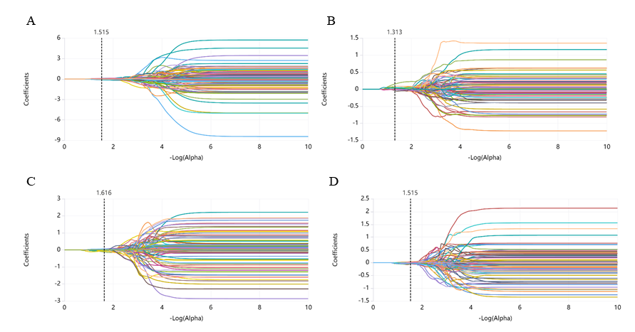
Figure S1. Plots of LASSO coefficient changes. T1C and T2-FS sequences predict ablation rates greater than 70% (A-B) and 50% (C-D).

Figure S2. Calibration curves for the task of predicting ablation rates greater than 50% and 70%. A, C training cohort, B, D testing cohort.

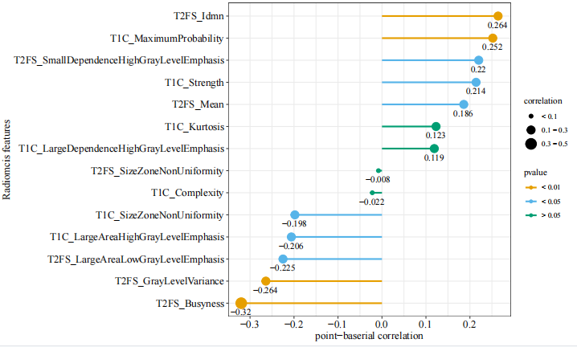
Figure S3. Correlation analysis was conducted between the ablation rate status (threshold = 50%) and radiological features. The size of the dots indicates the strength of the correlation, with larger dots representing a stronger correlation with the ablation rate status. The colors yellow, blue, and green represent correlation tests with p-values below 0.01, 0.05, and >0.05, respectively.

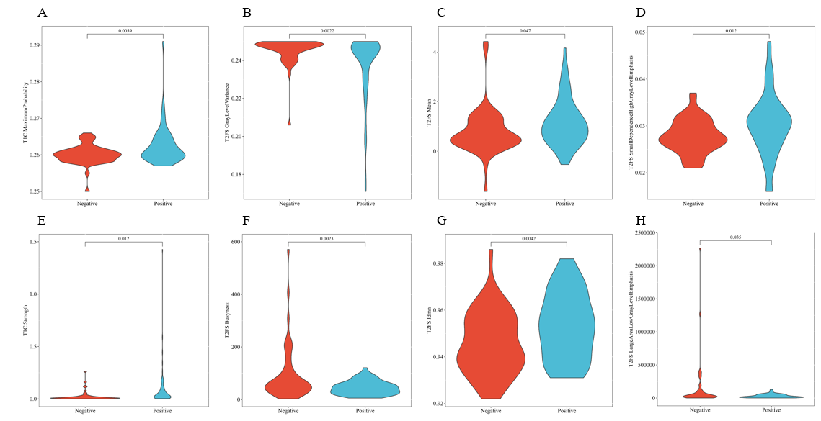
Figure S4. Violin plots of Radiomics features for T1C and T2FS sequences. The negative group represents patients with an ablation rate of less than 50%, while the positive group represents patients with an ablation rate of 50% or more.

