Supplemental Material 1

Supplementary materials and methods
PUFA metabolites LC-MS/MS measurements
PUFA metabolites were extracted from the supernatant or the cell pellets following the methods previously described ¹. PGE₂, 15d-PGJ₂, PGD₂ were quantified. To simultaneously separate lipids of interest and three deuterated internal standards (5-HETEd8, LxA4d4 and LtB4d4), LC-MS/MS analysis was performed on an ultra-high-performance liquid chromatography system (UHPLC; Agilent LC1290 Infinity) coupled to an Agilent 6460 triple quadrupole MS (Agilent Technologies) equipped with electrospray ionization operating in negative mode. Reverse-phase UHPLC was performed using a ZorBAX SB-C18 column (Agilent Technologies) with a gradient elution. The mobile phases consisted of water, acetonitrile (ACN), and formic acid (FA) [75:25:0.1 (v/v/v)] (solution A) and ACN and FA [100:0.1 (v/v)] (solution B). The linear gradient was as follows: 0% solution B at 0 min, 85% solution B at 8.5 min, 100% solution B at 9.5 min, 100% solution B at 10.5 min, and 0% solution B at 12 min. The flow rate was 0.35 ml/min. The autosampler was set at 5°C, and the injection volume was 5 µL. Data were acquired in multiple reaction monitoring (MRM) mode with optimized conditions. Peak detection, integration, and quantitative analysis were performed with MassHunter Quantitative analysis software (Agilent Technologies). For each standard, calibration curves were built using 10 solutions at concentrations ranging from 0.95 to 500 ng/ml. A linear regression with a weight factor of 1/X was applied for each compound. The limit of detection (LOD) and the limit of quantification (LOQ) were determined for the 28 compounds using signal-to-noise (S/N) ratios. The LOD corresponded to the lowest concentration leading to an S/N value >3, and LOQ corresponded to the lowest concentration leading to an S/N value >10. All values less than the LOQ were not considered. Blank samples were evaluated, and their injection showed no interference (no peak detected), during the analysis.

1. Le Faouder P, Baillif V, Spreadbury I, et al. LC-MS/MS method for rapid and concomitant quantification of pro-inflammatory and pro-resolving polyunsaturated fatty acid metabolites. J Chromatogr B Analyt Technol Biomed Life Sci. 2013;932:123-133.

Reagent list
REAGENT | SOURCE | IDENTIFIER
Antibodies
Mouse Anti-Human CD117 (c-Kit) BUV395 | BD Biosciences | Cat#745733; RRID:AB_2743207
Mouse Anti-Human CD117 BV421 | BD Biosciences | Cat# 563856, RRID:AB_2738452
Mouse anti-Human CD117 PE-Cy7 | BioLegend | Cat# 313212, RRID:AB_893222
Mouse anti Human IL17A FITC | Thermo Fisher Scientific | Cat# 11-7179-42, RRID:AB_10805390
Mouse anti- Human IL17A BV510 | Biolegend | Cat# 512330, RRID:AB_2562745
Mouse anti Human IFN-gamma PE | Biolegend | Cat# 502509, RRID:AB_315234
Mouse anti Human IFN-gamma FITC | BD Biosciences | Cat# 554700, RRID:AB_395517
Mouse anti Human IFN-gamma BV421 | BD Biosciences | Cat# 562988, RRID:AB_2737934
Mouse anti Human IL-22 PE-cy7 | Thermo Fisher Scientific | Cat# 25-7229-42, RRID:AB_10853346
Mouse anti-Human IL-4 APC | Biolegend | Cat# 500714, RRID:AB_1877159
Mouse anti Human CD25 Pe-Cy5 | BD Biosciences | Cat# 555433, RRID:AB_395827
Mouse anti Human CD127 BV786 | BD Biosciences | Cat# 563324, RRID:AB_2738138
Mouse anti-Human FoxP3 A488 | BD Biosciences | Cat# 560047, RRID:AB_1645349
Mouse anti-Human LAP PE | BD Biosciences | Cat# 562260, RRID:AB_10895568
Rat anti Human GM-CSF PERCP-Cy5.5 | BD Biosciences | Cat# 562258, RRID:AB_11154230
Mouse anti-Human Granzyme B Alexa Fluor 700 | BD Biosciences | Cat# 560213, RRID:AB_1645453
Mouse anti-Human CD4 | BioLegend | Cat# 344604, RRID:AB_1937227
Mouse (IgG1) anti Human-Tryptase | Agilent | Cat# M7052, RRID:AB_2206478
Rabbit Anti-IL-1 beta antibody | Abcam | Cat# ab9722, RRID:AB_308765
Mouse anti-Chymase | Millipore | Cat# MAB1254, RRID:AB_2083625
Goat anti-Human CD4 | R and D Systems | Cat# AF-379-NA, RRID:AB_354469
Rabbit anti-Human Cleaved-IL-1β | Cell Signaling Technology | Cat# 83186, RRID:AB_2800010
Rabbit anti-Cox2 | Cell Signaling Technology | Cat# 13596, RRID:AB_2798270
Donkey anti-Rabbit IgG (H+L) Highly Cross-Adsorbed Secondary Antibody, Alexa Fluor 555 | Thermo Fisher Scientific | Cat# A-31572, RRID:AB_162543
Donkey anti-Mouse IgG (H+L) Highly Cross-Adsorbed Secondary Antibody, Alexa Fluor 647 | Thermo Fisher Scientific | Cat# A-31571, RRID:AB_162542
Donkey anti-Goat IgG (H+L) Cross-Adsorbed Secondary Antibody, Alexa Fluor 488 | Thermo Fisher Scientific | Cat# A-11055, RRID:AB_2534102
AF555, Donkey anti-rabbit IgG | Invitrogen | Cat# A32794; RRID: AB_2762834 ;
AF488, Goat anti-rat IgG | Fisher Scientific | Cat# A11006; RRID: AB_2534074
IgG rabbit anti-human CD3Ɛ | Diagnostic Biosystems | Cat# RMAB005; RRID: AB_2860564; clone: SP7
Biological Samples
Formalin-fixed paraffin embedded (FFPE) colon tissues from Crohn and healthy patients. | Biological Resource Centre (CRB)-CHU Toulouse (DC 2019-3464; AC-2008-820) | N/A
Buffy Coat | Etablissement français du sang | N/A
Chemicals
eBioscience™ Fixable Viability Dye eFluor™ 780 | Thermo Fisher Scientific | 65-0865-18
Protein Transport Inhibitor (Containing Brefeldin A) | BD Biosciences | Cat#555029
Protein Transport Inhibitor (Containing Monensin) | BD Biosciences | Cat#554724
CellTrace™ Violet Cell Proliferation Kit | Thermo Fisher Scientific | CatC34571
Phorbol 12-myristate 13-acetate | Sigma-Aldrich | Cat# P8139
Ionomycin calcium salt from Streptomyces conglobatus | Sigma-Aldrich | Cat# I0634
Human FoxP3 Buffer Set | BD Biosciences | Cat# 560098
Indometacin | Sigma-Aldrich | Cat# I7378
Recombinant Human IL-3 | PeproTech | Cat#200-03
L-902,688 | Cayman Chemical | Cat#10007712
Butaprost | Cayman Chemical | Cat# 13740
Sulprostone | Cayman Chemical | Cat#14765
Recombinant Human IL-6 | PeproTech | Cat#200-06
Recombinant Human IL-1RA (Animal-Free) | Biolegend | Cat# 714406
Dynabeads™ Human T-Activator CD3/CD28 for T Cell Expansion and Activation | Life Technologies | Cat#11131D
Prostaglandin E2 | Cayman Chemical | Cat# 14010
Prostaglandin d2 | Cayman Chemical | Cat# 12010
15-deoxy-Δ12,14-Prostaglandin J2 | Cayman Chemical | Cat# 18570
Citrate Buffer, pH 6.0, 10×, Antigen Retriever | Sigma-Aldrich | Cat# C9999
DAPI | Thermofisher | Cat# D1306
Dextran sulfate sodium | MP biomedicals | Cat# Q8758  Lot 160110
Kits
SuperScript™ IV VILO™ Master Mix with ezDNase™ Enzyme | Thermo Fisher Scientific | Cat# 11766050
Master Mix Fast Advanced TaqMan™ | Thermo Fisher Scientific | Cat#4444557
EasySep™ Human Memory CD4⁺ T Cell Enrichment Kit | Stemcell Technologies | Cat#19157
EasySep™ Human Whole Blood CD34 Positive Selection Kit | Stemcell Technologies | Cat#18086A
EasySep™ Human CD4⁺CD127lowCD25⁺ Regulatory T Cell Isolation Kit | Stemcell Technologies | Cat#18063
LEGENDplex™ HU Th Cytokine Panel (12-plex) | Biolegend | Cat# 741028
Oligonucleotides
FOXP3 (Hs01085834_m1) | Life Technologies | Cat# 4331182
TBX21 (Hs00894392_m1) | Life Technologies | Cat# 4331182
GATA3 (Hs00231122_m1) | Life Technologies | Cat# 4331182
RORC (Hs01076112_m1) | Life Technologies | Cat# 4331182
Software
GraphPad Prism 9 | graphpad.com | N/A
Flowjo 10.0 | Flowjo.com
R (4.2.2) | r-project.org
Zen | Carl Zeiss Microscopy
ImageJ | ImageJ
StepOne Software V2.3 | Thermo Fisher Scientific

Supplementary figures

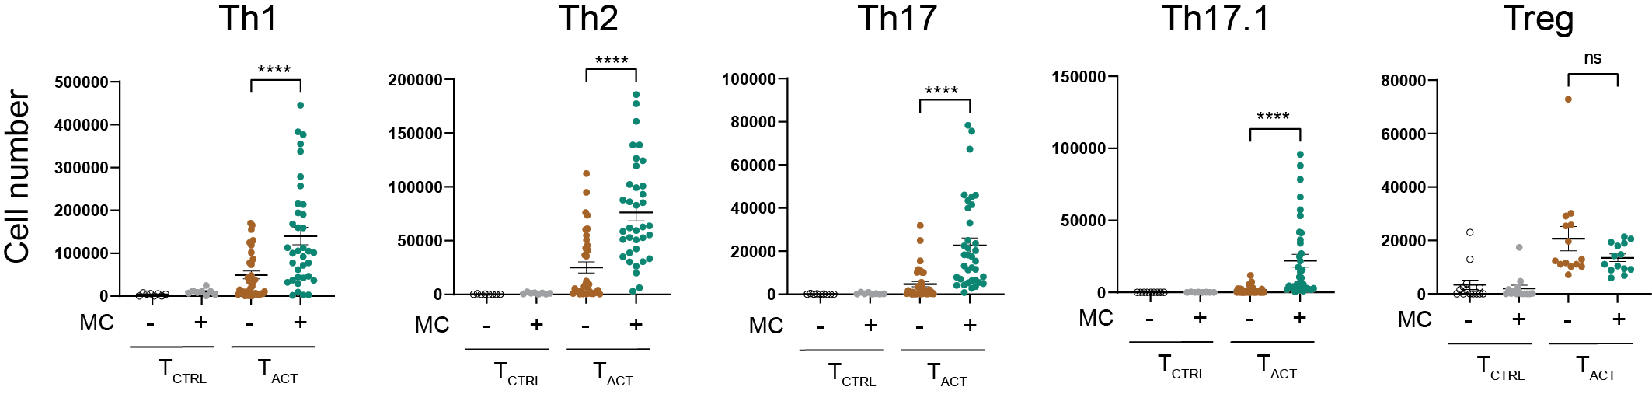
Figure S1. Numbers of Teff subsets after 6 days of coculture.
Freshly isolated memory CD4⁺ T cells from healthy blood donors were stimulated with anti-CD3/CD28 coated beads (T_{ACT}) or not (T_{CTRL}) for 6 days in the presence or the absence of MCs. Cell number of each Teff subsets were measured by flow cytometry using counting beads. Each point represents a combination of MCs and memory CD4⁺ T cells originating from different healthy donors (n=36 for Th cells and n=14 for Tregs). Wilcoxon matched-pairs signed rank test, ****p < 0.0001, ns not significant.

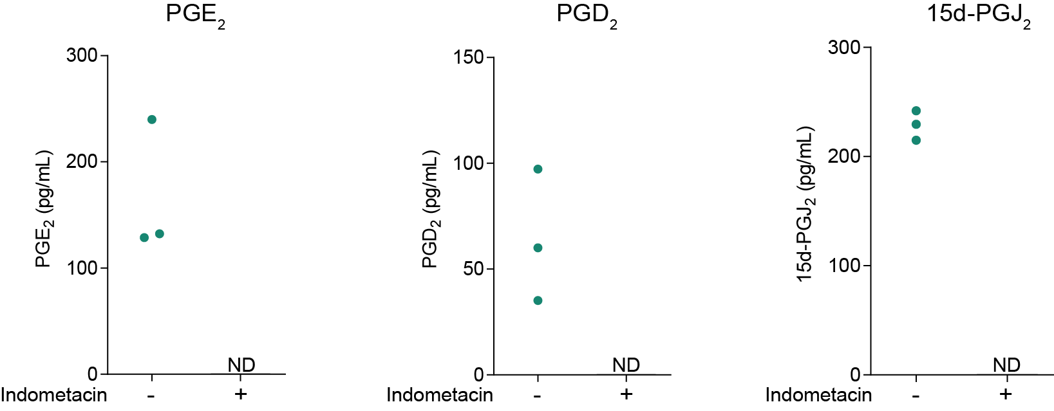
Figure S2. Indometacin treatment abolishes eicosanoids production in MC / CD4⁺ T cell co-culture.
MCs were co-cultured with effector/memory CD4⁺ T cells plus anti-CD3/28-coated beads for 48h with or without indometacin (100 µmol/L). Indicated eicosanoid concentrations were measured by LC-MS/MS. Each point represents one MC/T cell pair from different donors. ND, not detected.
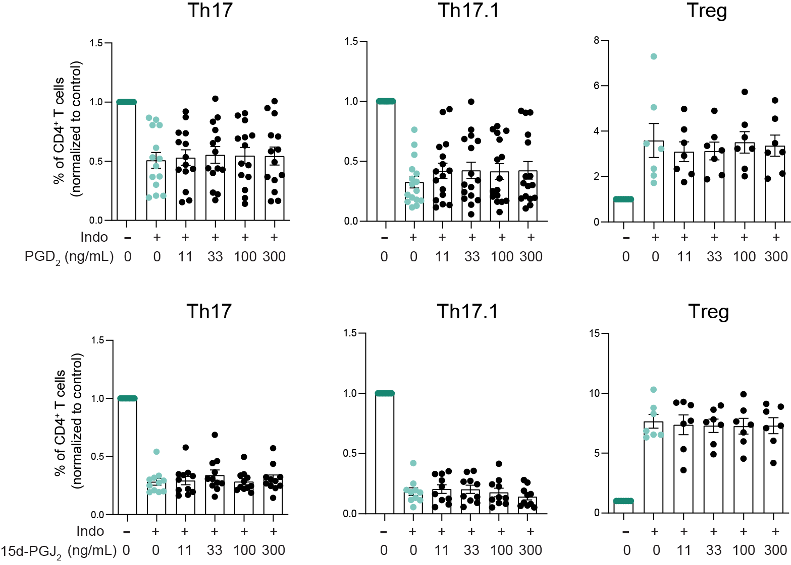
Figure S3. PGD₂ and 15d-PGJ₂ do not impact TH17/Treg balance.
Memory CD4⁺ T cells were co-cultured with MCs in the presence of anti-CD3/CD28 coated beads for 6 days. Indometacin-treated co-cultures were supplemented with increasing concentrations of PGD₂ (upper panel) or 15d-PGJ₂ (lower panel) and CD4⁺ T cell subset frequencies were analyzed by flow cytometry at day 6. Bars represent mean ± SEM (n=10-16). ANOVA showed no significant difference among groups.

