Supporting Online Information and Supplemental Figures
Dynamic Nanoscale Peptide Assemblies and Formulations for Temporally Controlled Ototopical Drug Delivery
Evan A. Patel,ª Swapnil V. Shah,^{a†}, Trevor A. Poulson,ª H. Christopher Fry,^{b} and Ashok A. Jagasiaª*
ª Rush University Medical Center, Chicago, IL 60612.
^{b} Center for Nanoscale Material, Argonne National Laboratory, Lemont, IL 60439.

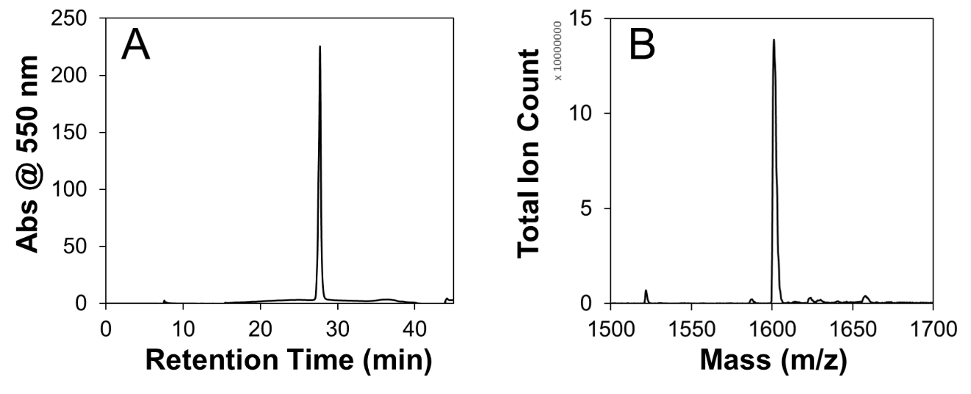
Supplemental Figure S1.A) HPLC ( > 99% pure) and S1B) ESI-Mass spectrometry characterization (Calculated for C86H133N15O14, 1600.02 (Monoisotopic mass); Found, 1601.1 (M+H+) of PA-TAMRA.

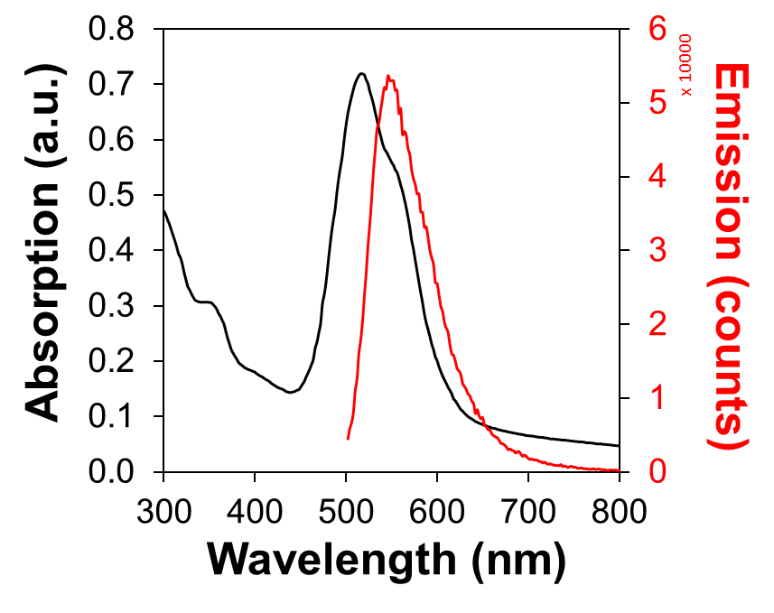
Supplemental Figure S2. UV/Visible (Black) and fluorescence spectroscopy (Red) of PA-TAMRA. labs = 510 nm, lem = 550 nm.

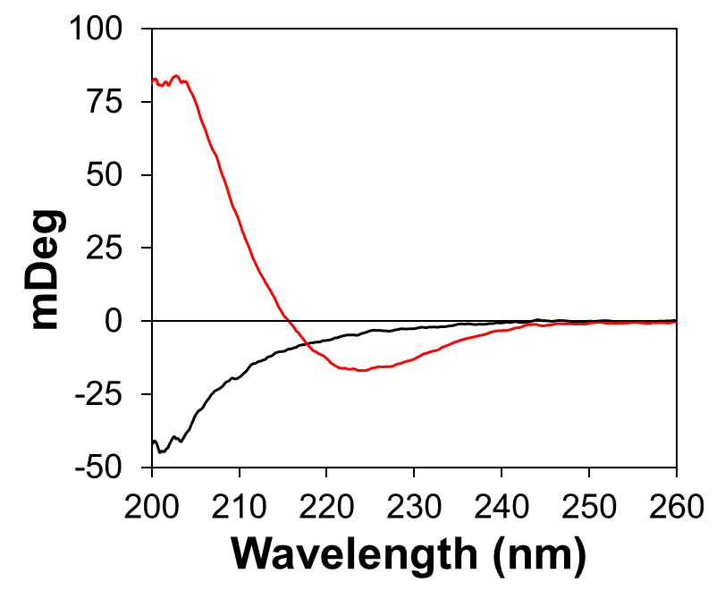
Supplemental Figure S3. Circular dichroism of 10:1 PA:PA-TAMRA (500 mM:50 uM) in PBS, pH 7.4 (Black) and PBS, pH 11 (Red). At pH 7, the CD spectrum demonstrates a random coil conformation. At pH 11, the CD spectrum demonstrates b-sheet formation with λ_{min} at 223 nm.

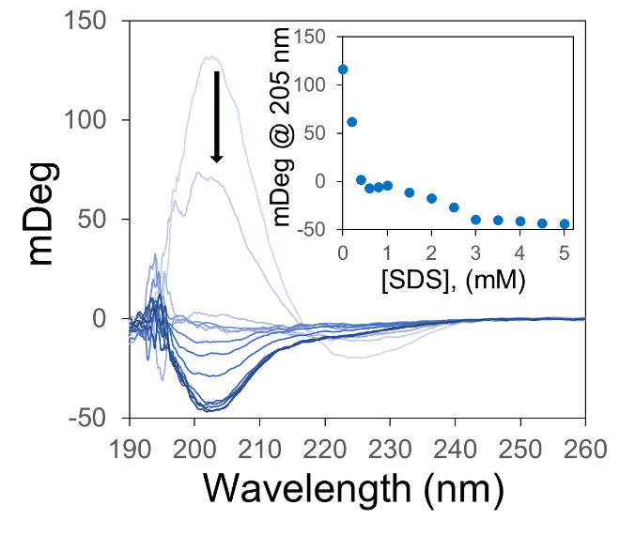
Supplemental Figure S4. Circular dichroism spectra of PA (500 μM) in PBS, pH 7.4 with increasing concentrations of SDS from 0 mM (light blue) to 5 mM (dark blue) as indicated by the black arrow. Inset: The CD signal at 205 nm as a function of increasing SDS concentration indicating a loss of β-sheet character transitioning to random coil.
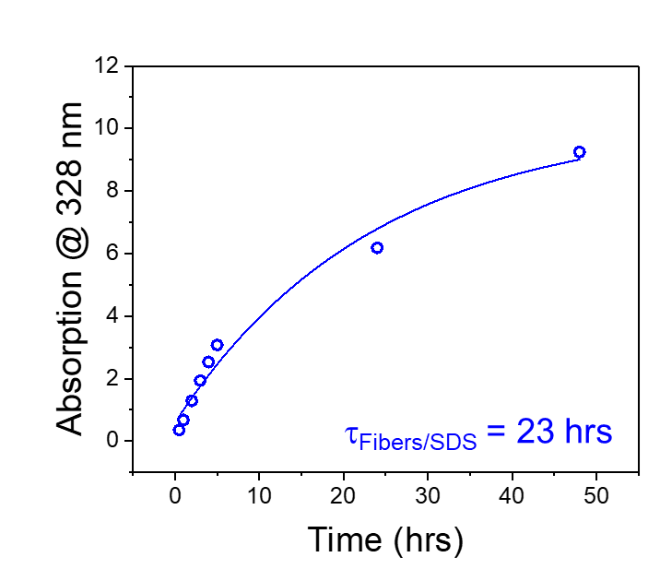
Supplemental Figure S5. Ciprofloxacin release from PA-fibers mixed with 1 wt% SDS over a 48 hr period.

