Supplementary figure 1. Top 25 Cited Authors with the Strongest Citation Bursts
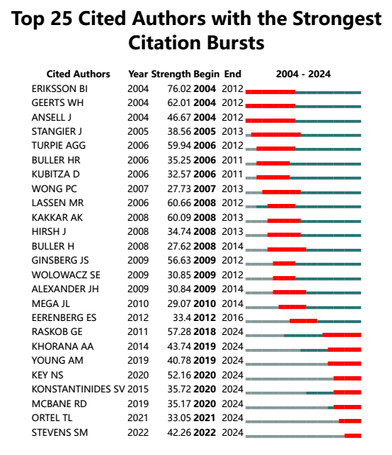

Supplementary figure 2. Top 25 Cited Journals with the Strongest Citation Bursts

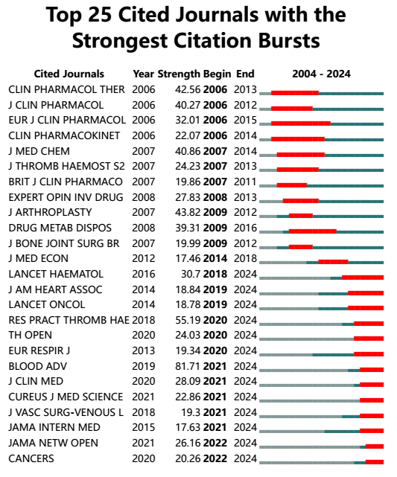

Supplementary figure 3. Top 25 citation bursts of highly cited institutions
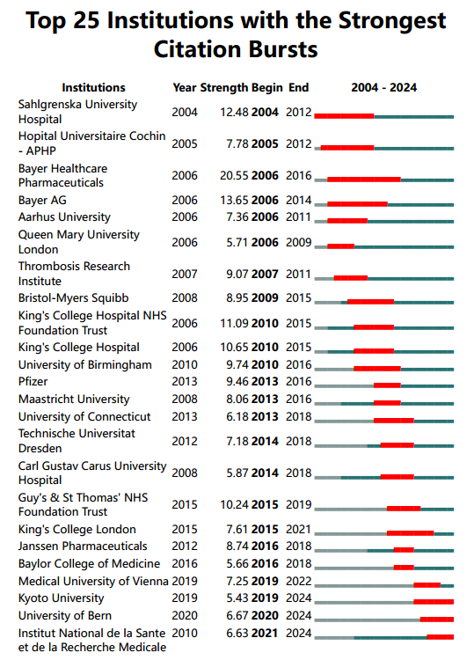

Supplementary figure 4. Top 25 citation bursts of highly cited keywords
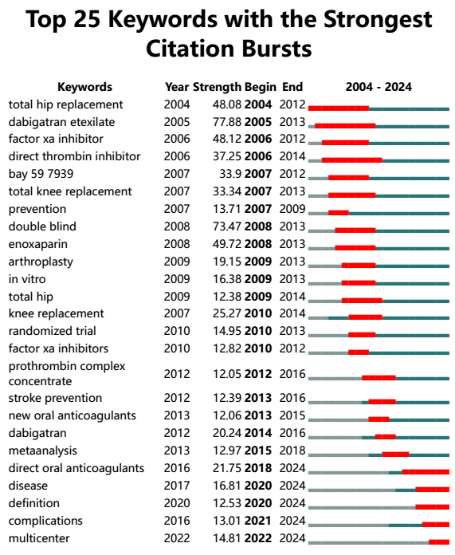

Supplementary figure 5. Top 25 citation bursts of highly cited references

