Supplementary Figure 1 – Flowchart of included participants

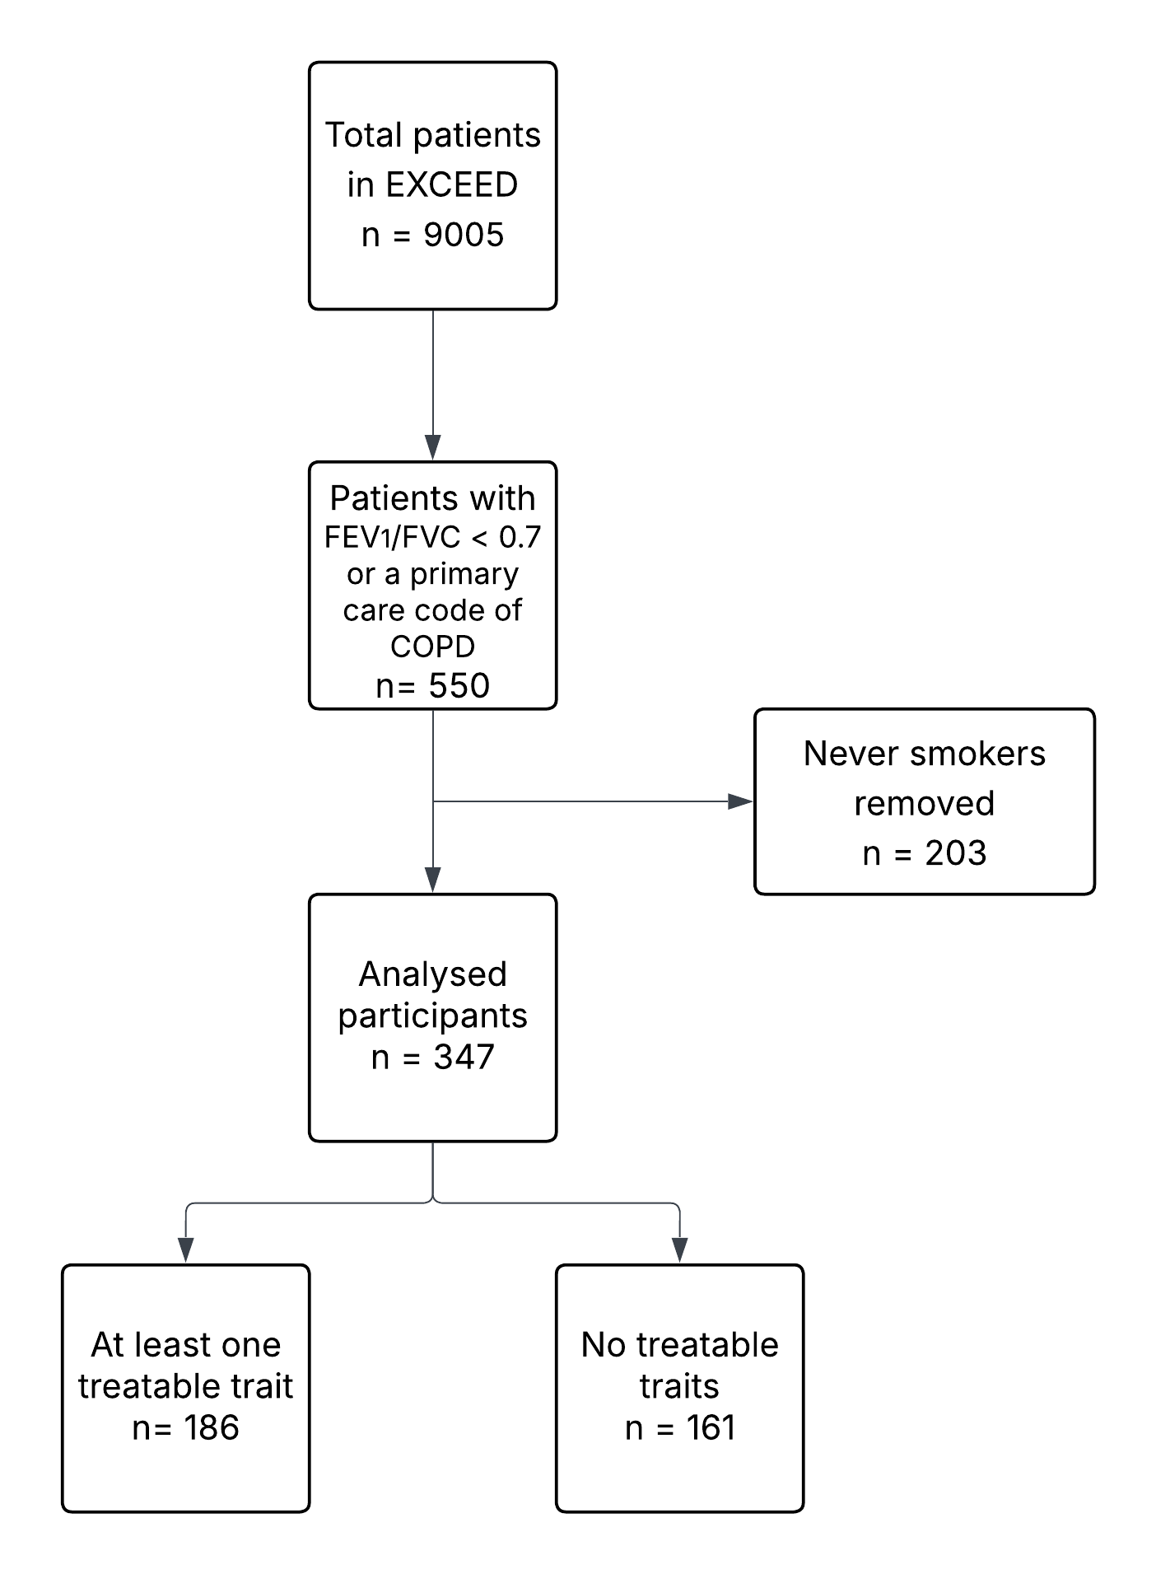

Supplementary Figure 2 – Upset plot of trait frequency restricted to those with a primary care code of COPD. Each vertical bar represents a unique combination of traits shared among patients, with bar height corresponding to frequency. Individual trait frequencies are displayed as horizontal bars on the left, representing the total number of patients exhibiting each trait. Categories and intersections with fewer than 5 occurrences have been removed to ensure privacy.
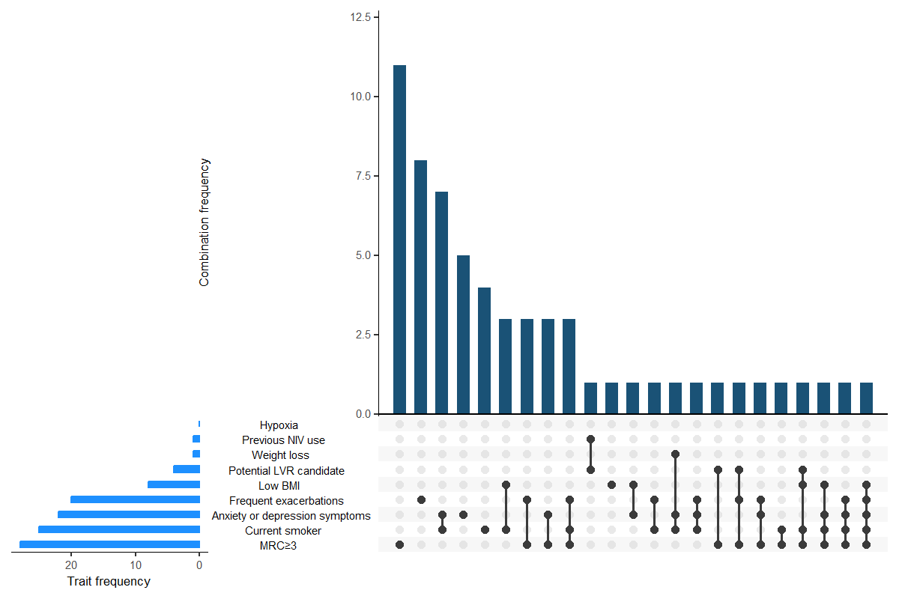

List of extracted primary care codes

Supplementary Table 1 - Depression codes
Code | Term ID | Description
6891. | Yaef0 | Depression screening
E1121 | Y01FS | Single major depressive episode, mild
E1122 | Y01FT | Single major depressive episode, moderate
E1123 | Y01FU | Single major depressive episode, severe, without mention of psychosis
E1124 | Y01FV | Single major depressive episode, severe, with psychosis
E112z | Y01FY | Single major depressive episode NOS
E1130 | Y01Fb | Recurrent major depressive episodes, unspecified
E1131 | Y01Fc | Recurrent major depressive episodes, mild
E1132 | Y01Fd | Recurrent major depressive episodes, moderate
E1133 | Y01Fe | Recurrent major depressive episodes, severe, without mention of psychosis
E1134 | Y01Ff | Recurrent major depressive episodes, severe, with psychosis
E1137 | YaYAt | Recurrent depression
E113z | Y01Fi | Recurrent major depressive episode NOS
E130. | Y01FI | Psychotic reactive depression
E2112 | YMBxo | Neurotic depression
E2B1. | YaYB5 | Chronic depression
X00S8 | Y01Cd | Post-schizophrenic depression
X00Sb | Y01Gs | Anxiety depression
X00SQ | Y01FK | Agitated depression
X00SR | Y01FO | Endogenous depression
X00SS | Y01Fj | Endogenous depression first episode
X761J | Y7D7m | Depression worse in morning
X761K | Y7D7n | Depression worse later in day
XaB9J | YMJar | Depression NOS
XaCHr | YMBxU | [X] Single episode agitated depression without psychotic symptoms
XaCHs | YMBxV | [X] Single episode major depression without psychotic symptoms
XaCIs | Yabyn | Mild depression
XaCIu | Yabyq | Severe depression
Xafff | Yaz1r | PHQ-15 (Patient Health Questionnaire 15) score
XagU1 | YazI5 | Recurrent reactive depressive episodes, severe, with psychosis
XagUK | YazIB | Prolonged single episode of reactive depression
XaImU | YalJv | Symptoms of depression
XaItx | Yale4 | Depression management programme
XaIwf | YaliE | HAD scale: depression score
XaK6e | YanJc | Depression medication review
XaKaX | Yantn | Depression anxiety stress scales depression score
XaKaY | Yantp | Depression anxiety stress scales stress score
XaKaZ | Yantr | Depression anxiety stress scales anxiety score
XaLDN | YaoHD | Patient health questionnaire (PHQ-9) score
XaLIc | YaoNB | Depression screening using questions
XaLLG | YaoQf | Beck depression inventory second edition score
XaPKm | Yas1A | On full dose long term treatment for depression
XaX0C | Yattn | Suspected depression
XaX1i | Yatuu | MADRS - Montgomery-Asberg depression rating scale
XaX53 | Yatxk | Single major depressive episode, severe, with psychosis, psychosis in remission
XaY4X | Yaue8 | Assessment using Whooley depression screen
XaYuW | YavAn | Depression intensity scale circles
XaYwr | YavNY | EQ-5D-5L (EuroQol five dimension five level) anxiety depression score
XaZJN | YavR7 | PHQ-2 - patient health questionnaire 2
XE1Y0 | Y01FQ | Single major depressive episode
XE1YC | Y01FL | Reactive depression
XM0aq | YM9Rj | BDI - Beck depression inventory
XM0bH | YM9SO | Brief depression rating scale
XM0cP | YM9U9 | Depression anxiety scale
XM0cQ | YM9UA | Depression self rating scale
XM0df | YaVJ2 | Geriatric depression score
XM0e0 | YM9Wc | Hamilton rating scale for depression
XM0eK | YaRJr | HADS - Hospital anxiety and depression scale
XM0ew | YM9Y1 | Leeds scale for the self-assessment of anxiety and depression
XM0km | YM9gN | WHO depression scale
XM0kW | YM9fy | Wakefield self-assessment depression inventory
XM0kx | YM9gZ | Zung self-rating depression scale
XM1GC | Y01FZ | Endogenous depression - recurrent
XSEGJ | YSNUF | Major depression
XSGok | YSRJY | Mild major depression
XSGol | YSRJZ | Moderate major depression
XSGom | YSRJa | Severe major depression without psychotic features
XSGon | YSRJb | Severe major depression with psychotic features
ZV790 | Ya0qU | [V]Screening for depression
E112. |  | Depression: [single major episode] or [agitated] or [endogenous (including first episode)]
E1120 |  | Single major depressive episode, unspecified
E113. |  | Recurrent depression: [major episode] or [endogenous]
E11y2 |  | Atypical depressive disorder
E2B.. |  | Depressive disorder NEC
Eu320 |  | [X]Mild depressive episode
Eu321 |  | [X]Moderate depressive episode
Eu322 |  | [X] Severe depressive episode without psychotic symptoms: (& [single episode agitated depression] or [single episode major depression] or [single episode vital depression])
Eu323 |  | [X] Severe depressive episode with psychotic symptoms: (& single episode of [major depression] or [psychogenic depressive psychosis] or [psychotic depression] or [reactive depressive psychosis])
Eu32y |  | [X] Depression: [other episodes] or [atypical] or [single episode masked NOS]
Eu32z |  | [X] (Depression: [episode, unspecified] or [NOS (& reactive)] or [depressive disorder NOS]
Eu331 |  | [X]Recurrent depressive disorder, current episode moderate
Eu332 |  | [X]Depression without psychotic symptoms: [recurrent: [major] or [manic-depressive psychosis, depressed type] or [vital] or [current severe episode]] or [endogenous]
Eu333 |  | [X] Depression with psychotic symptoms: [recurrent: (current episode severe) or (manic-depressive, depressed type) or (severe major episodes) or (severe episodes)] or [endogenous]
Eu33z |  | [X] Depression recurrent: [unspecified] or [monopolar NOS]
X00SO |  | Depressive disorder
X00SU |  | Masked depression
Xa0wV |  | Recurrent brief depressive disorder
XaCIt |  | Moderate depression
XE1aY |  | Depression: [reactive (neurotic)] or [postnatal]
XE1Y1 |  | Recurrent major depressive episodes
XE1Za |  | [X]Other depressive episodes
XE1Zb |  | [X]Depressive episode, unspecified
XE1Zd |  | [X]Recurrent depressive disorder, current episode severe without psychotic symptoms
XE1Ze |  | [X]Recurrent depressive disorder, current episode severe with psychotic symptoms
XE1Zf |  | [X]Recurrent depressive disorder, unspecified
XE1ZY |  | [X]Severe depressive episode without psychotic symptoms
XE1ZZ |  | [X]Severe depressive episode with psychotic symptoms
XaK6f |  | Depression interim review

Supplementary Table 2 Anxiety codes
Code | Term ID | Description
E200. | Y01Gq | Anxiety state
E2000 | Y01Gb | Anxiety state unspecified
E2002 | Y01Gl | Generalised anxiety disorder
E2004 | YaYAu | Chronic anxiety
E2005 | YaYAv | Recurrent anxiety
E200z | Y01Ga | Anxiety state NOS
Eu41. | YMB4X | [X]Other anxiety disorders
Eu410 | YMB4Y | [X]Panic disorder [episodic paroxysmal anxiety]
Eu413 | YMB4b | [X]Other mixed anxiety disorders
Eu41z | YMB4d | [X]Anxiety disorder, unspecified
Ua1qf | YMGWS | Terrified
Ua1qS | YMGBI | Panic attack
X00RP | Y017s | Organic anxiety disorder
X00Sa | Y01Gi | Non-situational panic attack
X00Sb | Y01Gs | Anxiety depression
X00Sc | Y01Gt | Anxiety hysteria
X00SZ | Y01Gh | Situational panic attack
X761b | Y7D8R | Fear of collapsing
X761g | Y7D8W | Fear of dying
X761N | Y7D7s | Anxiety and fear
X761P | Y7D8A | Ill-at-ease
X761T | Y7D8J | Anxiety about health
X762T | Y7D9Y | Fear of death
Xa0XQ | Ya1mD | Anxiety about dying
Xa3Vj | Ya5rp | Panic
Xa3Xk | Ya5up | Level of anxiety
Xa3Ys | Ya5wm | Character trait observations of level of anxiety
Xa3Yt | Ya5wn | Anxious character
Xa7kB | YaV9s | Anxiety attack
XaA5Z | YaYts | Beck anxiety inventory
Xaafv | YawVM | Anxiety about breathlessness
Xab9E | Yawxe | Anxiety screening
Xab9F | Yawxf | Anxiety screening using questions
Xab9G | Yawxg | Patient given advice about management of anxiety
Xaef0 | YayqD | Referral for psychological management of anxiety
XaIwe | YaliD | HAD scale: anxiety score
XaKaX | Yantn | Depression anxiety stress scales depression score
XaKaY | Yantp | Depression anxiety stress scales stress score
XaKaZ | Yantr | Depression anxiety stress scales anxiety score
XaNkT | Yaqjn | Generalised anxiety disorder 7 item score
XaYwr | YavNY | EQ-5D-5L (EuroQol five dimension five level) anxiety depression score
XaYwr | YavCf | EuroQol five dimension five level anxiety depression score
XaZe4 | Yavgi | Short health anxiety inventory
XaZJQ | YavR8 | Generalised anxiety disorder 2 scale
XaZJQ | YavR9 | GAD-2 (generalised anxiety disorder 2) scale
XE0rb | Ya5b6 | Anxiety
XE0ri | Y7D8h | Fear
XE1Y7 | Y01Gc | Panic disorder
XE1Y7 | Y01Gd | Episodic paroxysmal anxiety disorder
XE1Zj | YMB4c | [X]Other specified anxiety disorders
XM0ar | YM9Rk | Beck anxiety standardised rating scale
XM0bp | YM9TG | Clinical anxiety scale
XM0cP | YM9U9 | Depression anxiety scale
XM0eK | YM9X5 | Hospital anxiety and depression scale
XM0ew | YM9Y1 | Leeds scale for the self-assessment of anxiety and depression
XM0jC | YM9e9 | Speilberger state-trait anxiety inventory
XM0ky | YM9gc | ASI - Zung's anxiety status inventory
XM0kz | YM9gd | Zung's self-rating anxiety scale
Eu411 |  | [X]Generalized anxiety disorder
Eu054 |  | [X]Organic anxiety disorder
Eu41y |  | [X]Other specified anxiety disorders
Eu412 |  | [X]Mild anxiety depression
E2001 |  | Panic disorder
1B1V. |  | C/O - panic attack
1B13. |  | Anxiousness - symptom
E2003 |  | Anxiety with depression
Eu341 |  | [X]Persistant anxiety depression

Supplementary Table 3 - Breathlessness codes
Code | Term ID | Description
XaIUi | Yakx7 | MRC Breathlessness Scale: grade 1
XaIUl | YakxA | MRC Breathlessness Scale: grade 2
XaIUm | YakxB | MRC Breathlessness Scale: grade 3
XaIUn | YakxC | MRC Breathlessness Scale: grade 4
XaIUo | YakxD | MRC Breathlessness Scale: grade 5

Supplementary Table 4 - Oxygen saturation codes
Code | Term ID | Description
X7708 | YMGFA | O2 -oxygen saturation
X7709 | Y7FXY | Arterial oxygen saturation
X770C | Y7FXe | Capillary oxygen saturation
X770D | Y7FXg | Oxygen saturation at periphery
Xabhv | YaxUQ | Baseline SpO2 (oxygen saturation at periphery)
Xaa6l | Yaw03 | Peripheral blood oxygen saturation on supplemental oxygen at rest
Xaa6j | Yaw01 | Peripheral blood oxygen saturation on room air at rest
XSKud | YSY9E | Oxygen saturation measurement
XaIai | Yal43 | Blood oxygen saturation (calculated)
Xa2ZQ | Ya4YC | Invasive oxygen saturation monitoring
Xaa6l | Yaw03 | Peripheral blood oxygen saturation on supplemental oxygen at rest
44Y41 | YaXZE | Blood oxygen level abnormal
XSKud | YSY9E | Oxygen saturation measurement

Supplementary Table 5 - Use of home oxygen codes
Code | Term ID | Description
8771. | Y75QR | Oxygen therapy
cc... | y00D7 | Oxygen gas
pc... | y04wL | Oxygen equipment
pc1.. | y04wM | Oxygen set
pc11. | y04wO | BOC 33022 oxygen set
pc12. | y07EO | Medishield dom MDS240 oxygen set x1
pc13. | y04wT | Oxylitre MR210 oxygen set x1
pc14. | y07EP | Air app & valve D24 oxygen set x1
pc15. | y04wR | Ohmeda Domic 2/4 1550033 oxygen set
pc16. | y04wX | Oxygen giving set
pc17. | y04wP | BOC Domiflow 888830 oxygen set
pc18. | y04wQ | Puritan Bennett 778435 oxygen set
pc19. | y08Y3 | Sabre Medical Oxydom oxygen set
pc1A. | y0D6v | Therapy Equipment Dialreg 5120 oxygen set
pc1B. | y0Dbl | Oxylitre M410 oxygen set
pc2.. | y04wY | Oxygen mask
pc25. | y04wc | Venticaire oxygen mask
pc26. | y0ELT | Venticaire 28% Venturi oxygen mask
pc3.. | y04we | Oxygen cylinder
pc32. | y09qF | Oxygen gas cylinder AD
pc34. | y09qH | Oxygen gas cylinder C
pc35. | y09qI | Oxygen gas cylinder D
pc36. | y09qJ | Oxygen gas cylinder E
pc38. | y09qL | Oxygen gas cylinder G
pc39. | y09qM | Oxygen gas cylinder J
pc3A. | y09qN | Oxygen gas cylinder PD
pc3B. | y09qO | Oxygen gas cylinder SD
pc3C. | y0EQI | Oxygen gas cylinder DD
pc3D. | y0EQJ | Oxygen gas cylinder HD
pc3E. | y0EQK | Oxygen gas cylinder RD
pc3F. | y0EQL | Oxygen gas cylinder DF
pc3G. | y0EQM | Oxygen gas cylinder HX
pc3H. | y0Gwu | Oxygen gas cylinder FC
pc4.. | y04wg | Oxygen concentrator
pc41. | y04wh | Oxygen concentrator 1
pc5.. | y0C7E | Oxygen nasal cannula
x01Sl | y04wN | Oxygen regulator DT specification 01A
x01Sm | y04wU | Oxygen regulator DT specification 01B
x01Sn | y04wS | Oxylitre MR210 oxygen set
x028p | y04wW | Medishield Domiciliary MDS240 oxygen set
x028q | y04wV | Air Apparatus+Valve D24 oxygen set
X71a1 | YaRE5 | LTOT - Long-term oxygen therapy
X7742 | Y7Fjq | Oxygen concentration
X7743 | Y7Fjr | Respired oxygen concentration
X7744 | Y7Fjv | Oxygen concentration - inspired
X77PG | Y7GCE | Oxygen flux
X77PH | Y7GCG | Indexed oxygen delivery
XaA0s | YaYmG | Humidified oxygen therapy
Xaa6S | Yavzj | Number of hours oxygen therapy prescribed per day
Xaa6T | Yavzk | Supplier reported volume of supplemental oxygen prescribed per day
Xaa6U | Yavzl | Supplier reported volume of supplemental oxygen used per day
Xaa6V | Yavzm | Supplier reported volume variance between prescribed and used supplemental oxygen per day
Xaa8f | Yaw1x | Supplier reported percentage variance between prescribed and used supplemental oxygen per day
XaaNt | YawFZ | Requires oxygen therapy during exercise
XaaZl | YawQM | Number of hours long-term oxygen therapy prescribed per day
XaaZn | YawQO | Number of hours ambulatory oxygen therapy prescribed per day
XaaZo | YawQP | Supplier reported volume of long-term oxygen prescribed per day
XaaZr | YawQS | Supplier reported volume of ambulatory oxygen prescribed per day
XaFsb | Yah3a | High concentration oxygen therapy
XaLL8 | YaoQX | Ambulatory oxygen therapy
XaLL9 | YaoQY | Home oxygen supply - cylinder
XaLLA | YaoQZ | Home oxygen supply - concentrator
XaLLB | YaoQb | Home oxygen supply - liquid oxygen
XaLxV | Yap4Z | Patient consent given for supply of home oxygen
XaM30 | YapB7 | Oxygen therapy NOS
XaM31 | YapB8 | Other specified oxygen therapy
XaMGZ | YapRB | Home oxygen support
XaPy8 | YascF | Number of hours oxygen therapy required per day
XaQ11 | Yasf8 | Delivered oxygen flow rate
XaQ12 | Yasf9 | Delivered oxygen therapy percentage
XaWPM | Yatqm | HOOF (home oxygen order form) completed
XaZYY | YavbB | Patient on oxygen
XE1Sx | Y79zx | Oxygen at home
XM1Xh | Y79zw | Home oxygen supply started

Supplementary Table 6 - Use of non-invasive ventilation codes
Code | Term ID | Description
X71a8 | Y75Qt | BIPAP - Biphasic pressure airway support
Xa0Bz | Y75Rq | Domiciliary ventilation
XaLz1 | Yap62 | Ventilatory support
Xa4fY | YaRhI | Non-invasive ventilation
Xa1mN | Ya3T2 | Externally applied positive and negative pressure ventilation
872Z. | Yac8m | Mechanical respiratory assistance NOS
Xa3aa | Ya5z5 | Pressure controlled ventilation
XaXqa | YauYx | Non-invasive ventilation therapy review

Supplementary Table 7 - Respiratory failure codes
Code | Term ID | Description
H590. | YMAjP | Acute respiratory failure
H591. | YMAjQ | Chronic respiratory failure
R2y1. | YM17T | [D]Respiratory failure
R2y1z | YM17W | [D]Respiratory failure NOS
X008F | Y00S9 | Sleep-related respiratory failure
X103y | Y10ES | Respiratory failure without hypercapnia
X1040 | Y10EY | Hypercapnic respiratory failure
XaO5l | YaqtU | Chronic type 1 respiratory failure
XaO5m | YaqtV | Chronic type 2 respiratory failure
XaZhn | Yavii | History of acute type I respiratory failure
XaZhq | Yavim | History of acute type II respiratory failure
XM09V | Y10EQ | Respiratory failure

Supplementary Table 8 - Respiratory referral codes
Code | Term ID | Description
8H4C. | Y79jd | Referred to chest physician
9N1d. | Ya3pZ | Seen in asthma clinic
XaAcQ | YaZZq | Referral to chest medicine service
XaAcR | YaZZr | Referral to thoracic medicine service
XaAcS | YaZZs | Referral to respiratory medicine service
XaAfk | YaZdn | Referral to chest physician
XaAfl | YaZdo | Referral to thoracic physician
XaAfm | YaZdp | Referral to respiratory physician
XaASl | YaZMg | Seen by respiratory physician
XaAVY | YaZQD | Seen by respiratory medicine - service
XaIOU | Yakp3 | Referral to respiratory rapid response team
XaIoY | YalOg | Seen by rapid response team - respiratory
XaJeS | Yamir | Referral to respiratory nurse specialist
XaLr4 | YaoyT | Refer to community respiratory team
XaMjF | YapkW | Seen in community respiratory clinic
XaONr | YaqyL | Seen in respiratory clinic
XaRCE | Yatg9 | Referral to respiratory assistant practitioner
XaX21 | YatvB | Referral to respiratory outreach team
XaXyZ | Yaud8 | Seen by respiratory nurse specialist
XaYWS | Yauqx | Referral to respiratory clinic
XaZoz | Yavkr | Seen in chronic obstructive pulmonary disease clinic

Supplementary Table 9 - Eosinophil count codes
Code | Term ID | Description
42K.. | Y7FAh | Eosinophil count
42KZ. | Y7FAj | Eosinophil count NOS
42K1. | Y7FAi | Eosinophil count normal
42K3. | Y7FAk | Eosinophil count raised
XaCJj | Yaeib | Percentage eosinophil count

Supplementary Table 10 - Pulmonary rehabilitation referral codes
Code | Term ID | Description
XS7qP | YSCFO | Pulmonary rehabilitation
Ub1ni | Ya2KB | Pulmonary rehabilitation class
XaaNR | YawF7 | Pulmonary rehabilitation review
XabGM | Yax3X | Pulmonary rehabilitation offered
XaNQU | YaqRk | Pulmonary rehabilitation declined
XaIf9 | YalAF | Referral to pulmonary rehabilitation
XagBC | Yaz9u | Unsuitable for pulmonary rehabilitation
XaIUq | YakxF | Pulmonary rehabilitation programme commenced
XaIUs | YakxH | Pulmonary rehabilitation programme completed
XaPZH | YasIt | Chronic obstructive pulmonary disease patient unsuitable for pulmonary rehabilitation

Supplementary Table 11 Smoking cessation referral codes
Code | Term ID | Description
9OO1. | YacuF | Attends stop smoking monitoring
XaaDy | Yaw6E | Referral to smoking cessation service
Xaca0 | Yay94 | Varenicline smoking cessation therapy offered
XaIpo | YamDm | Did not attend smoking cessation clinic
XaItC | Yalcu | Referral to smoking cessation advisor
XaIth | Yaldf | Smoking cessation programme start date
XaIye | YaltA | Seen by smoking cessation advisor
XaLD4 | YaoGv | Smoking cessation advice provided by community pharmacist
XaLMR | YaoRb | Attends practice smoking cessation clinic
XaLMS | YaoRc | Attends smoking cessation clinic not at practice
XaMlI | YapmM | Smoking cessation drug therapy
XaMlJ | YapmF | Nicotine replacement therapy using nicotine patches
XaMlK | YapmG | Nicotine replacement therapy using nicotine gum
XaMlL | YapmH | Nicotine replacement therapy using nicotine inhalator
XaMlM | YapmI | Nicotine replacement therapy using nicotine lozenges
XaMlN | YapmJ | Other specified smoking cessation therapy
XaMt6 | YapvD | Smoking cessation therapy NOS
XaMwY | Yapyh | Smoking cessation therapy
XaQT5 | Yat2g | Referral to NHS stop smoking service
XaQU8 | Yat3n | Stop smoking face to face follow-up
XaW0h | YatoO | Practice based smoking cessation programme start date
XaX0O | Yattt | Consent given for follow-up evaluation after smoking cessation intervention
XaX5W | YatyN | Consent given for follow-up by smoking cessation team
XaXnG | YauW4 | Stop smoking service opportunity signposted
XaXR4 | YauFu | Referral for smoking cessation service offered
XM1Rv | Y7ARO | Stop smoking clinic admin.

Supplementary Table 12 - Weight loss codes
Code | Term ID | Description
R032. | YM0yB | [D]Abnormal loss of weight
X76CA | Y7DRN | Weight loss
X76CD | Y7DRQ | Percentage weight loss
XaBmk | YabBE | Excessive weight loss
XaIxC | Yaliw | Weight loss from baseline weight
XaKwR | Yao3m | Complaining of weight loss
XaQgK | YatEJ | Unexplained weight loss
XaXTs | YauJ3 | Unintentional weight loss
XE0qb | Y7DR9 | Abnormal weight loss

Supplementary Table 13 – Hospitalisation codes
Code | Term ID | Description
8H12. | Y79hA | Admit to respiratory ITU
8H2.. | Y79hF | Emergency hospital admission
8H21. | YacEm | Admit medical emergency unspecified
8H2P. | Y79hf | Emergency admission, asthma
8H2Z. | Y79hg | Admit hospital emergency NOS
8H3P. | Y79mY | Non-urgent respiratory admission
8H3Z. | Y79md | Other hospital admission NOS
8H7a. | YaXmu | Refer to hospital
8HJ.. | Y79jp | Self-referral to hospital
8HJZ. | Y79k9 | Self-referral to hospital NOS
8HM.. | YacFt | Listed for admission to hospital
8HM1. | Y79l7 | Listed for Gen Medicine admiss
8HMB. | Y79lH | Listed for Chest Med admission
8HMZ. | Y79lY | Listed for hosp admission NOS
8HN0. | YadXC | Inpatient stay longer than 12 hours
8HN1. | YadXD | Inpatient stay 1 day
8HN2. | YadXE | Inpatient stay 2 days
8HN3. | YadXF | Inpatient stay 3 days
8HN4. | YadXG | Inpatient stay 4 days
8HN5. | YadXH | Inpatient stay 5 days
8HN6. | YadXJ | Inpatient stay 6 days
8HN7. | YadXK | Inpatient stay 7 days
8HN8. | YadXL | Inpatient stay 8 days
8HN9. | YadXM | Inpatient stay 9 days
8HNA. | YadXN | Inpatient stay 10 days
8HNB. | YadXO | Inpatient stay 11 days
8HNC. | YadXP | Inpatient stay 12 days
8HND. | YadXQ | Inpatient stay 13 days
8HNE. | YadXR | Inpatient stay 14 days
8HNZ. | YadXS | Inpatient stay NOS
Xa1qK | Ya3Z1 | Hospital admission
XaABh | YaZ2Q | Inpatient care
XaAKz | YaZDS | Admission by doctor
XaAL0 | YaZDT | Admission by accident and emergency doctor
XaAL4 | YaZDZ | Admission by GP
XaAL5 | YaZDa | Admission by own GP
XaAL6 | YaZDb | Admission by GP partner
XaAL7 | YaZDc | Admission by assistant GP
XaAL8 | YaZDd | Admission by associate GP
XaAL9 | YaZDe | Admission by co-op GP
XaALA | YaZDf | Admission by deputising GP
XaALB | YaZDg | Admission by GP locum
XaALb | YaZEA | Admission by care of the elderly physician
XaALC | YaZDh | Admission by GP registrar
XaALc | YaZEC | Admission by chest physician
XaALd | YaZED | Admission by thoracic physician
XaALe | YaZEE | Admission by respiratory physician
XaALm | YaZEM | Admission by general physician
XaALY | YaZE7 | Admission by physician
XaAMf | YaZFO | Admission by nurse
XaAMg | YaZFP | Admission by agency nurse
XaAMh | YaZFQ | Admission by enrolled nurse
XaAMi | YaZFR | Admission by general nurse
XaAMm | YaZFV | Admission by nurse practitioner
XaAMv | YaZFe | Admission to tertiary referral hospital
XaAMw | YaZFg | Admission to ward
XaAN3 | YaZFq | Admission to department
XaAN6 | YaZFw | Admit to ITU
XaAN7 | YaZFx | Admission to adult intensive care unit
XaAN9 | YaZG1 | Admission to medical department
XaAND | YaZG5 | Admission to chest medicine department
XaANE | YaZG6 | Admission to thoracic medicine department
XaANF | YaZG7 | Admission to respiratory medicine department
XaANN | YaZGF | Admission to general medical department
XaarU | Yawfd | Admission notification
XaBV3 | YaaoA | Inpatient stay
XaCHY | YabxA | Referral to hospital
Xafex | Yaz1X | Number of hospital admissions due to COPD (chronic obstructive pulmonary disease) in past year
XaIgX | YalBd | Hospital admission note
XaJFu | YamED | Admit COPD emergency
XaJID | YamGX | Admit respiratory emergency
XaK8S | YanLc | Emergency chronic obstructive pulmonary disease admission since last appointment
XaKzy | Yao5h | Multiple chronic obstructive pulmonary disease emergency hospital admissions
XaYgC | Yauz4 | Hospital re-admission
XaYYP | Yausc | Admission by out of hours service doctor
XaZ6X | YavKF | Admission profile form completed
XaZJX | YavRE | Admission to acute assessment unit
XaZVU | YavZ3 | Emergency hospital admission from walk-in centre

