Supplementary Table 1. Selection criteria for study enrollment
Selection criteria
Inclusion criteria
- Patients aged 40 years or older.
- Patients diagnosed with chronic obstructive pulmonary disease (COPD).
- Patients who provided consent to participate in the study.
- Patients who had been receiving triple therapy with multiple inhalers.
Exclusion criteria
- Patients who are potentially pregnant.
- Patients with a life expectancy of less than 6 months or those with deteriorating health conditions.
- Patients with unstable COPD who experienced exacerbations within the past 4 weeks.
- Patients with other diseases or mental disorders.
- Patients with hypersensitivity to steroids, anticholinergic or muscarinic agents, or lactose/lactose proteins.
- Patients requiring long-term (more than 4 weeks) oral steroid use for conditions other than COPD.
- Patients currently participating in interventional clinical trials.
Abbreviations: COPD, chronic obstructive pulmonary disease

Supplementary Table 2. Additional baseline patient demographics and characteristics (N=107)
Characteristics | Baseline
Total | n
Smoking history at enrolment, n (%)
Never smoker |  | 23 | (21)
Current smoker |  | 32 | (30)
Ex- smoker |  | 52 | (49)
FEV1 pred (%), n, (%)
GOLD 1 (FEV1% predicted ≥80%) |  | 12 | (11)
GOLD 2 (FEV1% predicted <80% and ≥50%) |  | 47 | (44)
GOLD 3 (FEV1% predicted <50% and ≥30%) |  | 32 | (30)
GOLD 4 (FEV1% predicted <30%) |  | 16 | (15)
mMRC dyspnea scale score, n, Mean, ± SD* |  | 1.84 | ± 0.74
mMRC dyspnea scale score in baseline, n (%)
0 |  | 1 | (1)
1 |  | 35 | (33)
2 |  | 50 | (47)
3 |  | 20 | (19)
4 |  | 0 | -
Respiratory disease history & Comorbid diseases, n (%)**
Bronchiectasis |  | 18 | (17)
Chronic bronchitis |  | 31 | (29)
Emphysema |  | 39 | (37)
Pulmonary fibrosis |  | 17 | (16)
Previous history of TB |  | 14 | (13)
Measles |  | 2 | (2)
Whooping cough |  | 1 | (1)
Pneumonia |  | 5 | (5)
Bronchial asthma |  | 16 | (15)
Allergic rhinitis |  | 1 | (1)
Atopic dermatitis |  | 1 | (1)
Drug allergy |  | 0 | (0)
Abbreviations: SD, standard deviation; TB, Tuberculosis; FEV1, forced expiratory volume in 1; FVC, forced vital capacity; GOLD criteria based on Global initiative for Chronic Obstructive Lung Disease (GOLD) 2022 report⁴³.; *. Data captured from 106 subjects; **. Some subjects recorded more than one disease

Supplementary Table 3. CAT responders at week 24 (N = 91)
N (%)
Responder | 48 | 52.7%
Non-Ellipta MITT | 29 | 53.7%
Ellipta MITT | 19 | 51.4%
Non-Responder | 43 | 47.3%
Non-Ellipta MITT | 25 | 46.3%
Ellipta MITT | 18 | 48.6%
 | Crude OR  (95% CI) | Adjusted OR  (95% CI)
Responder
Ellipta MITT | 1.00 [reference] | 1.00 [reference]
Non-Ellipta MITT | 1.10 (0.48-2.54) | 1.23 (0.47-3.21)
Abbreviation: CI, confidence interval; OR odds ratio; Proportion of COPD Assessment Test (CAT) responders at week 24. Response is defined as a CAT score ≥2 units below baseline.

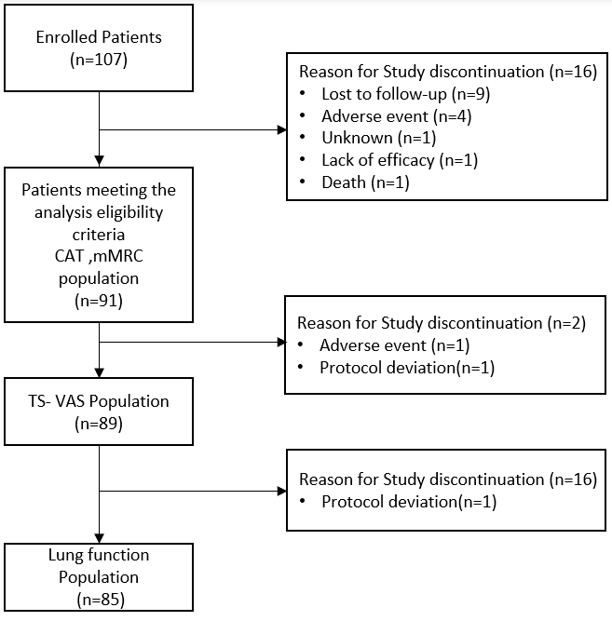
Supplementary Figure 1. Overview of enrolled patients.

