Supplemental Materials
e-Table 1. Baseline characteristics comparing populations with overlapping features
 | Total population | Non-CB & non-emphysema | Non-CB & emphysema | CB & non-emphysema | CB & emphysema | PRISm | p-values
 | (N=3436) | (N=1466) | (N=766) | (N=781) | (N=350) | (N=73)
Age | 68.5 ± 8.0 | 69.0 ± 7.9 | 69.1 ± 7.9 | 67.8 ± 8.1 | 67.6 ± 8.2 | 64.8 ± 9.1 | <0.001
Female sex | 268 (7.8%) | 142 (9.7%) | 37 (4.8%) | 71 (9.1%) | 8 (2.3%) | 10 (13.7%) | <0.001
Body mass index | 23.1 ± 3.4 | 23.5 ± 3.4 | 22.7 ± 3.4 | 23.2 ± 3.4 | 22.3 ± 3.3 | 4.2 ± 3.7 | <0.001
Smoking status |  |  |  |  |  |  | <0.001
Never | 316 (9.2%) | 174 (11.9%) | 26 (3.4%) | 95 (12.2%) | 6 (1.7%) | 15 (20.8%)
Ex- | 2210 (64.5%) | 975 (66.6%) | 531 (69.5%) | 444 (56.9%) | 220 (62.9%) | 40 (55.6%)
Current | 903 (26.3%) | 314 (21.5%) | 207 (27.1%) | 241 (30.9%) | 124 (35.4%) | 17 (23.6%)
Smoking pack-year | 38.2 ± 27.0 | 35.3 ± 26.0 | 42.5 ± 26.0 | 36.4 ± 27.9 | 45.8 ± 27.2 | 34.0 ± 31.4 | <0.001
Comorbidities
Hypertension | 1298 (37.8%) | 607 (41.4%) | 255 (33.3%) | 280 (35.9%) | 119 (34.0%) | 37 (50.7%) | <0.001
Diabetes | 595 (17.3%) | 267 (18.2%) | 124 (16.2%) | 123 (15.8%) | 67 (19.1%) | 14 (19.2%) | 0.444
Heart disease | 1511 (44.1%) | 681 (46.5%) | 303 (39.6%) | 346 (44.4%) | 142 (40.6%) | 39 (53.4%) | 0.007
GERD | 270 (7.9%) | 103 (7.0%) | 48 (6.3%) | 84 (10.8%) | 30 (8.6%) | 5 (6.8%) | 0.009
Asthma | 869 (25.4%) | 353 (24.1%) | 158 (20.8%) | 254 (32.6%) | 91 (26.1%) | 13 (18.1%) | <0.001
Tuberculosis | 792 (23.1%) | 349 (23.8%) | 138 (18.1%) | 205 (26.3%) | 81 (23.2%) | 19 (26.4%) | 0.003
Allergic rhinitis | 271 (7.9%) | 98 (6.7%) | 43 (5.6%) | 95 (12.2%) | 27 (7.7%) | 8 (11.1%) | <0.001
Atopic dermatitis | 66 (1.9%) | 24 (1.6%) | 7 (0.9%) | 28 (3.6%) | 3 (0.9%) | 4 (5.6%) | <0.001
Pulmonary function
FEV1 (L) | 1.7 ± 0.6 | 1.7 ± 0.6 | 1.7 ± 0.6 | 1.6 ± 0.6 | 1.6 ± 0.6 | 2.0 ± 0.5 | <0.001
FEV1 (%) | 57.0 ± 18.8 | 58.6 ± 18.8 | 56.4 ± 19.3 | 55.6 ± 18.7 | 53.2 ± 18.6 | 65.3 ± 9.5 | <0.001
FVC (L) | 3.2 ± 0.8 | 3.2 ± 0.8 | 3.3 ± 0.8 | 3.2 ± 0.8 | 3.4 ± 0.8 | 2.7 ± 0.7 | <0.001
FVC (%) | 78.8 ± 16.7 | 78.2 ± 16.5 | 80.8 ± 17.3 | 77.8 ± 16.0 | 81.9 ± 17.1 | 65.2 ± 11.3 | <0.001
FEV1/FVC (%) | 51.3 ± 12.9 | 52.7 ± 12.2 | 49.0 ± 12.3 | 50.9 ± 12.9 | 46.4 ± 12.3 | 73.7 ± 8.8 | <0.001
DLCO | 13.4 ± 4.8 | 13.9 ± 4.7 | 12.7 ± 4.8 | 13.9 ± 4.9 | 12.0 ± 4.4 | 14.9 ± 5.2 | <0.001
DLCO (%) | 65.1 ± 21.0 | 68.3 ± 20.3 | 61.1 ± 21.2 | 66.7 ± 21.1 | 57.1 ± 19.3 | 69.2 ± 21.5 | <0.001
DLCO/VA | 3.1 ± 1.0 | 3.3 ± 1.0 | 2.9 ± 0.9 | 3.2 ± 0.9 | 2.7 ± 0.9 | 3.8 ± 1.0 | <0.001
DLCO/VA (%) | 76.1 ± 23.0 | 79.8 ± 22.5 | 70.6 ± 22.8 | 78.7 ± 22.0 | 65.5 ± 20.9 | 89.3 ± 23.5 | <0.001
Laboratory findings
WBC | 7.3 ± 2.4 | 7.1 ± 2.3 | 7.3 ± 2.4 | 7.3 ± 2.4 | 7.9 ± 3.0 | 6.8 ± 2.1 | <0.001
Eosinophil (%) | 3.3 ± 3.2 | 3.3 ± 3.2 | 3.1 ± 2.8 | 3.4 ± 3.6 | 3.2 ± 3.0 | 3.7 ± 3.8 | 0.232
Hb | 14.2 ± 1.5 | 14.1 ± 1.6 | 14.2 ± 1.5 | 14.2 ± 1.5 | 14.3 ± 1.6 | 14.2 ± 1.6 | 0.563
ESR | 16.2 ± 16.7 | 15.0 ± 15.5 | 16.6 ± 17.6 | 17.5 ± 18.5 | 16.9 ± 15.1 | 16.4 ± 16.0 | 0.093
Quality of life
mMRC | 1.30 ± 0.91 | 1.16 ± 0.82 | 1.28 ± 0.89 | 1.45 ± 1.00 | 1.61 ± 0.99 | 1.08 ± 0.89 | <0.001
CAT | 13.9 ± 8.0 | 12.3 ± 7.1 | 12.7 ± 7.7 | 17.0 ± 8.6 | 17.4 ± 8.2 | 11.3 ± 7.2 | <0.001
SGRQ symptom score | 39.4 ± 21.4 | 33.5 ± 17.9 | 33.1 ± 19.1 | 51.5 ± 21.9 | 52.1 ± 22.1 | 32.6 ± 20.0 | <0.001
SGRQ activity score | 38.6 ± 26.7 | 34.4 ± 24.5 | 38.2 ± 26.7 | 43.7 ± 28.6 | 47.2 ± 27.4 | 29.8 ± 23.1 | <0.001
SGRQ impacts score | 20.6 ± 21.4 | 16.0 ± 17.1 | 17.8 ± 20.0 | 28.4 ± 24.8 | 29.5 ± 25.3 | 14.3 ± 17.2 | <0.001
SGRQ total score | 29.5 ± 20.7 | 24.8 ± 17.2 | 26.9 ± 20.0 | 37.1 ± 22.9 | 39.0 ± 22.8 | 22.3 ± 16.8 | <0.001
6-minute walk distance | 381.5 ± 116.2 | 380.9 ± 119.8 | 387.7 ± 115.4 | 381.6 ± 111.7 | 379.6 ± 111.8 | 340.3 ± 117.8 | 0.09
BODE index | 2.3 ± 1.9 | 2.0 ± 1.8 | 2.3 ± 2.0 | 2.5 ± 1.9 | 2.8 ± 2.1 | 1.6 ± 1.5 | <0.001
Exacerbation
Moderate | 568 (16.5%) | 226 (15.4%) | 119 (15.5%) | 151 (19.3%) | 72 (20.6%) | 0 (0.0%) | <0.001
Severe | 163 (4.7%) | 61 (4.2%) | 41 (5.4%) | 36 (4.6%) | 25 (7.1%) | 0 (0.0%) | 0.043
Total | 626 (18.2%) | 252 (17.2%) | 133 (17.4%) | 163 (20.9%) | 78 (22.3%) | 0 (0.0%) | <0.001

Abbreviations: CB, chronic bronchitis; PRISm, preserved ratio impaired spirometry; PY, pack-year; GERD, gastro-esophageal reflux disease; FEV1, forced expiratory volume in 1 second; FVC, forced vital capacity; DLCO, diffusion capacity; DLCO/VA, diffusion capacity/alveolar volume; WBC, white blood cell; BEC, blood eosinophil count; Hb, hemoglobin; ESR, erythrocyte sedimentation rate; mMRC, modified Medical Research Council; CAT, COPD assessment test; SGRQ, St. George Respiratory Questionnaire; 6MWD, 6-minute walk distance

e-Table 2. Baseline characteristics comparing populations of patients with and without history of tuberculosis
 | PTB (-) | PTB (+) | p-value
 | (N=2634) | (N=792)
Age | 68.7 ± 8.0 | 67.8 ± 8.2 | 0.007
Female sex | 186 (7.1%) | 79 (10.0%) | 0.009
Body mass index | 23.3 ± 3.4 | 22.6 ± 3.4 | <0.001
Smoking status |  |  | <0.001
Never | 205 (7.8%) | 108 (13.6%)
Ex- | 1669 (63.5%) | 535 (67.6%)
Current | 753 (28.7%) | 149 (18.8%)
Smoking pack-year | 38.8 ± 26.3 | 36.4 ± 29.0 | 0.037
Comorbidities
Hypertension | 983 (37.3%) | 314 (39.7%) | 0.243
Diabetes | 462 (17.5%) | 131 (16.5%) | 0.547
Heart disease | 1138 (43.3%) | 371 (46.9%) | 0.076
GERD | 198 (7.5%) | 71 (9.0%) | 0.216
Asthma | 675 (25.7%) | 192 (24.4%) | 0.491
Allergic rhinitis | 216 (8.2%) | 55 (7.0%) | 0.284
Atopic dermatitis | 49 (1.9%) | 17 (2.2%) | 0.706
Pulmonary function
FEV1 (L) | 1.7 ± 0.6 | 1.6 ± 0.6 | <0.001
FEV1 (%) | 58.2 ± 18.8 | 53.1 ± 18.6 | <0.001
FVC (L) | 3.3 ± 0.8 | 3.1 ± 0.9 | 0.002
FVC (%) | 79.4 ± 16.6 | 76.7 ± 16.8 | <0.001
FEV1/FVC (%) | 51.8 ± 13.0 | 49.5 ± 12.5 | <0.001
DLCO | 13.6 ± 4.8 | 12.8 ± 4.6 | <0.001
DLCO (%) | 66.2 ± 21.2 | 61.5 ± 20.0 | <0.001
DLCO/VA | 3.1 ± 1.0 | 3.1 ± 1.0 | 0.745
DLCO/VA (%) | 76.3 ± 23.0 | 75.1 ± 23.1 | 0.25
Laboratory findings
WBC | 7.2 ± 2.4 | 7.4 ± 2.5 | 0.175
Eosinophil (%) | 3.3 ± 3.2 | 3.3 ± 3.3 | 0.863
Hb | 14.2 ± 1.5 | 14.1 ± 1.6 | 0.046
ESR | 15.5 ± 16.2 | 17.9 ± 17.3 | 0.007
Quality of life
MMRC | 1.27 ± 0.90 | 1.39 ± 0.93 | 0.024
CAT score | 13.8 ± 8.1 | 14.3 ± 7.9 | 0.108
SGRQ symptom score | 38.9 ± 21.5 | 41.1 ± 21.2 | 0.012
SGRQ activity score | 37.6 ± 26.5 | 41.5 ± 26.9 | <0.001
SGRQ impacts score | 19.8 ± 21.1 | 22.9 ± 22.2 | <0.001
SGRQ total score | 28.7 ± 20.4 | 31.8 ± 21.1 | <0.001
6-minute walk distance | 380.3 ± 116.8 | 384.9 ± 114.6 | 0.401
BODE index | 2.2 ± 1.9 | 2.6 ± 1.9 | <0.001
Exacerbation
Moderate | 397 (15.1%) | 168 (21.2%) | <0.001
Severe | 96 (3.6%) | 64 (8.1%) | <0.001
Total | 435 (16.5%) | 187 (23.6%) | <0.001

Abbreviations: PTB, pulmonary tuberculosis; PY, pack-year; GERD, gastro-esophageal reflux disease; FEV1, forced expiratory volume in 1 second; FVC, forced vital capacity; DLCO, diffusion capacity; DLCO/VA, diffusion capacity/alveolar volume; WBC, white blood cell; BEC, blood eosinophil count; Hb, hemoglobin; ESR, erythrocyte sedimentation rate; mMRC, modified Medical Research Council; CAT, COPD assessment test; SGRQ, St. George Respiratory Questionnaire; 6MWD, 6-minute walk distance

e-Figure 1. Wayne diagram of study population
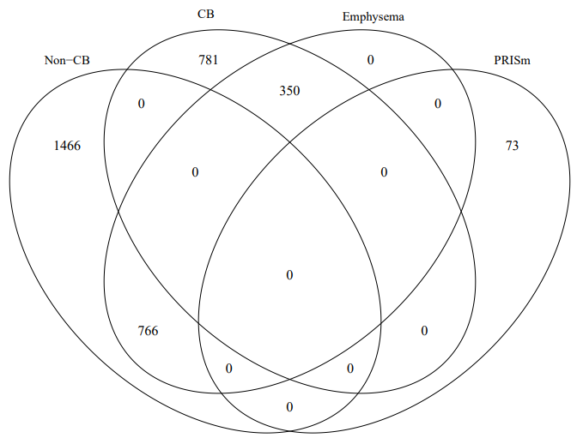

CB, chronic bronchitis; PRISm, preserved ratio impaired spirometry

e-Figure 2. Correlation network of the entire population
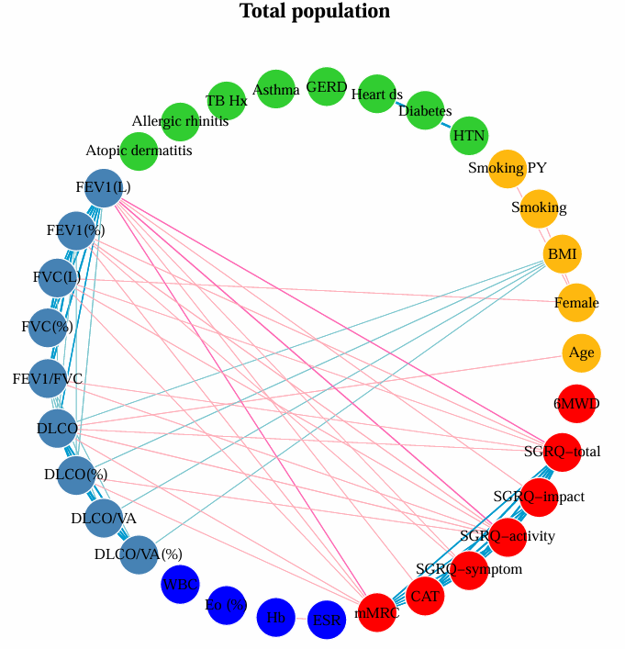

Spearman’s rank correlation was applied to generate the correlation network. Each variable was represented by a node, and links between the nodes indicated the existence of a significant association with a coefficient of >0.3. The thickness and darkness of the links represented the strength of the correlation (Spearman’s coefficient), and the color indicated the direction of the association (blue for positive and pink for negative).
e-Figure 3. Correlation matrices
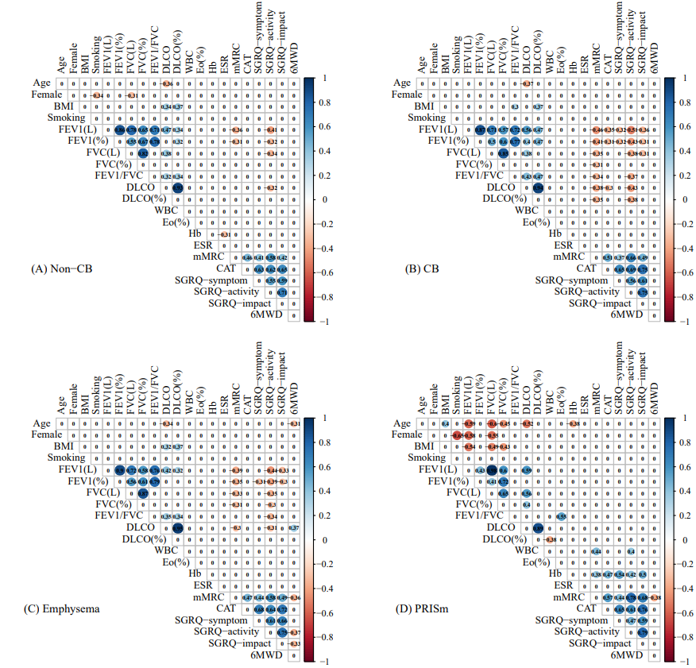

The correlation matrices of the (A) non-chronic bronchitis, (B) chronic bronchitis, (C) emphysema, and (D) preserved ratio impaired spirometry groups are presented. Only Spearman’s coefficients with significant correlations are shown.

e-Figure 4. The P-values for comparing Spearman’s correlation coefficients
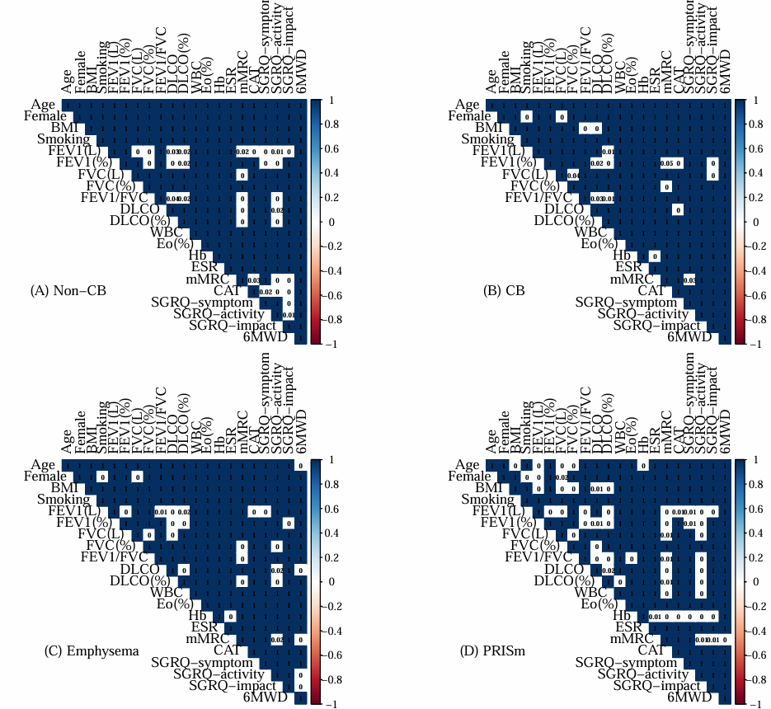

The Spearman’s correlation coefficients are compared between the (A) non-chronic bronchitis, (B) chronic bronchitis, (C) emphysema, and (D) preserved ratio-impaired spirometry groups

e-Figure 5. The least absolute shrinkage and selection operation regression analysis coefficient profiles were used to select variables for inclusion in the multivariable analysis to identify predictors of chronic obstructive pulmonary disease exacerbation in the (A) total patient population, (B) non-chronic bronchitis group, (C) chronic bronchitis group, and (D) emphysema group.
