Supplementary materials

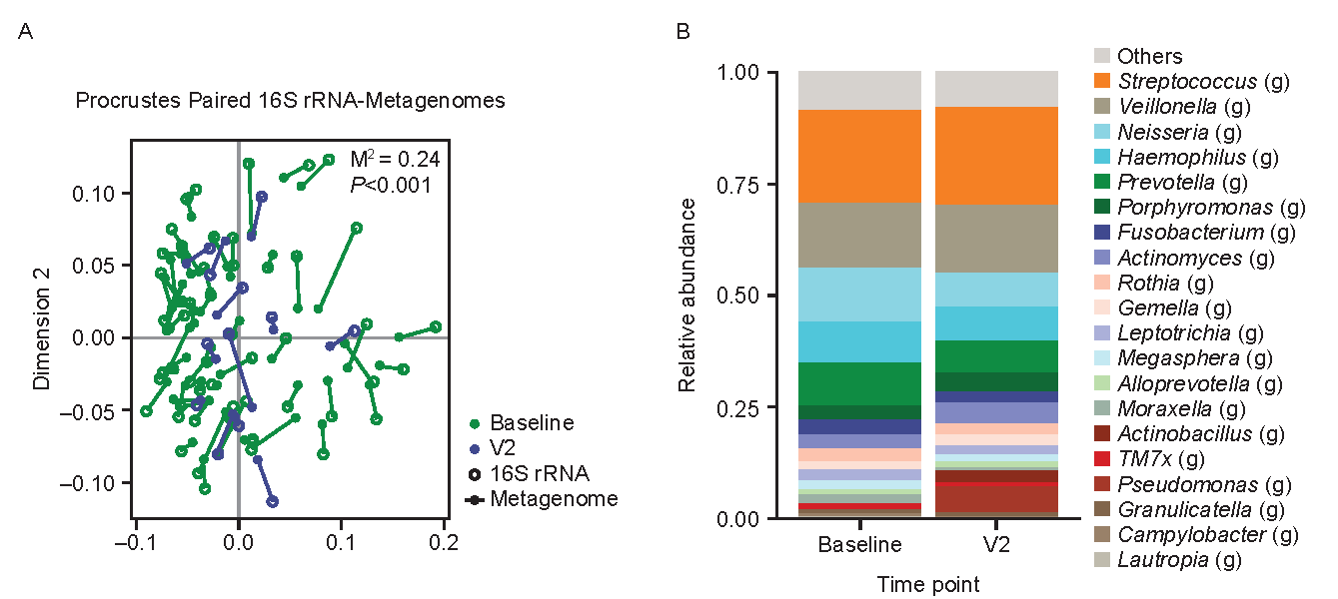
Figure S1. Procrustes analysis of the 16S rRNA and metagenomic datasets (a) and relative abundance of bacterial genera (b) at baseline and V2.
Relative abundance from 16S rRNA. Paired analysis performed using Procrustes analysis.
V2, Visit 2.

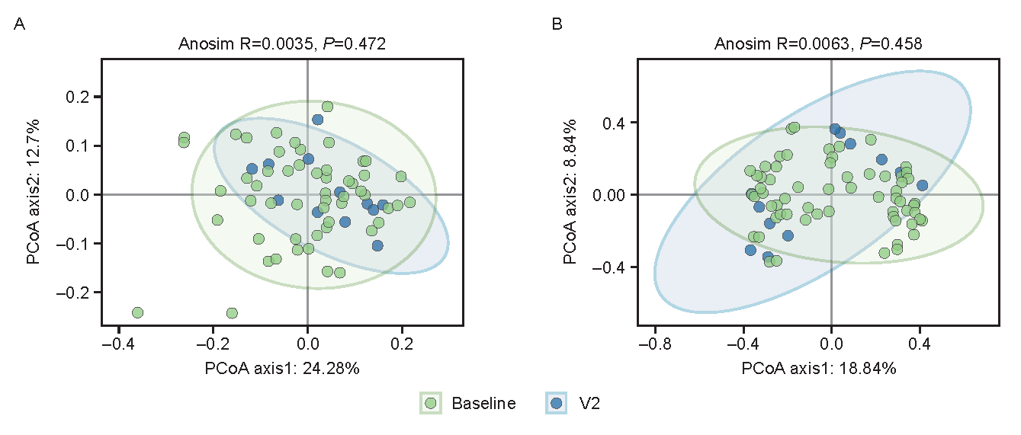
Figure S2. Beta diversity for baseline–V2 paired sputum samples in the 16S rRNA (a) and metagenomics (b) datasets.
Beta diversity was assessed using Anosim R value.
PCoA, principal coordinates analysis; V2, Visit 2.

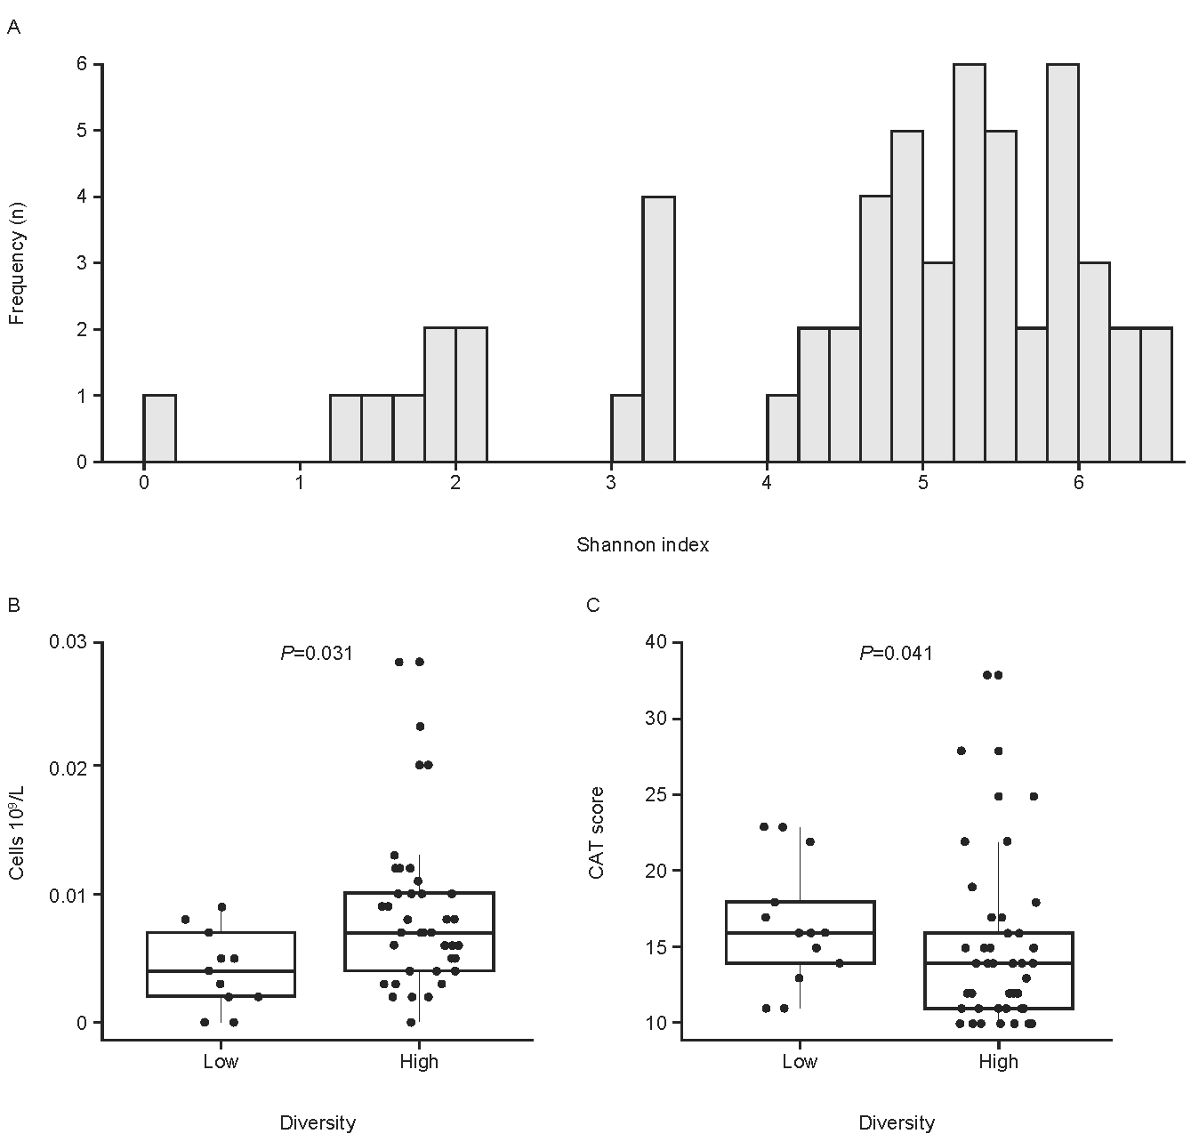
Figure S3. Patients were categorized into lower and higher diversity groups based on the baseline Shannon index scores (a) and blood basophils (b) and CAT scores (c) assessed.
CAT, COPD Assessment Test; COPD, chronic obstructive pulmonary disease

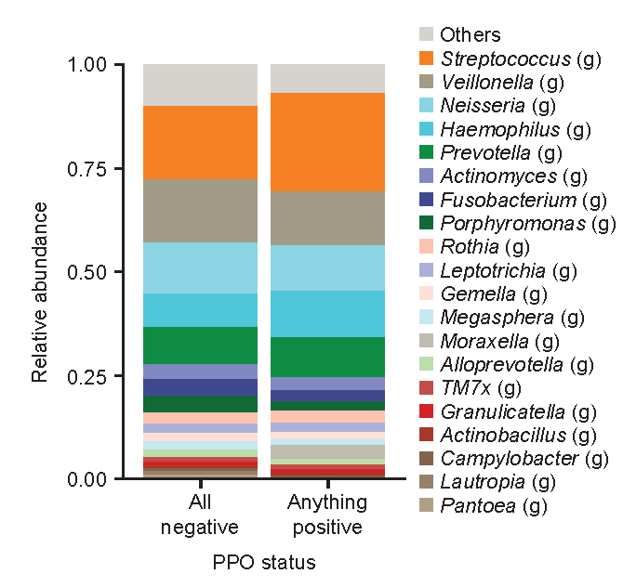
Figure S4. Baseline genus-level bacterial profile by PPO status.
Bacterial profile from 16S rRNA. PPO status, identified by qPCR or bacterial culture, was stratified by all negative (n=30) or any positive (n=26), using baseline sputum samples.
PPO, potentially pathogenic organisms; qPCR, quantitative polymerase chain reaction.

Table S1. Baseline sputum cytology.
Cell type | Patients (n/N) | Mean (SD) | Median (IQR)
Eosinophils, % | 23/63 | 4.6 (6.8) | 1.8 (3.8)
Lymphocytes, % | 23/63 | 5.0 (5.6) | 2.4 (7.2)
Neutrophils, % | 23/63 | 48.6 (29.3) | 54.5 (57.9)
Macrophages, % | 23/63 | 41.8 (28.7) | 36.0 (57.1)
Squamous cells, count | 11/63 | 165.6 (222.2) | 51.0 (395.0)
Bronchial epithelial cells, count | 4/63 | 1.8 (2.4) | 1.0 (3.5)
IQR, interquartile range; SD, standard deviation

Table S2. Baseline blood leukocyte count.
Cell type | Patients (n/N) | Mean (SD) | Median (min, max)
Total leukocyte count, 10⁹/L | 63/63 | 6.5 (1.7) | 6.2 (2.8, 12.7)
Basophils, % | 62/63 | 0.6 (0.5) | 0.5 (0.0, 2.8)
Eosinophils, % | 62/63 | 3.7 (3.7) | 2.7 (0.0, 19.2)
Lymphocytes, % | 62/63 | 28.8 (8.8) | 27.8 (11.6, 60.0)
Monocytes, % | 62/63 | 6.4 (1.3) | 6.2 (3.6, 9.0)
Neutrophils, % | 62/63 | 60.5 (10.1) | 60.2 (22.0, 81.1)
SD, standard deviation

Table S3. Baseline post-BD lung function, stratified by the number of EXACT events.
EXACT events | 0  (n=50) | ≥1  (n=13)
Post-BD FEV₁, % predicted normal (%), mean (SD) | 58.7 (14.7) | 56.6 (13.1)
Post-BD FEV₁/FVC ratio, mean (SD) | 49.6 (12.0) | 51.7 (9.6)
BD, bronchodilator; EXACT, EXAcerbations of Chronic pulmonary disease Tool; FEV₁, forced expiratory volume in 1 second; FVC, forced vital capacity; SD, standard deviation.

Table S4. Independent Ethics Committee/Institutional Review Board that approved the AERIS-J study.
NHO Kinki-chuo Chest Medical Center Clinical Trials and Contract Research Review Committee. 1180, Nagasone-cho, Kita-ku, Sakai-city, Osaka, Japan
Hiroshima Prefectural Hospital Ethics Review Committee. 1-5-54, Ujinakanda, Minami-ku, Hiroshima-city, Hiroshima, Japan
NHO Fukuoka National Hospital Ethics Review Committee. 4-39-1, Yakatahara, Minami-ku, Fukuoka-city, Fukuoka, Japan
NHO Osaka Toneyama Medical Center Clinical Research Review Committee. 5-1-1, Toneyama, Toyonaka-city, Osaka, Japan
NHO Ehime Medical Center Ethics Review Committee. 366, Yokogawara, Touon-city, Ehime, Japan
University of Occupational and Environmental Health Clinical Research Review Committee. 1-1, Iseigaoka, Hachimanishi-ku, Kitakyushu-shi, Fukuoka, Japan
Japanese Red Cross Nagasaki Genbaku Isahaya Hospital Ethics Committee. 986-2, Taramichokeya, Isahaya-city, Nagasaki, Japan
Kishiwada City Hospital Ethics Committee. 1001, Gakuhara-cho, Kishiwada-city, Osaka, Japan
Nagaoka Red Cross Hospital Medical Ethics Committee. 2-297-1, Senshu, Nagaoka-city, Niigata, Japan
Matsusaka Municipal Hospital Clinical Research Ethics Committee. 1550, Tonomachi, Matsusaka-city, Mie, Japan
Ethics Committee on Research Involving Human Subjects at Showa University. 1-5-8, Hatanodai, Shinagawa-ku, Tokyo, Japan
Iwata City Hospital Clinical Research Review Committee. 512-3 Okubo, Iwata-shi, Shizuoka, Japan
Aso Corporation Iizuka Hospital Ethics Committee. 3-83, Yoshiomachi, Iizuka-city, Fukuoka, Japan
Public University Corporation Fukushima Medical University General Ethics Committee. 1 Hikariga-oka, Fukushima-city, Fukushima, Japan

