Supplementary Material

Figure S1. The flowchart of the study.
Figure S2. The distribution of z-score for height across SWS% quartile groups in non-OSA children (n=537).
Figure S3. The distribution of z-score for height across SWS% quartile groups in OSA children (n=1990).
Table S1. Demographic and sleep characteristics of non-OSA children and OSA children (n=2527).
Table S2. Demographic and sleep characteristics in non-OSA children stratified by SWS% quartiles (n=537).
Table S3. Demographic and sleep characteristics of OSA children stratified by SWS% quartiles (n=1990).
Table S4. Adjusted ORs and 95% CIs for the association between SWS% and short stature after January 2013.
Table S5. Adjusted ORs and 95% CIs for the association between SWS% and short stature across different severity in children with OSA.
Table S6. Adjusted ORs and 95% CIs for the association between SWS% and short stature across different arousal index in children with OSA.
Table S7. Association between SWS% and z-score for height.

Figure S1. The flowchart of the study.
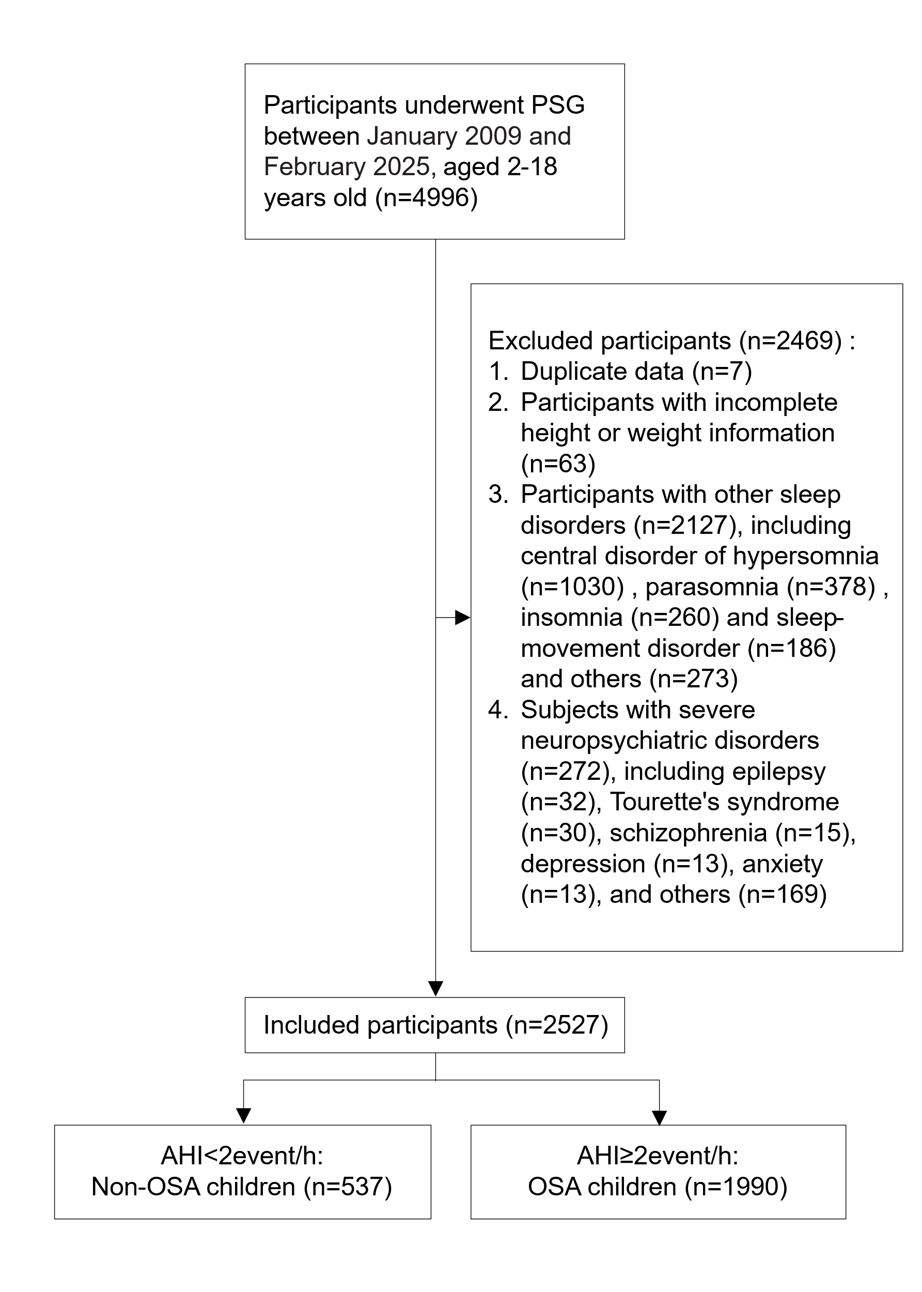
PSG=polysomnography; OSA=obstructive sleep apnea; AHI=apnea-hypopnea index.

Figure S2. The distribution of z-score for height across SWS% quartile groups in non-OSA children (n=537).
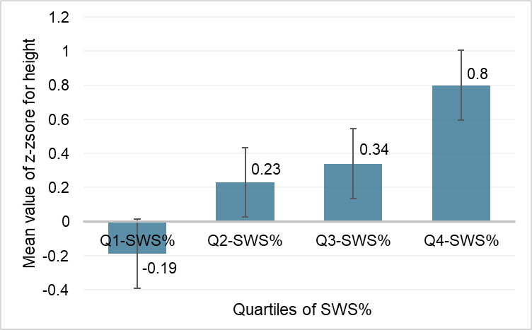
Abbreviations: SWS=slow wave sleep; OSA=obstructive sleep apnea

Figure S3. The distribution of z-score for height across SWS% quartile groups in OSA children (n=1990).
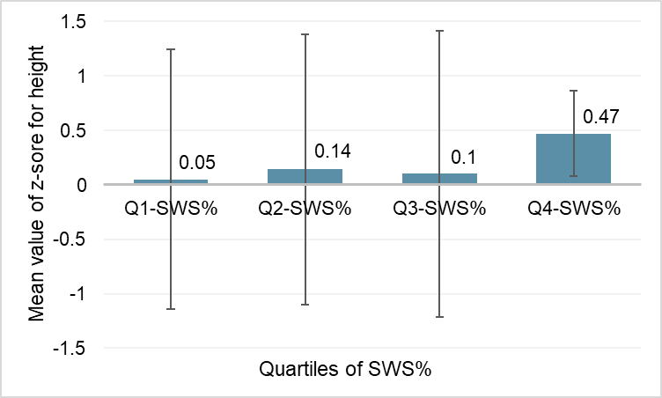
Abbreviations: SWS=slow wave sleep; OSA=obstructive sleep apnea

Table S1. Demographic and sleep characteristics of non-OSA children and OSA children (n=2527).

 | Non-OSA children (n=537) | OSA children (n=1990) | P Value
Demographic characteristics
Men | 318 (59.22%) | 135 (68.14%) | <0.001
Age, y | 6.67 (3.24) | 6.51 (3.25) | 0.310
Z-score for height | 0.29 (1.23) | 0.19 (1.20) | 0.075
Z-score for BMI | 0.13 (1.38) | 0.34 (1.52) | 0.003
Polysomnography
Total sleep time, min | 472.81 (48.15) | 477.49 (48.37) | 0.046
Sleep efficiency, % | 89.33 (7.30) | 89.62 (7.41) | 0.623
Wake after sleep onset, min | 42.25 (37.00) | 41.93 (39.32) | 0.296
Sleep onset latency, min | 14.81 (16.96) | 13.95 (16.46) | 0.416
Arousal index, events/h | 8.48 (4.51) | 11.27 (6.04) | <0.001
N1, % | 11.78 (8.22) | 13.55 (8.22) | <0.001
N2, % | 43.56 (10.93) | 43.60 (10.04) | 0.935
SWS, % | 27.63 (9.32) | 25.07 (7.95) | <0.001
REM, % | 17.03 (5.92) | 17.77 (5.51) | 0.009
AHI, events/h | 1.07 (5.24) | 11.20 (11.03) | <0.001
Mean SpO₂, % | 96.19 (1.82) | 95.62 (2.14) | <0.001
Values are expressed as numbers (%) or as mean (SD).
OSA=obstructive sleep apnea; BMI=body mass index; N1=non-rapid eye movement sleep stage 1; N2=non-rapid eye movement sleep stage 2; SWS=slow wave sleep; REM=rapid eye movement sleep; AHI=apnea-hypopnea index; SpO2=oxygen saturation during sleep.

Table S2. Demographic and sleep characteristics in non-OSA children stratified by SWS% quartiles (n=537).

 | Q4-SWS% (n=134) | Q3-SWS%  (n=136) | Q2-SWS%  (n=132) | Q1-SWS%  (n=135) | P Value
Demographic characteristics
Men | 78 (58.21%) | 84 (61.76%) | 81 (61.36%) | 75 (55.56%) | 0.700
Age, y | 6.13 (2.67) | 6.22 (2.79) | 6.60 (3.13) | 7.75 (3.98) | <0.001
Z-score for height | 0.80 (1.10) | 0.34 (1.23) | 0.23 (1.24) | -0.19 (1.20) | <0.001
Z-score for BMI | 0.22 (1.40) | 0.12 (1.39) | 0.10 (1.43) | 0.10 (1.30) | 0.874
Polysomnography
Total sleep time, min | 458.89 (47.33) | 465.87 (43.17) | 477.90 (54.06) | 488.65 (42.37) | <0.001
Sleep efficiency, % | 87.18 (8.04) | 88.44 (7.25) | 89.75 (6.96) | 91.94 (6.05) | <0.001
Wake after sleep onset, min | 51.20 (40.55) | 46.70 (39.52) | 40.68 (32.56) | 30.41 (31.47) | <0.001
Sleep onset latency, min | 16.68 (20.37) | 15.61 (16.31) | 13.80 (15.57) | 13.13 (15.02) | 0.294
Arousal index, events/h | 7.71 (4.31) | 8.08 (4.38) | 8.71 (4.21) | 9.43 (4.95) | 0.010
N1, % | 10.94 (8.99) | 10.57 (6.89) | 13.19 (9.09) | 12.47 (7.54) | 0.027
N2, % | 34.42 (10.94) | 43.18 (8.29) | 45.60 (8.84) | 51.02 (8.31) | <0.001
SWS, % | 39.81 (8.30) | 29.18 (1.67) | 23.89 (1.53) | 17.62 (2.89) | <0.001
REM, % | 14.84 (5.87) | 17.06 (5.39) | 17.32 (6.42) | 18.89 (5.29) | <0.001
AHI, events/h | 1.00 (0.53) | 1.10 (0.55) | 1.13 (0.51) | 1.05 (0.50) | 0.181
Mean SpO₂, % | 96.46 (1.72) | 96.27 (2.05) | 96.08 (1.71) | 95.93 (1.74) | 0.098
Values are expressed as numbers (%) or as mean (SD).
Q1, SWS≤21.4; Q2, 21.4<SWS≤26.6; Q3, 26.6<SWS≤32.2; Q4, SWS>32.2.
OSA=obstructive sleep apnea; BMI=body mass index; N1=non-rapid eye movement sleep stage 1; N2=non-rapid eye movement sleep stage 2; SWS=slow wave sleep; REM=rapid eye movement sleep; AHI=apnea-hypopnea index; SpO2=oxygen saturation during sleep.

Table S3. Demographic and sleep characteristics of OSA children stratified by SWS% quartiles (n=1990).

 | Q4 -SWS%  (n=492) | Q3-SWS%  (n=497) | Q2-SWS%  (n=497) | Q1-SWS%  (n=504) | P Value
Demographic characteristics
Men | 356 (72.36%) | 332 (66.80%) | 339 (68.21%) | 329 (65.28%) | 0.093
Age, y | 5.53 (2.34) | 6.00 (2.64) | 6.38 (2.89) | 8.11 (4.20) | <0.001
Z-score for height | 0.47 (0.39) | 0.10 (1.31) | 0.14 (1.24) | 0.05 (1.19) | <0.001
Z-score for BMI | 0.35 (1.62) | 0.37 (1.55) | 0.36 (1.54) | 0.28 (1.36) | 0.763
Polysomnography
Total sleep time, min | 466.26 (48.29) | 477.13 (49.84) | 481.18 (46.85) | 485.15 (46.53) | <0.001
Sleep efficiency, % | 87.69 (7.83) | 89.67 (7.31) | 90.10 (7.55) | 90.50 (6.53) | <0.001
Wake after sleep onset, min | 50.02 (42.03) | 41.55 (38.93) | 41.08 (41.65) | 35.24 (32.80) | <0.001
Sleep onset latency, min | 16.40 (19.40) | 14.00 (16.43) | 12.63 (14.79) | 12.83 (14.60) | <0.001
Arousal index, events/h | 10.72 (5.92) | 10.85 (5.20) | 11.00 (5.09) | 12.50 (7.47) | <0.001
N1, % | 12.66 (7.64) | 12.99 (7.46) | 13.55 (8.00) | 14.99 (9.45) | <0.001
N2, % | 36.36 (9.30) | 42.08 (7.79) | 45.54 (7.96) | 50.27 (9.50) | <0.001
SWS, % | 35.17 (6.41) | 26.84 (1.22) | 22.54 (11.32) | 15.97 (3.78) | <0.001
REM, % | 15.82 (5.54) | 18.10 (5.30) | 18.37 (5.27) | 18.77 (5.44) | <0.001
AHI, events/h | 10.01 (10.15) | 11.40 (10.89) | 11.39 (11.14) | 11.97 (11.79) | 0.037
Mean SpO₂, % | 95.74 (2.64) | 95.60 (2.01) | 95.63 (1.91) | 95.60 (1.93) | 0.395
Values are expressed as numbers (%) or as mean (SD).
Q1, SWS≤20.2; Q2, 20.2<SWS≤24.7; Q3, 24.7<SWS≤29.2; Q4, SWS>29.2.
OSA=obstructive sleep apnea; BMI=body mass index; N1=non-rapid eye movement sleep stage 1; N2=non-rapid eye movement sleep stage 2; SWS=slow wave sleep; REM=rapid eye movement sleep; AHI=apnea-hypopnea index; SpO2=oxygen saturation during sleep.

Table S4. Adjusted ORs and 95% CIs for the association between SWS% and short stature after January 2013.

 | n | OR (95% CI)
 | n | Model 1 | Model 2 | Model 3
Non-OSA | 448
Q4-SWS% | 112 | Reference | Reference | Reference
Q3-SWS% | 110 | 3.76 (1.76 to 8.06)*** | 3.95 (1.81 to 8.61)*** | 3.80 (1.73 to 8.32)***
Q2-SWS% | 113 | 3.32 (1.54 to 7.15)** | 3.27 (1.49 to 7.16)** | 3.09 (1.40 to 6.79)**
Q1-SWS% | 113 | 6.66 (3.13 to 14.15)*** | 6.31 (2.84 to 13.99)*** | 6.00 (2.69 to 13.38)***
P value for trend |  | <0.001*** | <0.001*** | <0.001***
OSA | 1820
Q4-SWS% | 450 | Reference | Reference | Reference
Q3-SWS% | 456 | 1.82 (1.32 to 2.51)*** | 1.79 (1.29 to 2.46)*** | 1.80 (1.30 to 2.49)***
Q2-SWS% | 458 | 1.67 (1.21 to 2.31)** | 1.65 (1.19 to 2.29)** | 1.66 (1.20 to 2.31)**
Q1-SWS% | 456 | 1.79 (1.28 to 2.50)*** | 1.73 (1.23 to 2.43)** | 1.74 (1.23 to 2.45)**
P value for trend |  | 0.003* | 0.007* | 0.007*
*P<0.05; **P<0.01; ***P<0.001.
In non-OSA children, Q1, SWS≤21.2; Q2, 21.2<SWS≤26.5; Q3, 26.5<SWS≤32.0; Q4, SWS>32.0. In OSA children, Q1, SWS≤20.0; Q2, 20.0<SWS≤24.4; Q3, 24.4<SWS≤28.7; Q4, SWS>28.7.
Model 1 was adjusted for sex, age, and z-score for BMI; model 2 was adjusted for variables included in model 1, sleep onset latency, total sleep time, sleep efficiency, wake after sleep onset, and arousal index; model 3 was adjusted for variables included in model 2, AHI, and mean SpO2.
OR=odds ratio; CI=confidence interval; SWS=slow wave sleep; OSA=obstructive sleep apnea; AHI=apnea-hypopnea index; SpO2=oxygen saturation during sleep.

Table S5. Adjusted ORs and 95% CIs for the association between SWS% and short stature across different severity in children with OSA¹.

 | n | OR (95% CI)
Mild OSA | 719
Q4-SWS% | 202 | Reference
Q3-SWS% | 167 | 0.91(0.56-1.49)
Q2-SWS% | 166 | 1.17(0.72-1.89)
Q1-SWS% | 184 | 1.19(0.73-1.94)
Moderate OSA | 535
Q4-SWS% | 130 | Reference
Q3-SWS% | 146 | 2.93(1.58-5.42)***
Q2-SWS% | 148 | 2.02(1.07-3.82)*
Q1-SWS% | 111 | 3.52(1.81-6.84)***
Severe OSA | 736
Q4-SWS% | 160 | Reference
Q3-SWS% | 184 | 12.20(5.03-29.56)***
Q2-SWS% | 183 | 9.34(3.2-22.83)***
Q1-SWS% | 209 | 7.02(2.83-17.45)***
*P<0.05; ***P<0.001; Mild: AHI ≥2, Moderate: AHI ≥5, and Severe: AHI ≥10 events/hour
¹The model was adjusted for sex, age, z-score for BMI, sleep onset latency, total sleep time, sleep efficiency, wake after sleep onset, arousal index and mean SpO2.
Abbreviations: OR=odds ratio, CI=confidence interval, SWS= slow wave sleep, OSA= obstructive sleep apnea; AHI=apnea-hypopnea index; SpO2=oxygen saturation during sleep
Table S6. Adjusted ORs and 95% CIs for the association between SWS% and short stature across different arousal index in children with OSA¹.

 | n | OR (95% CI)
Children with OSA with low levels of arousal | 1185
Q4-SWS% | 316 | Reference
Q3-SWS% | 298 | 2.35(1.60-3.46)***
Q2-SWS% | 301 | 1.82(1.22-2.71)**
Q1-SWS% | 270 | 1.88(1.24-2.85)**
Children with OSA with high levels of arousal | 805
Q4-SWS% | 176 | Reference
Q3-SWS% | 199 | 2.55(1.43-4.54)**
Q2-SWS% | 196 | 2.70(1.52-4.81)***
Q1-SWS% | 234 | 2.93(1.63-5.28)***
**P<0.01; ***P<0.001.
Low levels of arousal: arousal index<11.3; High levels of arousal: arousal index≥11.3
¹The model was adjusted for sex, age, z-score for BMI, sleep onset latency, total sleep time, sleep efficiency, wake after sleep onset, AHI and mean SpO2.
Abbreviations: OR=odds ratio, CI=confidence interval, SWS=slow wave sleep, OSA= obstructive sleep apnea, AHI= apnea-hypopnea index; SpO2=oxygen saturation during sleep

Table S7. Association between SWS% and z-score for height¹.

 | n | β | P value
Non-OSA | 537 | 0.028 | <0.001
OSA | 1990 | 0.019 | <0.001
Mild OSA | 719 | 0.011 | 0.052
Moderate OSA | 535 | 0.022 | 0.003
Severe OSA | 736 | 0.026 | <0.001
¹Adjusted for sex, age, z-score for BMI, sleep onset latency, total sleep time, sleep efficiency, wake after sleep onset, arousal index, AHI, and mean SpO2.
SWS=slow wave sleep; OSA=obstructive sleep apnea; AHI=apnea-hypopnea index; SpO2=oxygen saturation during sleep

