Figure S1. Flow diagram of patient enrollment and inclusion.
A total of 1050 patients with moderate-to-severe atopic dermatitis were screened across seven tertiary hospitals. After exclusion of 40 patients who did not meet the inclusion criteria, 1010 patients were included in the final analysis.
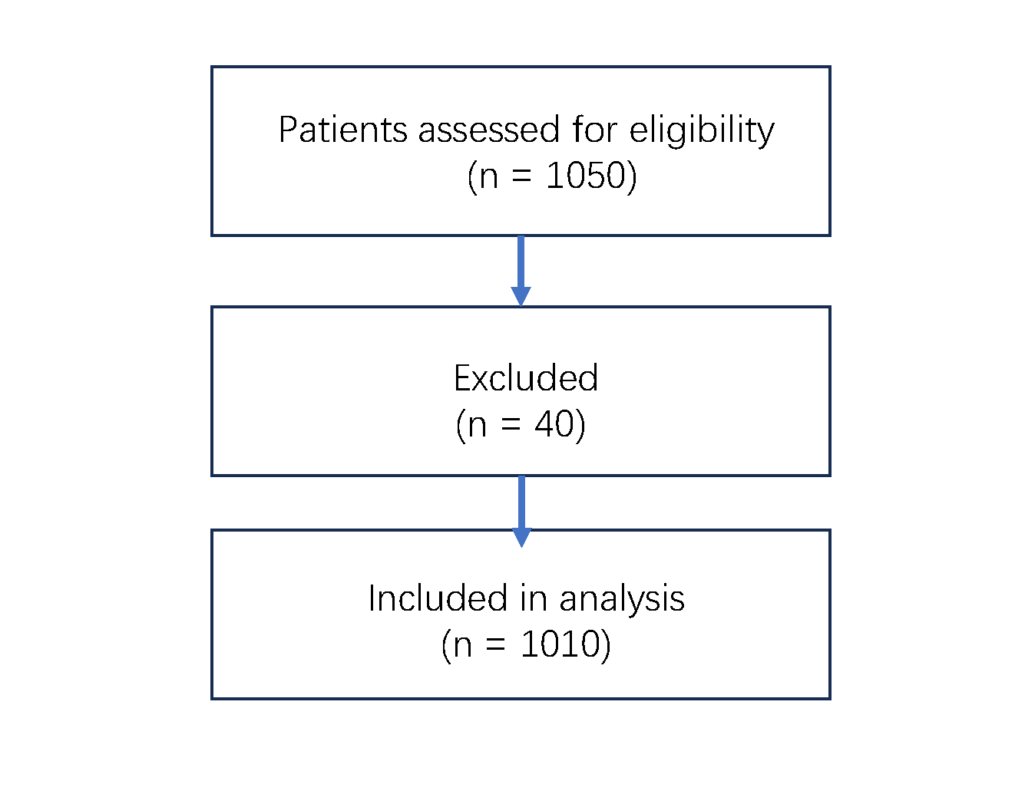
Figure S2. Spearman correlation matrix between SCORAD and patient-reported outcome measures.

Spearman correlation heatmap (n=50, Affiliated Hospital of Xuzhou Medical University). Confirms strong positive correlations between SCORAD and PROs (ρ=0.59-0.75; strongest SCORAD-POEM ρ=0.75, all P<0.001), validating main text findings with clear visual representation.