Supplementary Table 1 Clinical and genotypic characteristics of the 5 CIKA strains
Sample ID | Sample Source | Isolation Date | Resistance genes
 |  |  | Carbapenemase  genes | ESBLs  genes | AmpC  genes | Porin genes | ARD gens | QRD genes
CIKA-1 | secretion | 09-2015 | - | - | bla_{EBC},  bla_{ACC} | ompE35, ompE36 | acc（6'）-1b | qnrD, qnrS
CIKA-2 | sputum | 09-2017 | - | - | bla_{EBC}, bla_{ACC} | ompE35, ompE36 | - | qnrD
CIKA-3 | blood | 12-2017 | - | - | bla_{ACC} | ompE35, ompE36 | armA | qnrD, qnrS
CIKA-4 | sputum | 03-2018 | - | - | bla_{ACC} | ompE35, ompE36 | - | qnrD, qnrS
CIKA-5 | sputum | 07-2018 | - | - | bla_{ACC} | ompE35, ompE36 | - | qnrD, qnrS

Abbreviations: CIKA, Carbapenem-intermediate Klebsiella aerogenes; ESBLs, Extended Spectrum Beta-Lactamases; QRD, quinolone resistance determinants; ARD, aminoglycoside resistance determinants; “-”, not detected.

Supplementary Figure 1 Distribution of Carbapenem sensitivity of 892 Klebsiella aerogenes isolates from 2012-2018 in our hospital
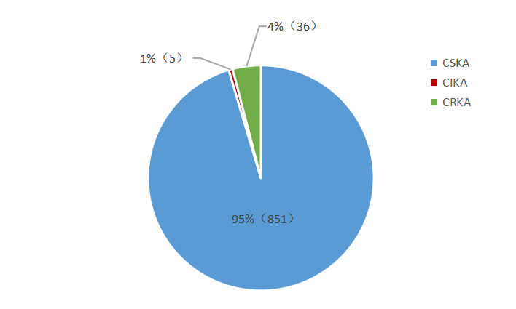

Abbreviations: CRKA, carbapenem-resistant Klebsiella aerogenes; CIKA, carbapenem-intermediate Klebsiella aerogenes; CSKA，carbapenem-susceptible Klebsiella aerogenes.

