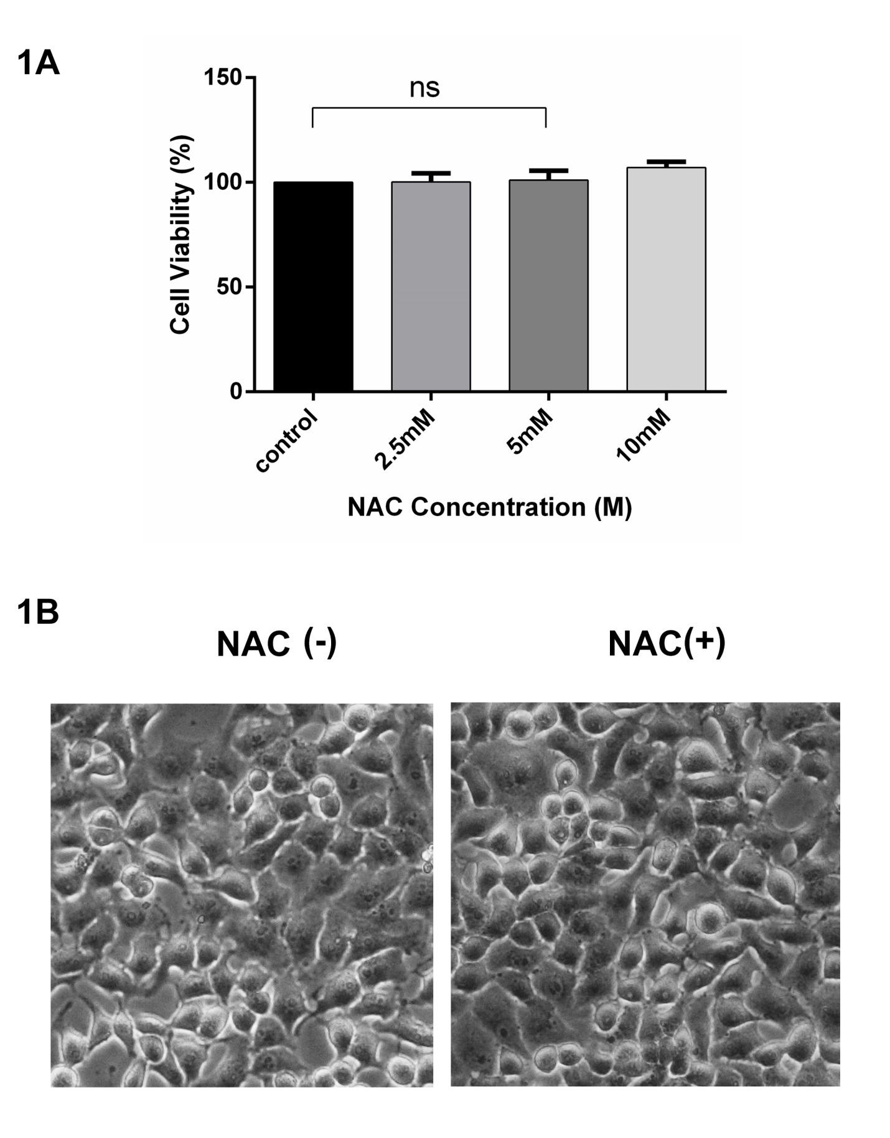
Figure S1 (A) MCF-7 cells were supplemented with indicated concentrations of NAC for 24 h and CCK-8 assay kit was used to measure cell viability percentage. (B) Morphology of MCF-7 cells was observed in presence or absence of NAC (5mM). (A) Graphical data are expressed as Mean ± SD while all experiments were performed in triplicate independently.

