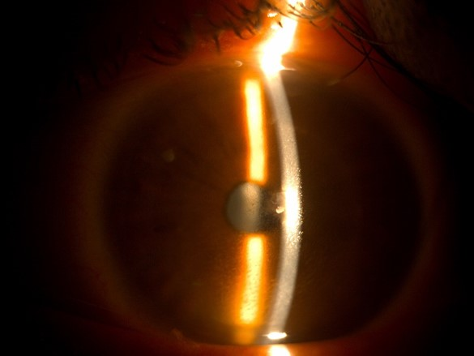

e-figure 1: Slit lamp examination, day 25

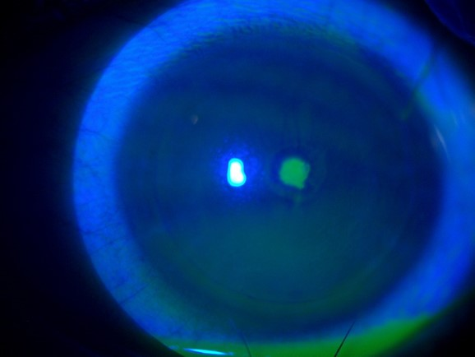

e-figure 2: Slit lamp examination, day 25

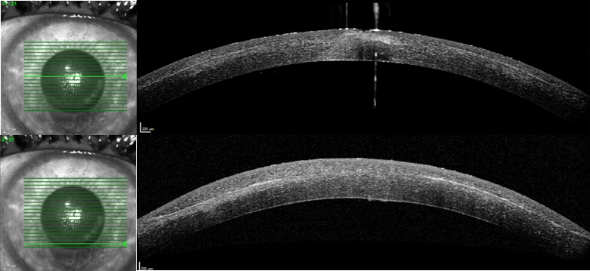
e-figure 3: Anterior segment OCT, day 25

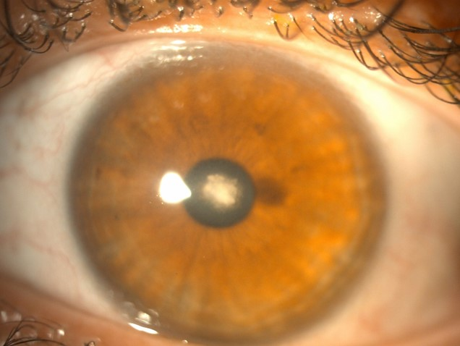

e-figure 4: Slit lamp examination, day 28

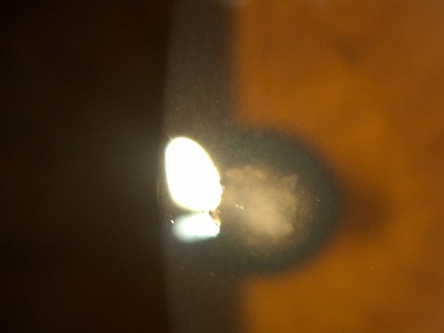

e-figure 5: Slit lamp examination, day 28

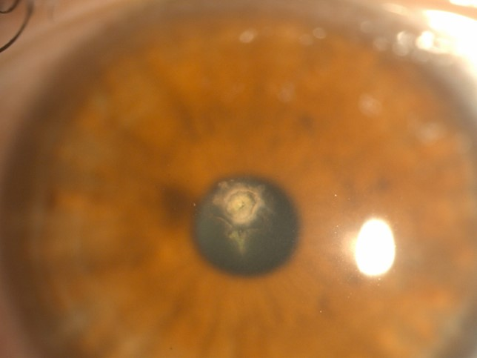

e-figure 6: Slit lamp examination, day 33

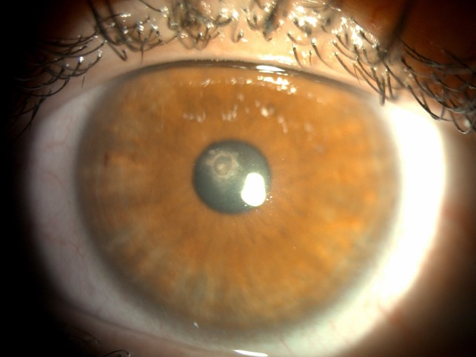

e-figure 7: Slit lamp examination, day 40

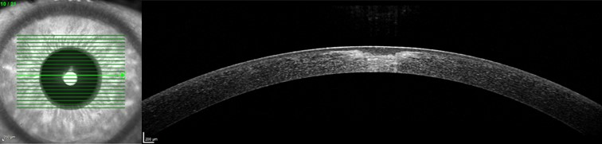

e-figure 8: Anterior segment OCT, day 40

