Figure S1: Antimicrobial resistance genes in carbapenem-producing K. pneumoniae isolates.
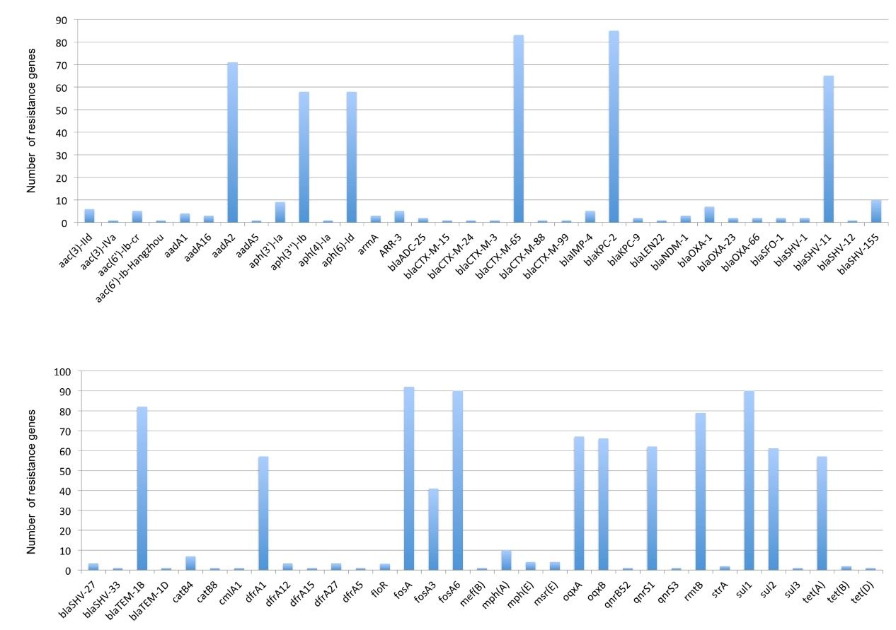

Table S1. Amino acid substitution in a zone with high frequency of SNPs in the P2405-9’s core genome compared with other CT2405 isolates’.
Gene | Codon position | Amino acid position | Product
DinI | 127 A＞G  181 A＞G, 183 T＞A | 43 Thr＞Ala  61 Ile＞Val | DNA damage-inducible protein I
LexA | 13 A＞C, 15 T＞C  52A＞G | 5 Thr＞Pro  18 Thr＞Ala | LexA repressor
YciE | 452 T＞A | 151 Ile＞Asn | Protein YciE
Smc | 427 A＞G  499 A＞G  580 T＞A  697 T＞G  708 T＞G  869 T＞C  1315 A＞C  1398 G＞C  1405 A＞T  2018 A＞G  2372 T＞C  4134 T＞G  4193 T＞C  6296 A＞G  11196 T＞G | 143 Lys＞Glu  167 Thr＞Ala  194 Ser＞Thr  233 Ser＞Ala  236 Phe＞Leu  290 Ile＞Thr  439 Met＞Leu  466 Met＞Ile  469 Ile＞Phe  673 Asn＞Ser  791 Val＞Ala  1378 His＞Gln  1398 Met＞Thr  2099 Asn＞Ser  3732 Phe＞Leu | Chromosome partition protein Smc
RrrD | 23 C＞G, 24 T＞C  86 T＞C  118 T＞G, 119 C＞A  166 G＞A  334 G＞A  347 C＞A  362 G＞A  433 A＞C | 8 Thr＞Ser  29 Met＞Thr  40 Ser＞Asp  56 Ala＞Thr  112 Gly＞Arg  116 Thr＞Asn  121 Arg＞His  145 Lys＞Gln | Lysozyme RrrD

