Supplementary Figures

Figure S1. T1WI image of Gd@C-dots and Gd-DTPA-BMA in HCC827 tumor model. (a)Gd@C-dot. (b) Gd-DTPA-BMA. (c) statistics of three different contrast agents T1WI imaging in HCC827, Gd@C-dots-Cys-Z_{EGFR:1907} was higher than Gd@C-dots and Gd-DTPA-BMA in 1h (****p<0.0001).

Figure S2. Distribution of analysis Gd@C-dots-Cys-Z_{EGFR:1907}. (a) Immuno-fluorescence of major elimination organs liver, spleen, kidney in pre and after 4 hours injection (b) and (c) ICP-MS analysis of major organs Gd@C-dots-Cys-Z_{EGFR:1907} mainly accumulated in liver and spleen , there is little accumulation in kidney.
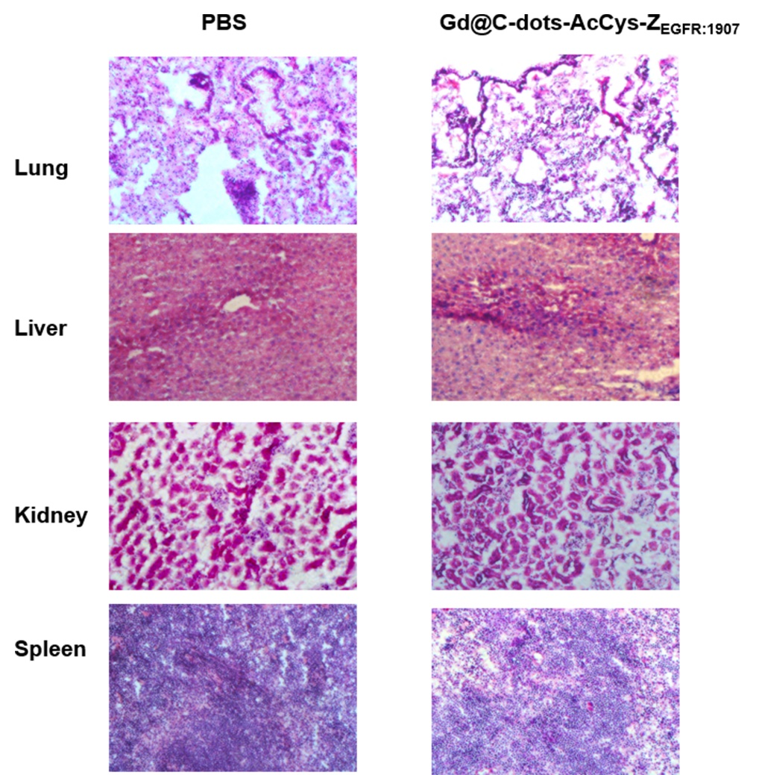

Figure S3. H&E-staining for toxicity study. H&E-staining tissue slices under light microscope showed that the morphology in the mice liver, spleen, lung, and kidney tissues after the PBS or Gd@C-dots-Cys-Z_{EGFR:1907} injections were not obviously different(200X).

Figure S4. Targeting and distribution of 3nm Gd@C-dots-Cys-Z_{EGFR:1907} in HCC827. (a) In vivo MR HCC827 tumor imaging with 3nm Gd@C-dots-Cys-Z_{EGFR:1907} there is no significant signal enhanced (p>0.05). (b) ICP-MS analysis of Gd in major organs after injection with 3nm Gd@C-dots-Cys-Z _{EGFR:1907} 4h later.

