Supplementary Table 1. Pharmacological medications taken by patients in this study
Clinical phenotype | Pharmaco-therapy | Mechanism of action | No. of patients
Parkinson’s disease | Levodopa  Carbidopa  Pramipexol | dopamine precursor  DOPA decarboxylase inhibitor  dopamine agonist | 13
Parkinson’s disease | Levodopa  Carbidopa  Rasagiline  Ropinirole | dopamine precursor  DOPA decarboxylase inhibitor  prevents dopamine breakdown  stimulates post-synaptic D2 dopamine receptors | 4
Parkinson’s disease | Levodopa  Carbidopa  Pramipexol  Entacapone | dopamine precursor  DOPA decarboxylase inhibitor  dopamine agonist  catechol o-methyl transferase inhibitor | 3
Parkinson’s disease | Levodopa  Carbidopa  Rasagiline | dopamine precursor  DOPA decarboxylase inhibitor  Mono amine oxidase inhibitor | 5
Parkinson’s disease | Levodopa  Carbidopa  Pramipexol  Ropinirole | dopamine precursor  DOPA decarboxylase inhibitor  dopamine agonist  stimulates post-synaptic D2 dopamine receptors | 2
Parkinson’s disease | Levodopa  Carbidopa  Amantadine | dopamine precursor  DOPA decarboxylase inhibitor  NMDA receptor antagonist | 1
Schizophrenia | Olanzapine  Resperidon | D2 receptor antagonist  D2 receptor antagonist | 2
Schizophrenia | Olanzapine  Resperidon  Haloperidol | D2 receptor antagonist  D2 receptor antagonist  D2 receptor antagonist | 2

Supplementary Figure 1

Supplementary Figure 1 Pie chart showing protein profile based on abundance in CSF in each clinical phenotype. Light shade represents high abundance; medium shade represents moderate abundance, and dark shade represents low abundant proteins.

Supplementary Figure 2

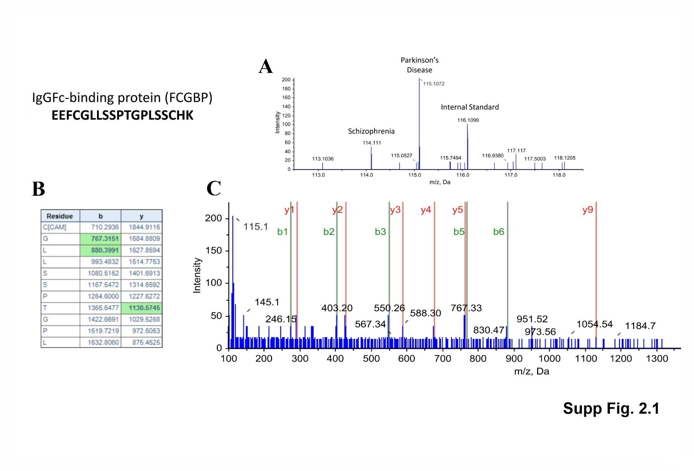

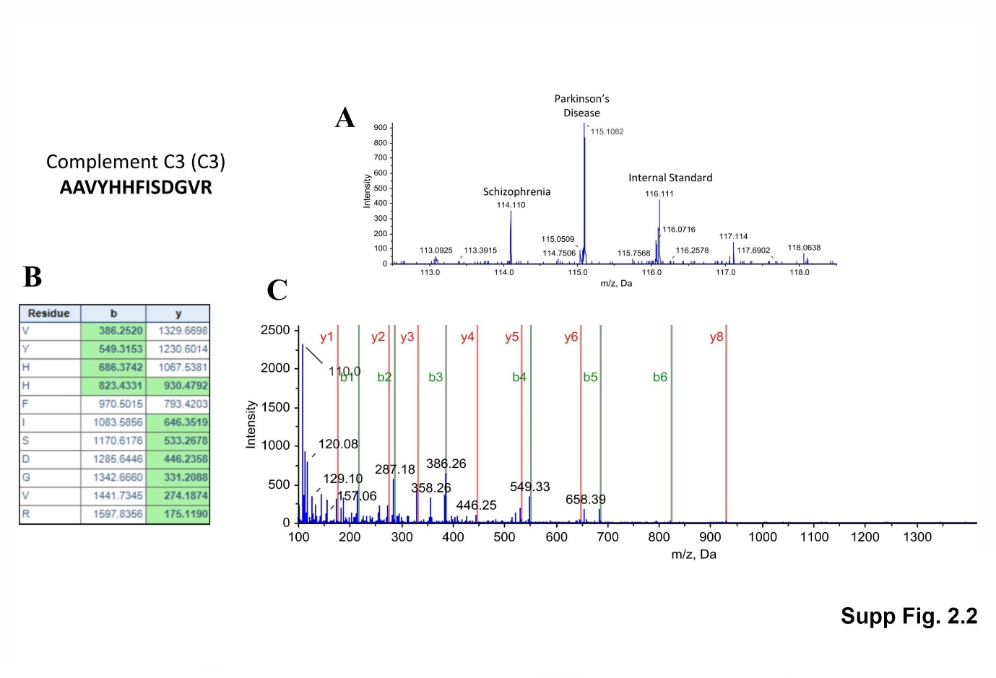

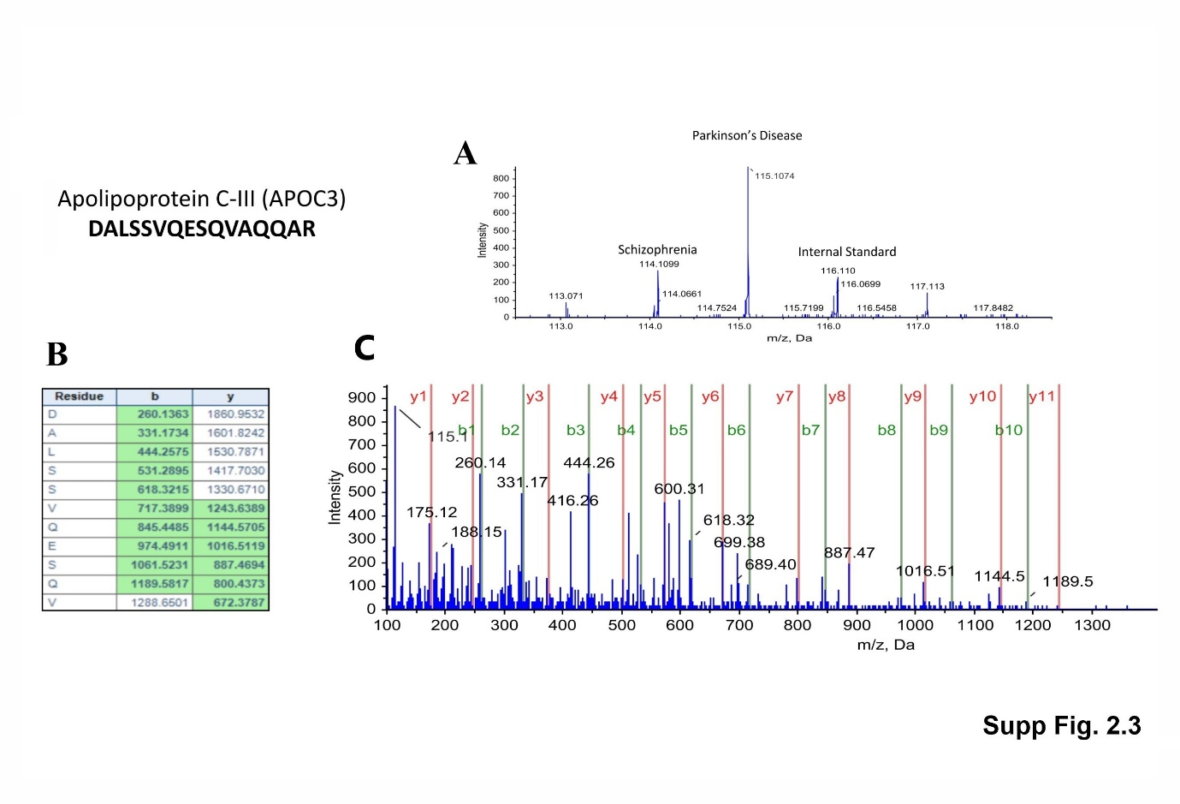

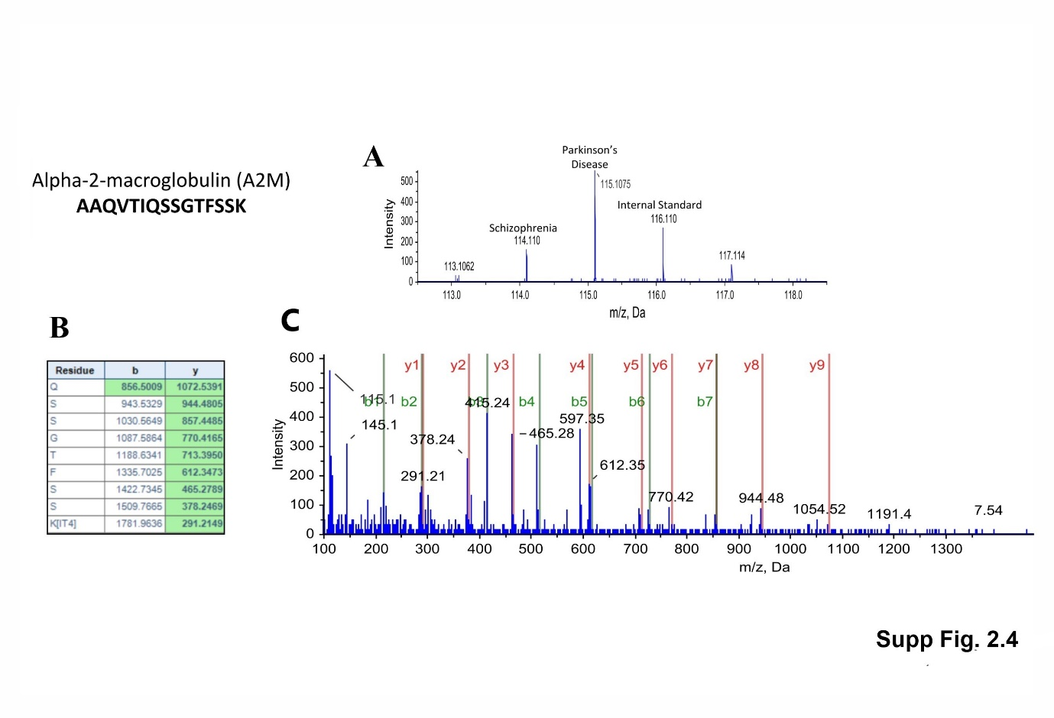

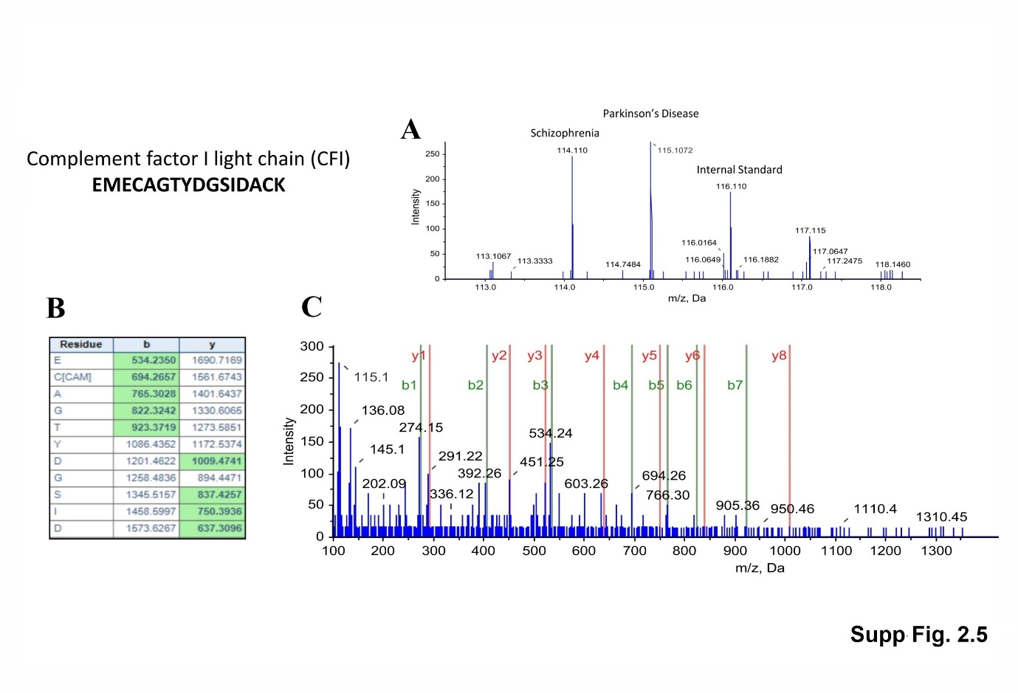

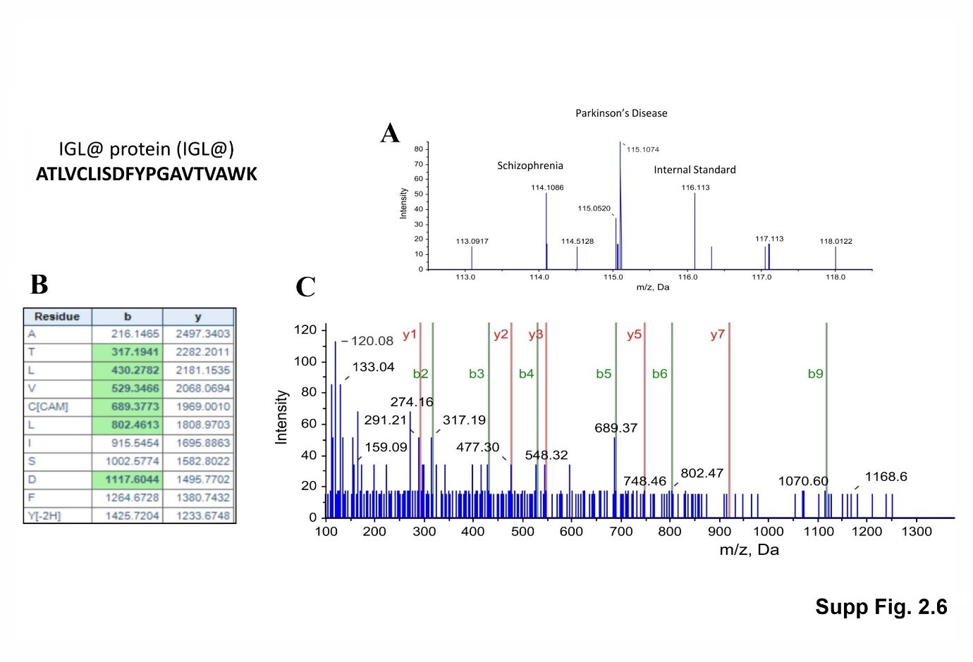

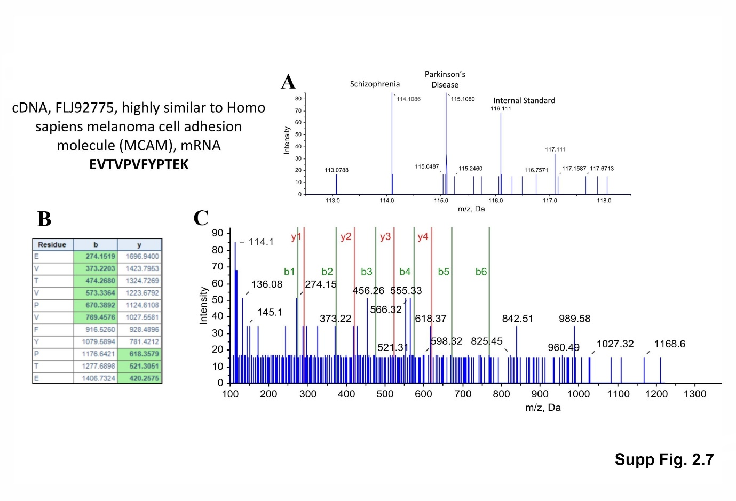

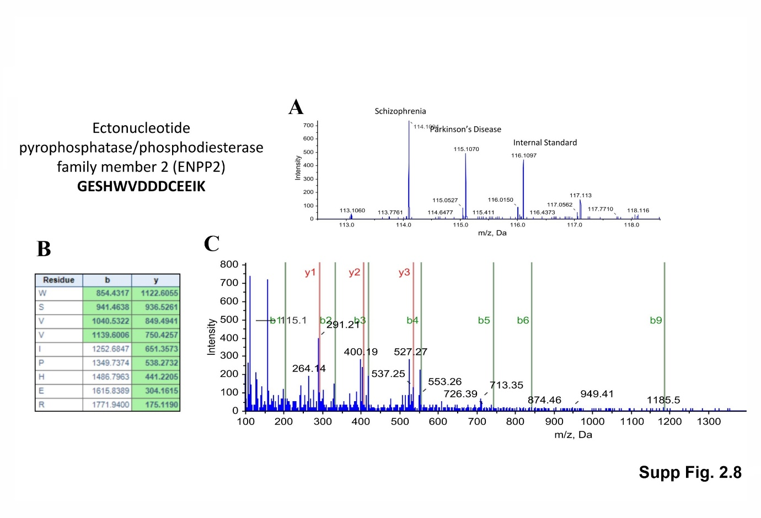

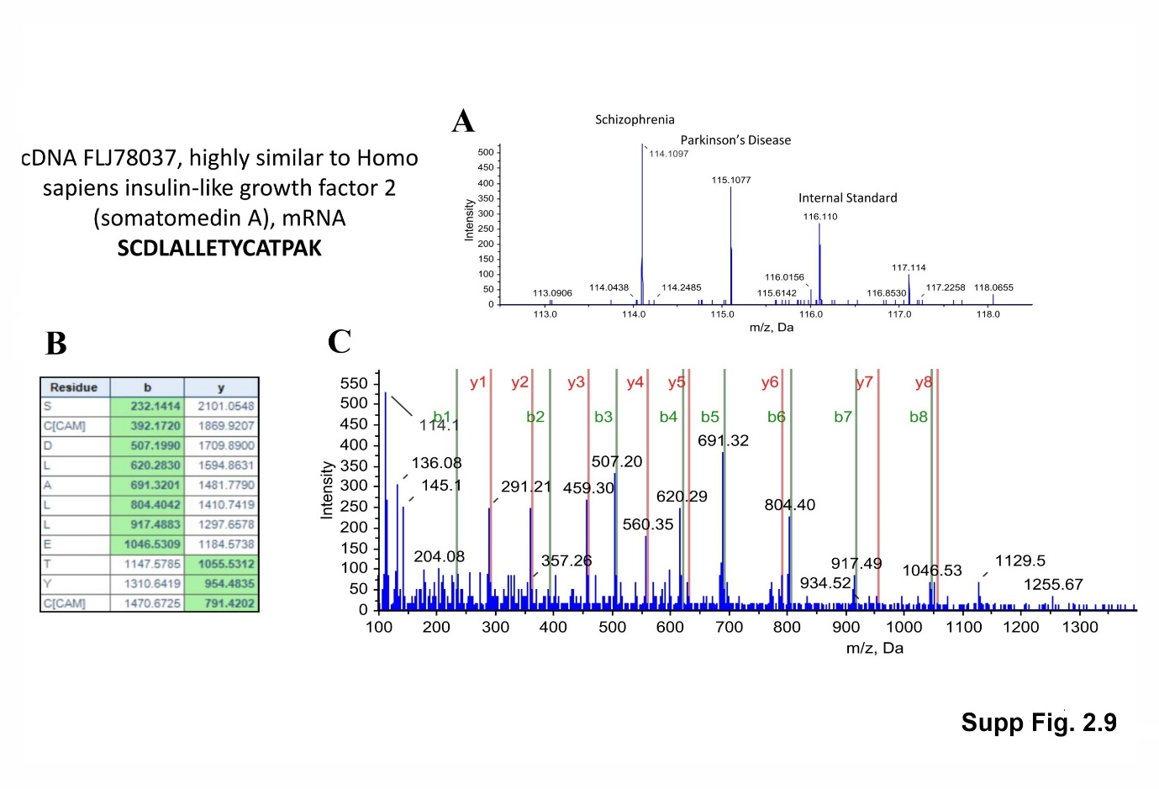

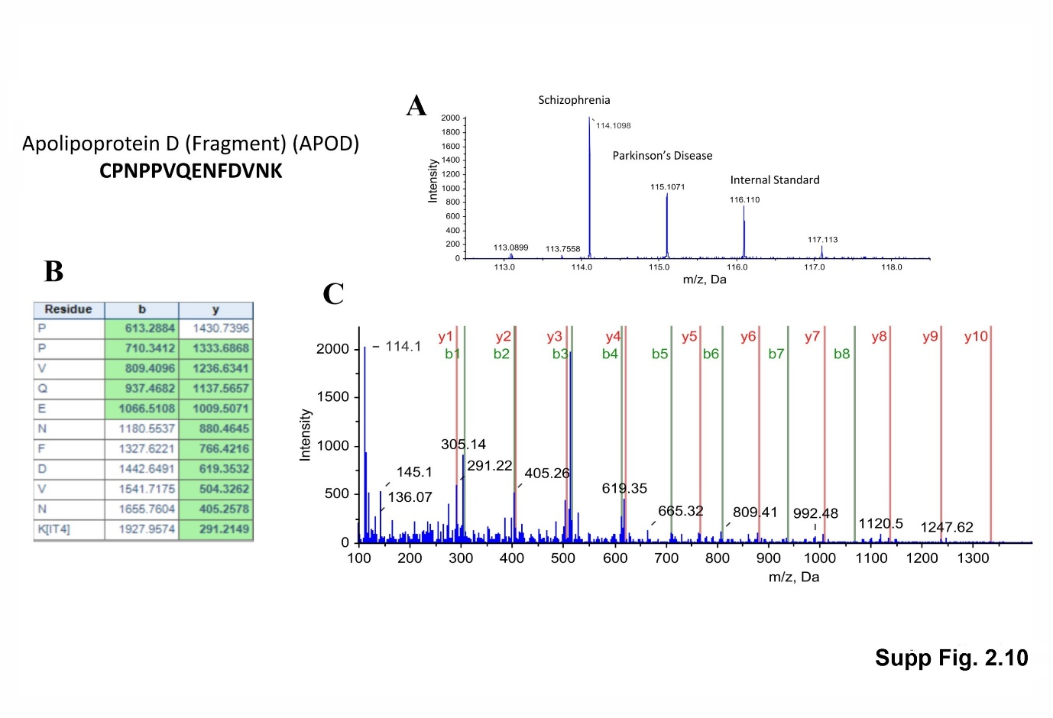

Supplementary Figure 2 (2.1–2.10) Mass spectrometric results for the iTRAQ experiment with protein from CSF samples of patients with Schizophrenia and Parkinson’s disease. (A) Precursor peptide reporter ion peaks with differential intensities between clinical phenotypes of Schizophrenia and Parkinson’s disease; (B) m/z values for different b and y peptide ion pairs; (C) Mass spectra intensity plot for different b and y ions. The y1 peak represents the C-terminal Lysine or Arginine of the tryptic peptide. Subsequent y peaks have one addition amino acid in addition to the previous y peak, and the molecular mass difference identifies the extra amino acid. Similarly all the b fragment peptide ion peaks contain a common N terminal amino acid. Ion y1 and b1 are the smallest of them. The numerical subscript represents the number of amino acids in that fragment.

