Supplementary 1 The code of R for conditional frailty model

# conditional frailty model

> library(survival)

> library(splines)

> library(survC1)

> library(MASS)

> library(boot)

> library(frailtypack)

>data$Health care=factor(data$Health care)

> str(Health care)

>fit2<-coxph(Surv(gaptime,status)~Age+Female+Non-manual+Health care+QRS duration+PCI+strata(counts)+frailty.gamma(id),data=data,na.action = na.exclude,method="efron")

> summary(fit2)

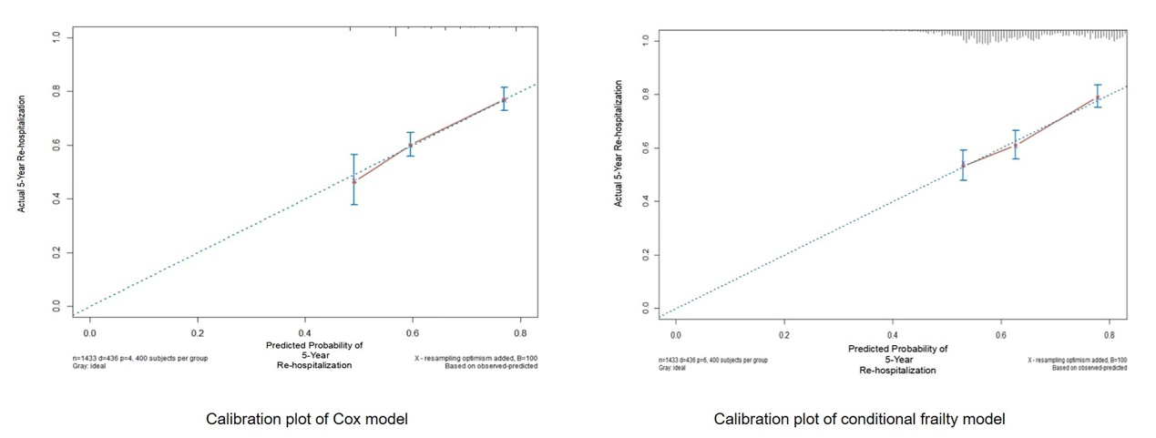

Supplementary 2 **The calibration plot of the Cox model and the conditional frailty model.** Calibration plot for predictions of 5 years re-hospitalization of the Cox model (left panel) and the conditional frailty model (right panel).

Supplementary 3 PH hypothesis tests of Cox model and conditional frailty model

|  |  |  |  |  |
| --- | --- | --- | --- | --- |
|  | Cox regression model | | Conditional frailty model | |
|  |  | *P* |  | *P* |
| Age | - | - | 0.019 | 0.502 |
| Female | - | - | -0.005 | 0.860 |
| Non-manual worker | -0.036 | 0.313 | -0.012 | 0.700 |
| Health-care | -0.020 | 0.556 | -0.055 | 0.057 |
| QRS duration | - | - | 0.028 | 0.319 |
| Diastolic dysfunction | -0.013 | 0.712 | -0.004 | 0.900 |
| Beta-blocker | -0.027 | 0.435 | - | - |
| PCI | - | - | 0.047 | 0.080 |
| Global | - | 0.771 | - | 0.301 |

PH, proportional hazard; PCI, percutaneous coronary intervention.