Additional file 1: The socio-demographic characteristics of mothers and Under-five children in Northwest, Ethiopia, 2019
Variables |  | Frequency (N=422) | Percent (%)
Age of mothers(year) | 16-27 | 106 | 25.1
 | 28-33 | 109 | 25.8
 | 34-42 | 107 | 25.4
 | 43-80 | 100 | 23.7
Religion of mother | Orthodox | 264 | 62.6
 | Muslim | 97 | 23.0
 | Protestant | 49 | 11.6
 | Catholic | 9 | 2.1
 | Others | 3 | 0.7
Family monthly income (ETB) | <500 | 257 | 60.9
 | 500-2500 | 47 | 11.1
 | 2501-3500 | 36 | 8.5
 | 3501-5100 | 41 | 9.7
 | 5101+ | 41 | 9.7
Educational status of mothers | Illiterate | 122 | 28.9
 | Literate | 300 | 71.1
Sex of child | Male | 211 | 50.0
 | Female | 211 | 50.0
Place of residence | Urban | 238 | 56.4
 | Rural | 184 | 43.6
Age of children in Month | 2-26 | 108 | 25.6
 | 27-36 | 107 | 25.4
 | 37-46 | 110 | 26.1
 | 47⁺ | 97 | 22.9
Marital Status | Unmarried | 179 | 42.4
 | Married | 243 | 57.6

Additional file 2: The primary source of information of mother’s about hand washing practice in Northwest Ethiopia, 2019
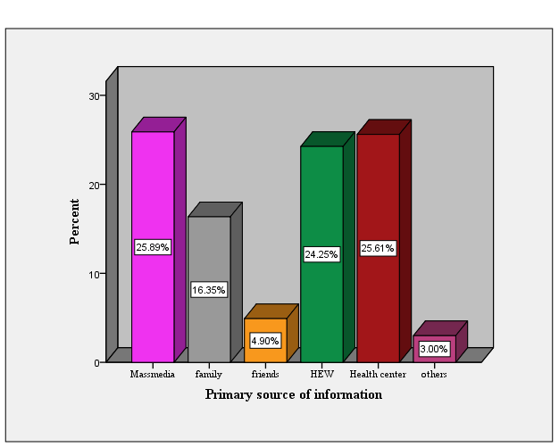

Additional file 3: hand washing practice of mothers in Northwest Ethiopia, 2019
Items |  |  | Always |  | Usually | Sometimes |  |  | Never
 |  |  | N (%) |  | N (%) | N (%) |  |  | N (%)
Do you wash your hands after using toilet? |  |  | 274(64.9) |  | 120 (28.4) | 26 (6.2) |  |  | 2 (0.5)
Do you wash your hands before eating meal? |  |  | 364(86.3) |  | 38 (9.0) | 16 (3.8) |  |  | 4 (0.9)
Do you use chemicals when you are washing your hands? |  |  | 113(26.8) |  | 53 (12.6) | 120 (28.4) |  |  | 136 (32.2)
I always remind the children to wash hands before eating? |  |  | 229(54.3) |  | 101 (23.9) | 88 (20.9) |  |  | 4 (0.9)
I always remind the children to wash hands after eating |  |  | 226(53.6) |  | 100 (23.7) | 94 (22.3) |  |  | 2 (0.5)
I wash hands after interacting with children/ sick person |  |  | 84 (19.9) |  | 81 (19.2) | 219 (51.9) |  |  | 38 (9.0)
I always wash my hands before and after handling raw material such as vegetables/ chicken/mutton etc. |  |  | 74 (17.5) |  | 77 (18.2) | 218 (51.7) |  |  | 53 (12.6)
I wipe my wet hands until dry |  |  | 68 (16.1) |  | 47 (11.1) | 185 (43.8) |  |  | 122 (28.9)
Washing hands with soap is my routine practice |  |  | 161(38.2) |  | 157 (37.2) | 94 (22.3) |  |  | 10 (2.4)
Hand washing methods |  |  | Frequency |  |  | Percent
Washing hands by Water only |  |  | 87 |  |  | 20.6
Washing hands by Water and grass |  |  | 3 |  |  | 0.7
Washing hands by Water and ash |  |  | 28 |  |  | 6.6
Washing hands by Water and soap/detergent |  |  | 304 |  |  | 72
Additional file 4: the correlation of health outcomes of under-five children and mother’s hand washing practice in Northwest Ethiopia, 2019
Health outcomes of under-five children |  | Hand washing practice of mothers |  |  |  |  | P-value
 |  | Good |  | Poor
Diarrheal disease | Yes | 62 |  | 65 |  |  | 0.001
 | No | 103 |  | 192
Acute respiratory tract infection (ARTI) | Yes | 42 |  | 73 |  |  | 0.5
 | No | 123 |  | 184
Meningitis | Yes | 17 |  | 28 |  |  | 0.84
 | No | 148 |  | 229
Malnutrition | Yes | 32 |  | 71 |  |  | 0.05
 | No | 133 |  | 186
Other childhood illness | Yes | 27 |  | 39 |  |  | 0.74
 | No | 138 |  | 218

