Supplementary Data

Supplementary Table 1. Antimicrobial resistance phenotypes (Minimum inhibitory concentrations, MICs) and genotypes of strain 2019036D.
Isolate | 2019036D
Resistance genes | mcr-8.2 | bla_{CTX-M-27}, bla_{CTX-M-55}, bla_{DHA-1} |  |  |  | tet(D) | qnrB4 | mph(A) | sul1, dfrA12 | mph(A) | qnrB4 | floR, cmlA1 | none
Antibioticsª | CL | CFZ | CFX | CTX | CAZ | TET | NAL | ERY | SXT | AZM | CIP | CHL | IPM
MICs(μg/ml) | 4 | 16 | >64 | 8 | 32 | 32 | >64 | 16 | 8 | >64 | 32 | >64 | 0.5
ª CL colistin, CFZ cefazolin, CFX cefoxitin, CTX cefotaxime, CAZ ceftazidime, TET tetracycline, NAL nalidixicacid, ERY erythromycin, SXT trimethoprim/sulfamethoxazole, AZM azithromycin, CIP ciprofloxacin, CHL chloramphenicol, IPM imipenem.

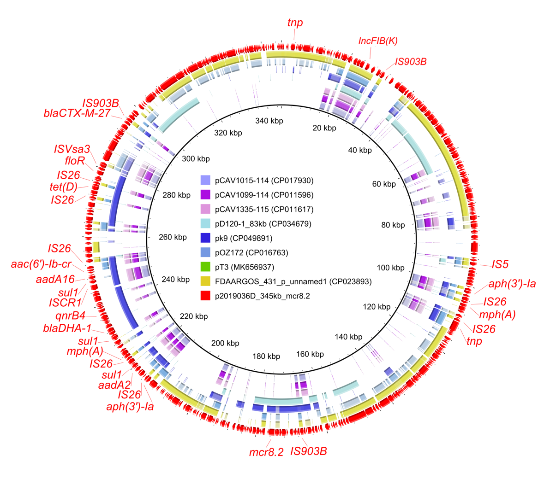Supplementary Figure 1. Comparative analysis of p2019036D-mcr8-345kb (this study) with other mcr-bearing IncFIB(K) plasmids in NCBI databases.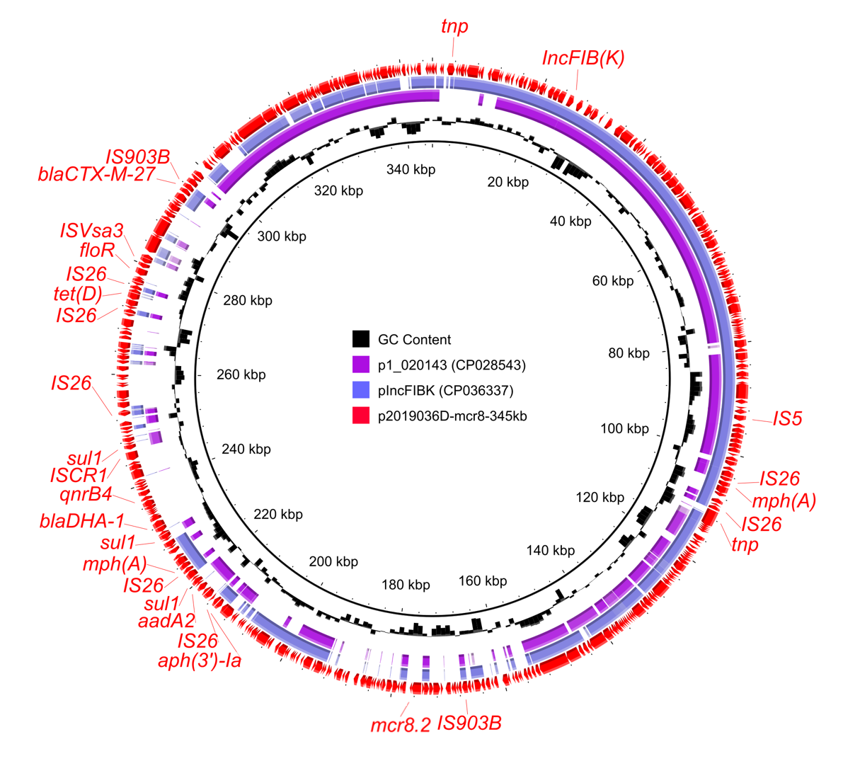
Supplementary Figure 2. Comparative analysis of p2019036D-mcr8-345kb (this study) with most similar plasmids pIncFIBK and p1_020143.
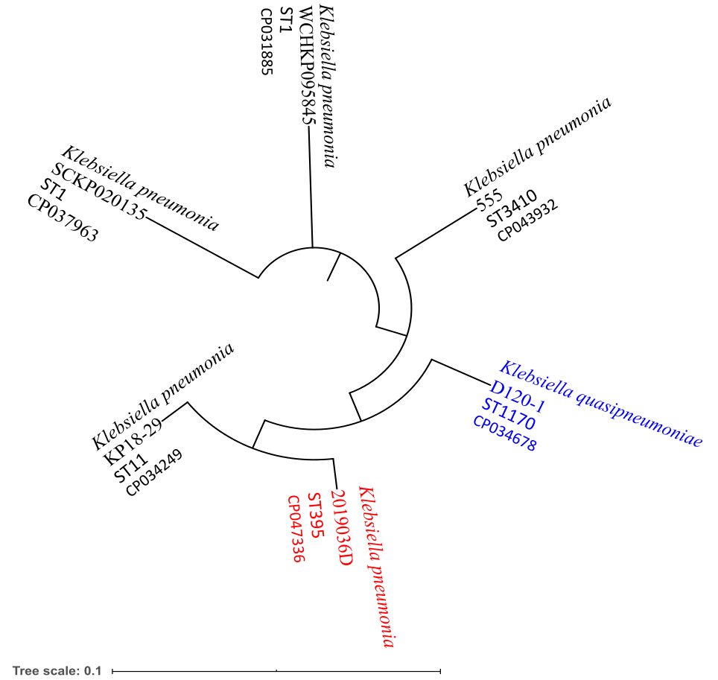
Supplementary Figure 3. Phylogenetic tree of six mcr-8.2-positive strains and their basic information.

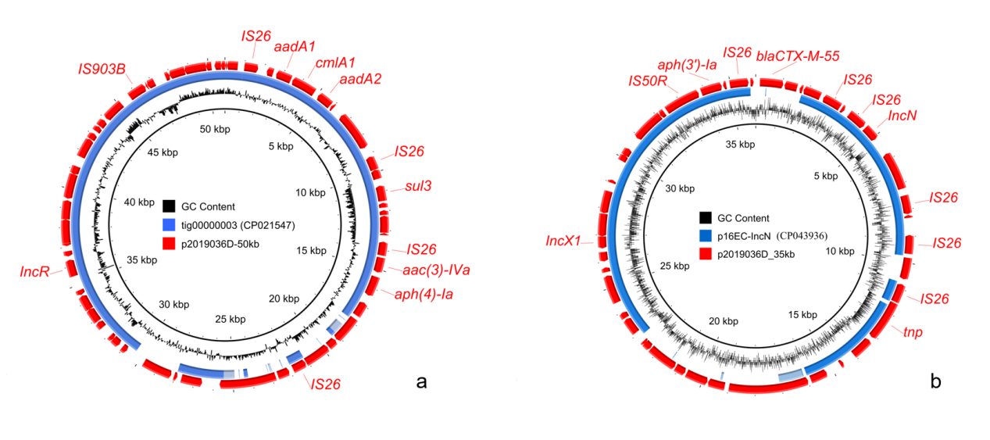Supplementary Figure 4. Circular plasmids comparison of p2019036D-50kb (a) and p2019036D-35kb (b) with most similar plasmids in NCBI databases.

