Smokers with COPD Show a Shift in Energy and Nitrogen Metabolism at Rest and During Exercise

Holz Olaf, DeLuca David S., Röpcke Stefan, Illig Thomas, Weinberger M. Klaus, Schudt Christian, Hohlfeld Jens M.

Online Data Supplement

Figure E1: Correlation between acylcarnitine C2 and total acylcarnitines separately for smokers with and without COPD and the 4 time points (1: before, 2: after 5 min, 3: at the end of exercise, 4: after 20 min rest). Data of the first exercise challenge.
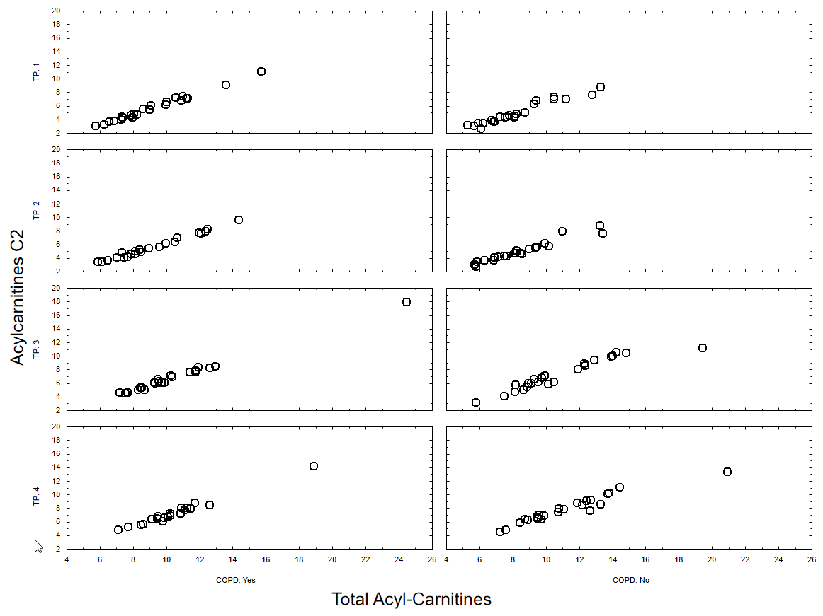

Figure E2: Correlation between lactate and pyruvate separately for smokers with and without COPD and the 4 time points (1: before, 2: after 5 min, 3: at the end of exercise, 4: after 20 min rest). Data of the first exercise challenge.
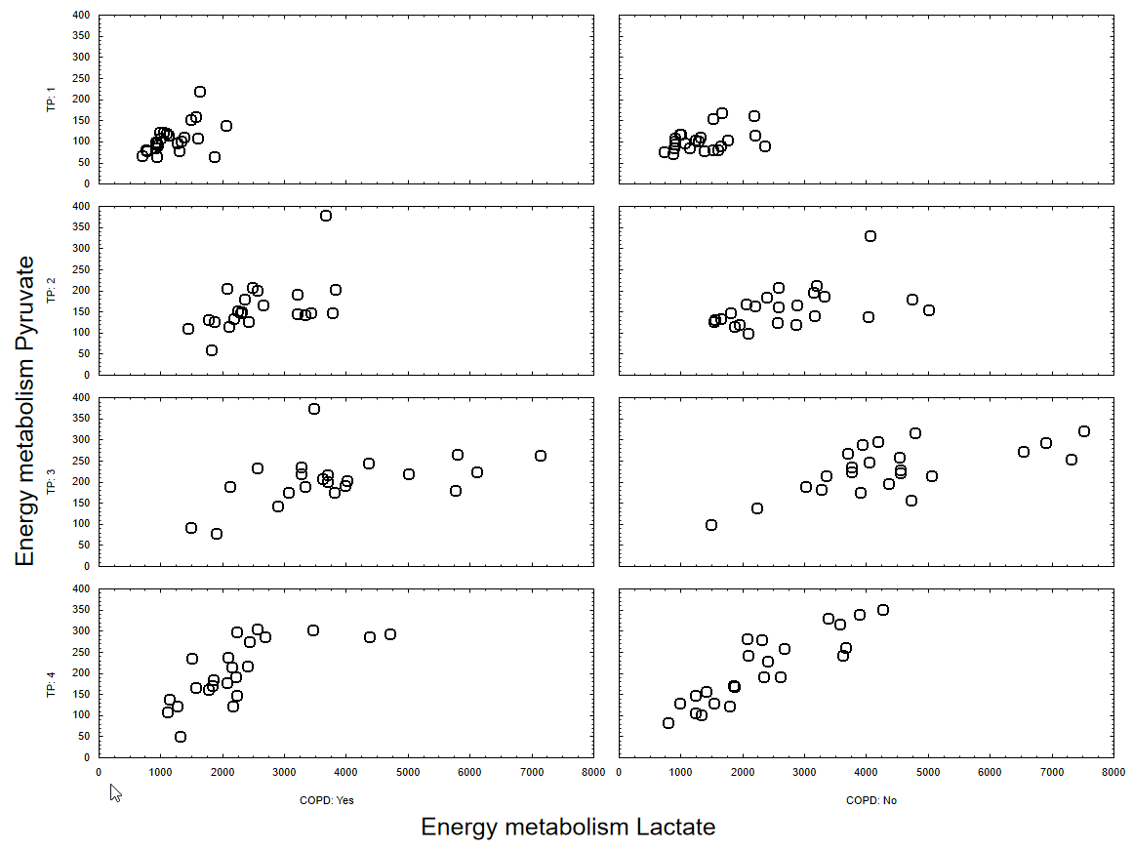

Figure E3: Correlation between GLN and ALA separately for smokers with and without COPD and the 4 time points (1: before, 2: after 5 min, 3: at the end of exercise, 4: after 20 min rest). Data of the first exercise challenge.
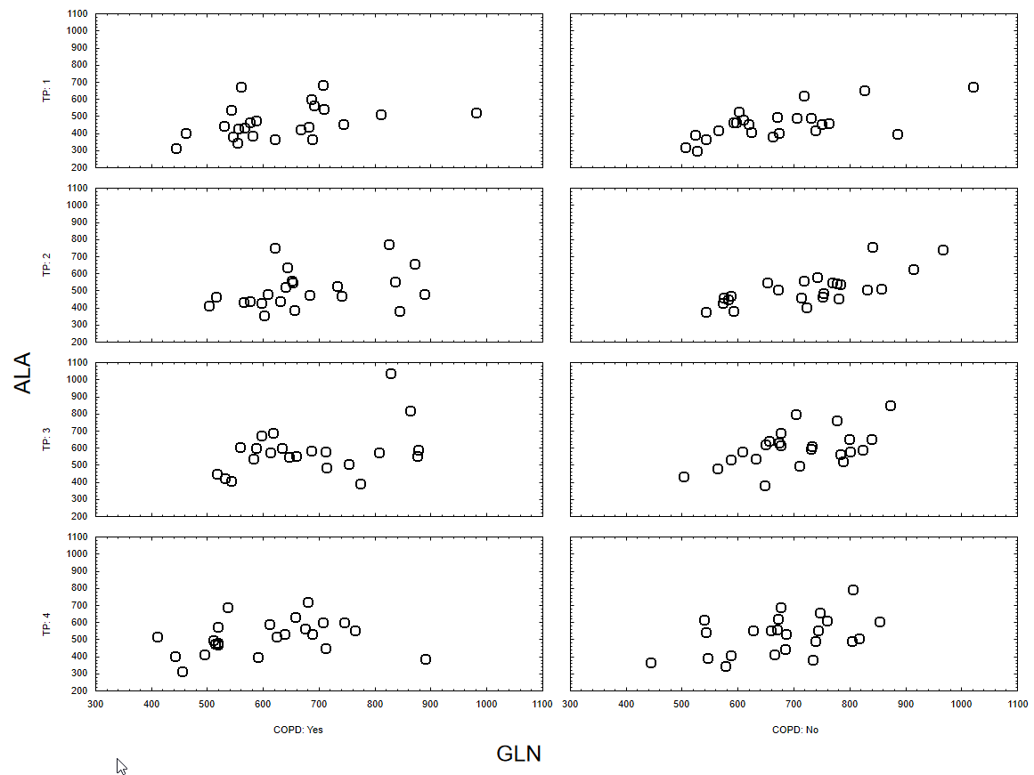

Figure E4: Correlation between GLN and BCAA separately for smokers with and without COPD and the 4 time points (1: before, 2: after 5 min, 3: at the end of exercise, 4: after 20 min rest). Data of the first exercise challenge.
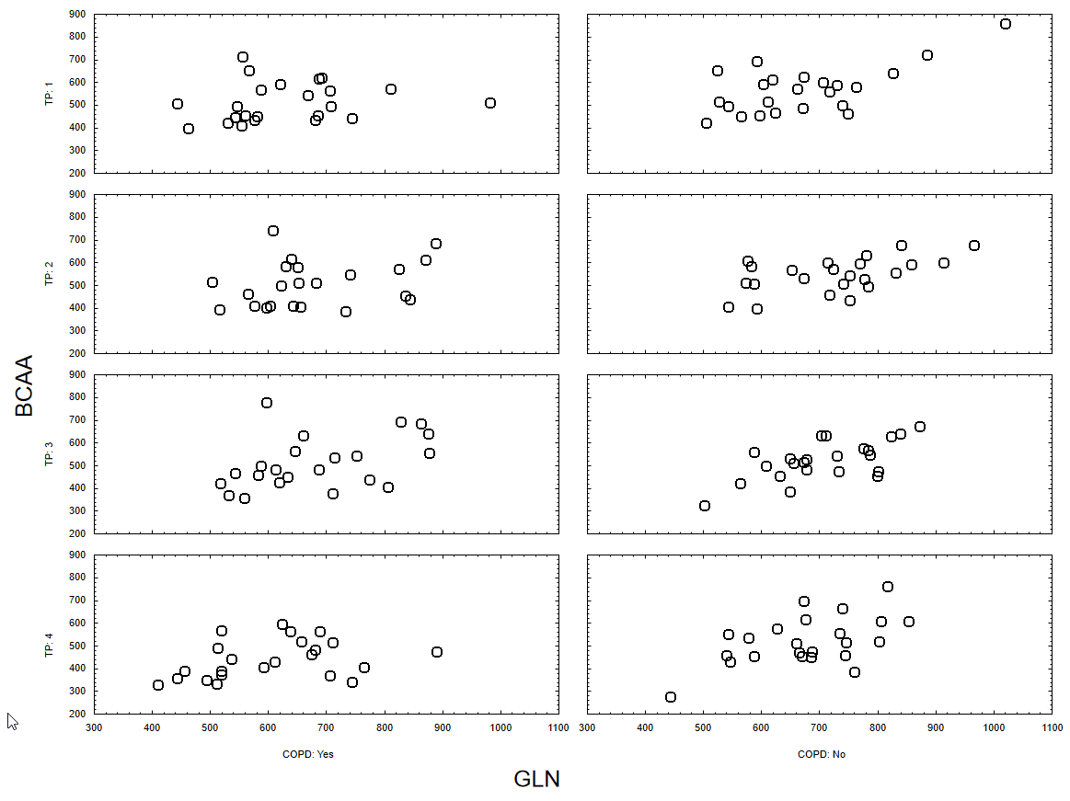

Figure E5: Correlation between GLN and ASP separately for smokers with and without COPD and the 4 time points (1: before, 2: after 5 min, 3: at the end of exercise, 4: after 20 min rest). Data of the first exercise challenge.
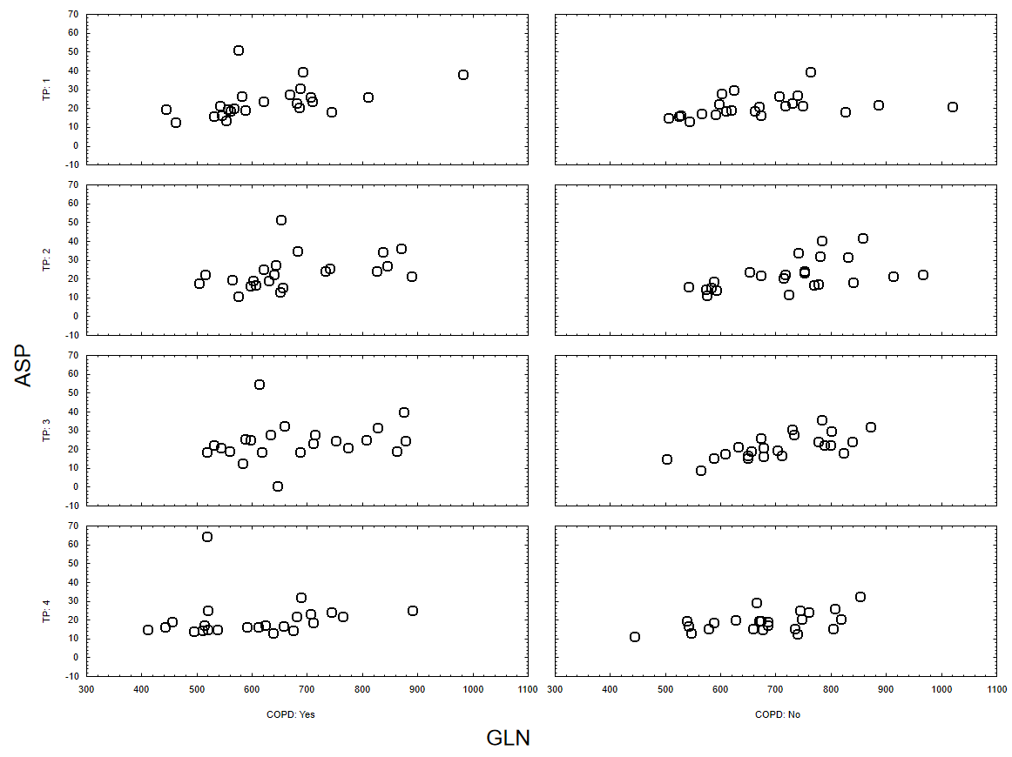

Figure E6: Correlation between duration of exercise (min) and the levels of a-KG and succinate (µM)
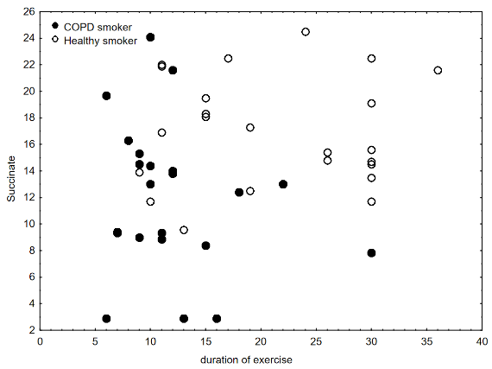
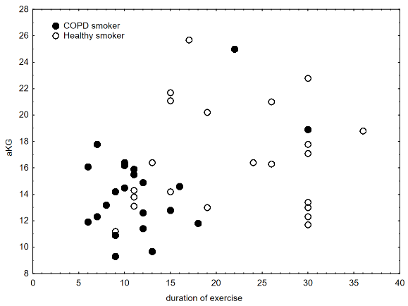

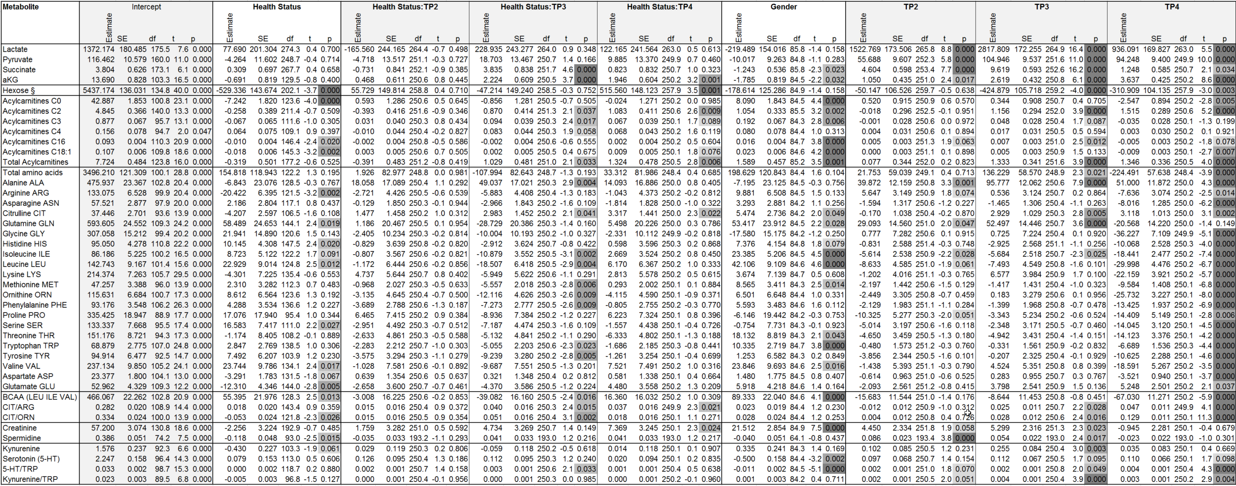
Table E1: List of parameter estimates and statistics from the mixed model analysis.

Health status is in reference to healthy smokers as baseline, and TP2,3,4 are in reference to TP1 as baseline.

