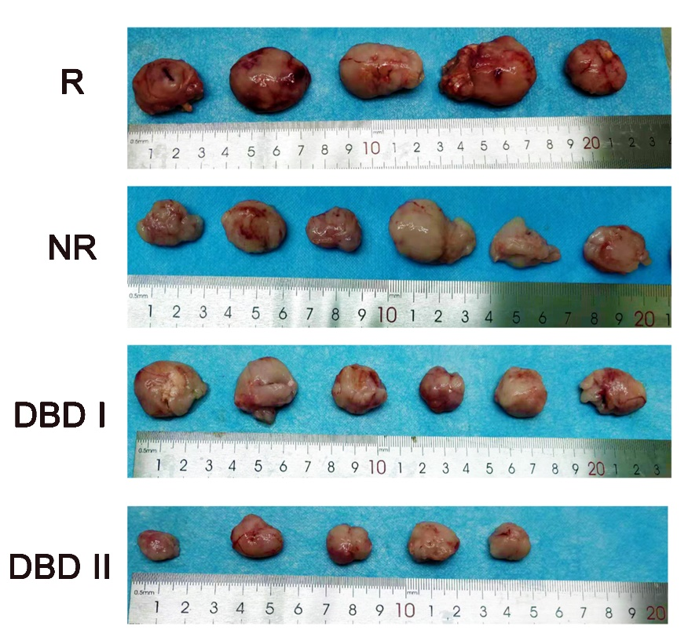

Supplementary Figure S1 Tumor samples in groups R, NR, DBD I and DBD II.

Supplementary Table S1 The 61 potential targets of DBD against MCC
Number | Gene |  | Number | Gene
1 |  | MMP2 | 31 | AKR1B10
2 |  | NOS2 | 32 | RXRA
3 |  | MET | 33 | PON1
4 |  | SHBG | 34 | CASP8
5 |  | BCL2 | 35 | PPARG
6 |  | CYP1A1 | 36 | ABCB1
7 |  | NQO2 | 37 | LCK
8 |  | AHR | 38 | NR1H2
9 |  | NFE2L2 | 39 | STAT3
10 |  | CYP19A1 | 40 | ADRB2
11 |  | CA9 | 41 | ACHE
12 |  | PTGS2 | 42 | CASP3
13 |  | ESR1 | 43 | PARP1
14 |  | MMP1 | 44 | VDR
15 |  | HMGCR | 45 | PTPN1
16 |  | PPARD | 46 | PPARA
17 |  | NR3C2 | 47 | TTR
18 |  | PTGER2 | 48 | CYP1A2
19 |  | EGFR | 49 | TOP2A
20 |  | G6PD | 50 | CA2
21 |  | NCOA1 | 51 | RELA
22 |  | PGR | 52 | OPRM1
23 |  | CYP17A1 | 53 | TLR9
24 |  | CASP9 | 54 | PTGS1
25 |  | NCOA2 | 55 | F3
26 |  | ESR2 | 56 | JUN
27 |  | CYP1B1 | 57 | AR
28 |  | PLAU | 58 | BAX
29 |  | SLC6A4 | 59 | PRKCA
30 |  | ALOX5 | 60 | APP
 |  |  | 61 | MMP9

