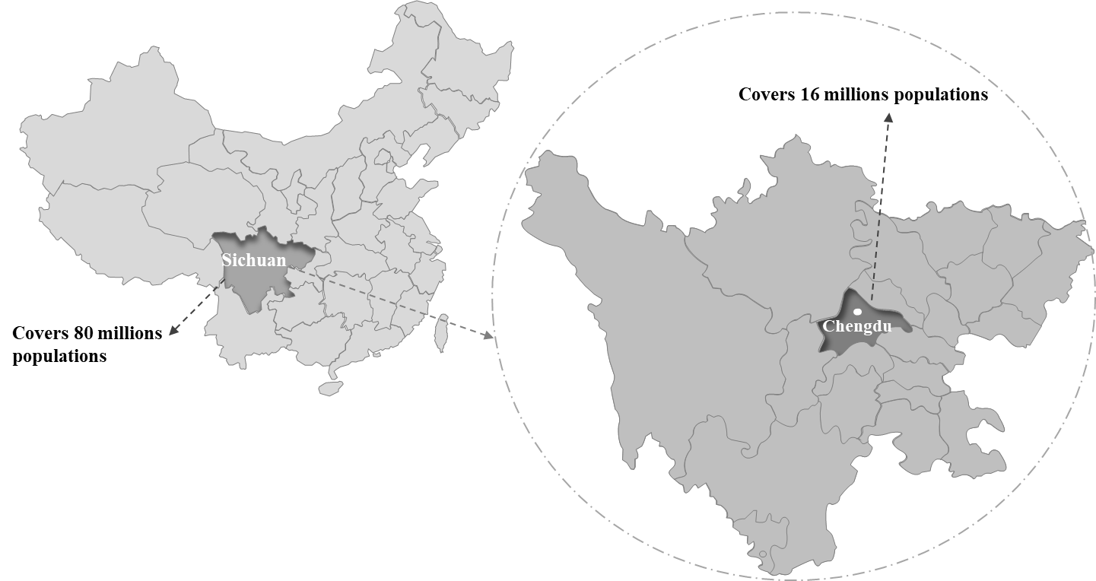
Figure S1 Study location for the ICU-HAI registry

Diagnosis | ICD-10 code
Valvulopathy | I05, I06, I07, I08, I34, I35, I36, I37
Pneumonia | A02.2, A40.3, B20.6, B25.0, B44.1, B49.X, B59.0, B59.X, I88.9，J10.0, J11.0, J12.0, J12.9-J13.0, J15.0-J15.2, J15.4-J16.0, J18.0, J18.8-J18.9, J24.9, J44.0, J44.8, J69.0, J84.1, J84.9, J85.1-J85.2, J98.4, O99.5, P23.9
Heart septal defectsatrial | Q21
Cerebral hemorrhage | I60, I61, I62, I69, O99.4
Aortic dissection | I71
Table S1. The primary ICD-10 code of discharge diagnosis

