Supplemental material

Materials and Methods

Histological sections, CD31, Ki-67 and active caspase-3
NCI-H460 tumor bearing mice were treated as previously described, then tumors were resected, and paraffin fixed. Slides from each treatment group were then stained for CD31 using anti-CD31 polyclonal antibody (Santa Cruz Biotechnology). Blood vessels were quantified by randomly selecting 400× fields and counting the number of blood vessels per field. This was done in triplicate and the average of the three counts was calculated. Staining for Ki67 (Thermo fisher scientific) and active caspase-3 (Cell Signaling Technology) were performed in the Thomas Jefferson University Pathology Core laboratory using standard protocols. The number of positive cells per field were scored and graphed by averaging three repeated assessments.

Figure
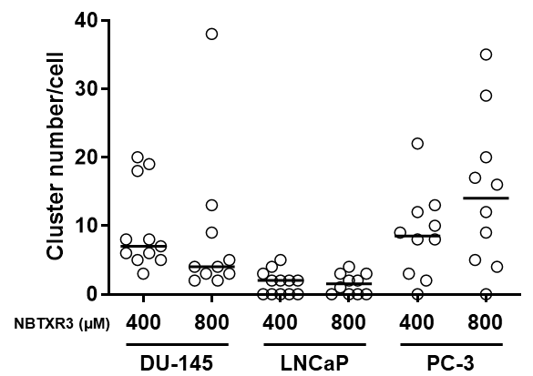
Figure S1. Scatter plot of NBTXR3 cluster number per cell (n≥10 cells). Bar, median; circle, one individual cell.

A
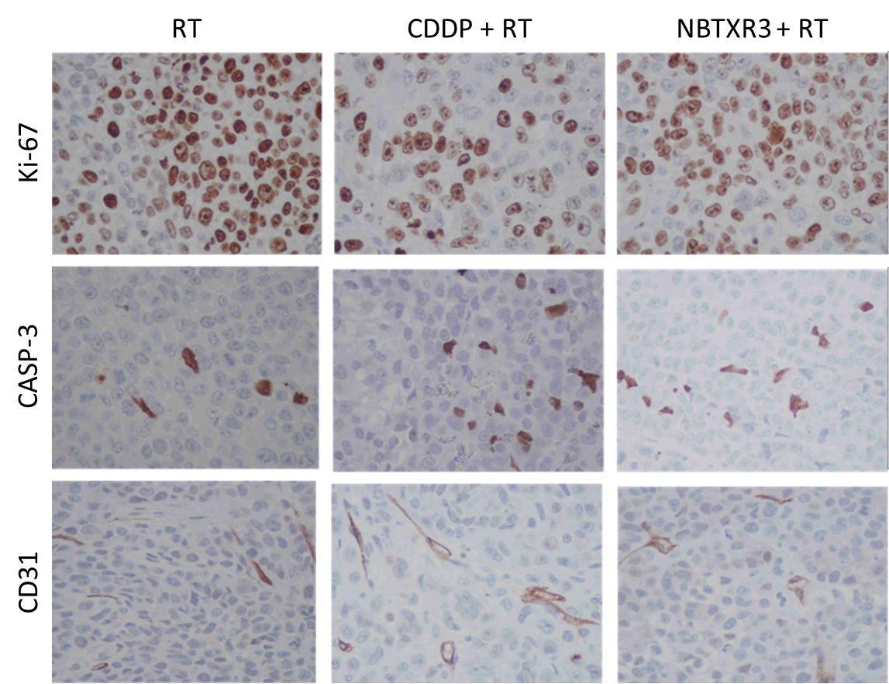

B
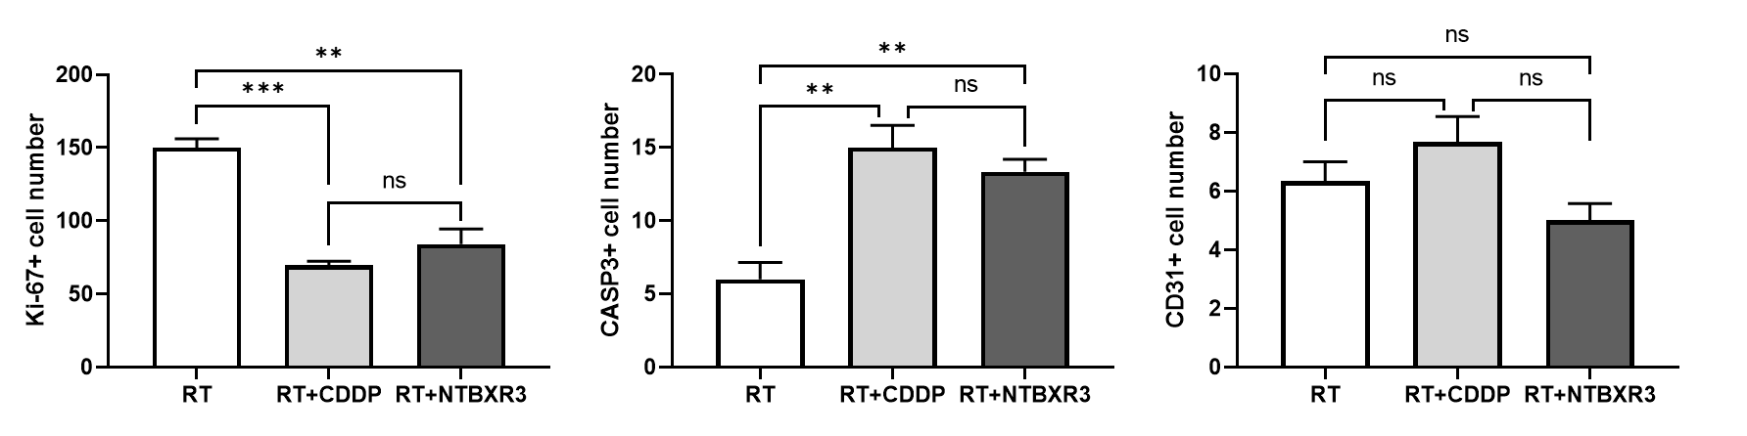
Figure S2. Representative IHC images for Ki-67, CASP-3 and CD31 staining in tumor treated with RT, CDDP+RT or NBTXR3+RT. (B) NBTXR3+RT or CDDP+RT reduced the number of proliferating cells (Ki-67) and induced apoptosis cell death (CASP-3) in lung cancer xenograft model when compared to RT alone (control), but not blood vessel number (CD31). Presented data: mean±SD, quantitative data (n=3). Student’s t-test was utilized to determine the significance between groups. Statistical analysis was performed with Microsoft Excel. Significance was defined at the level of p<0.05. **, p<0.01; ***, p<0.001; ns, not significant.

