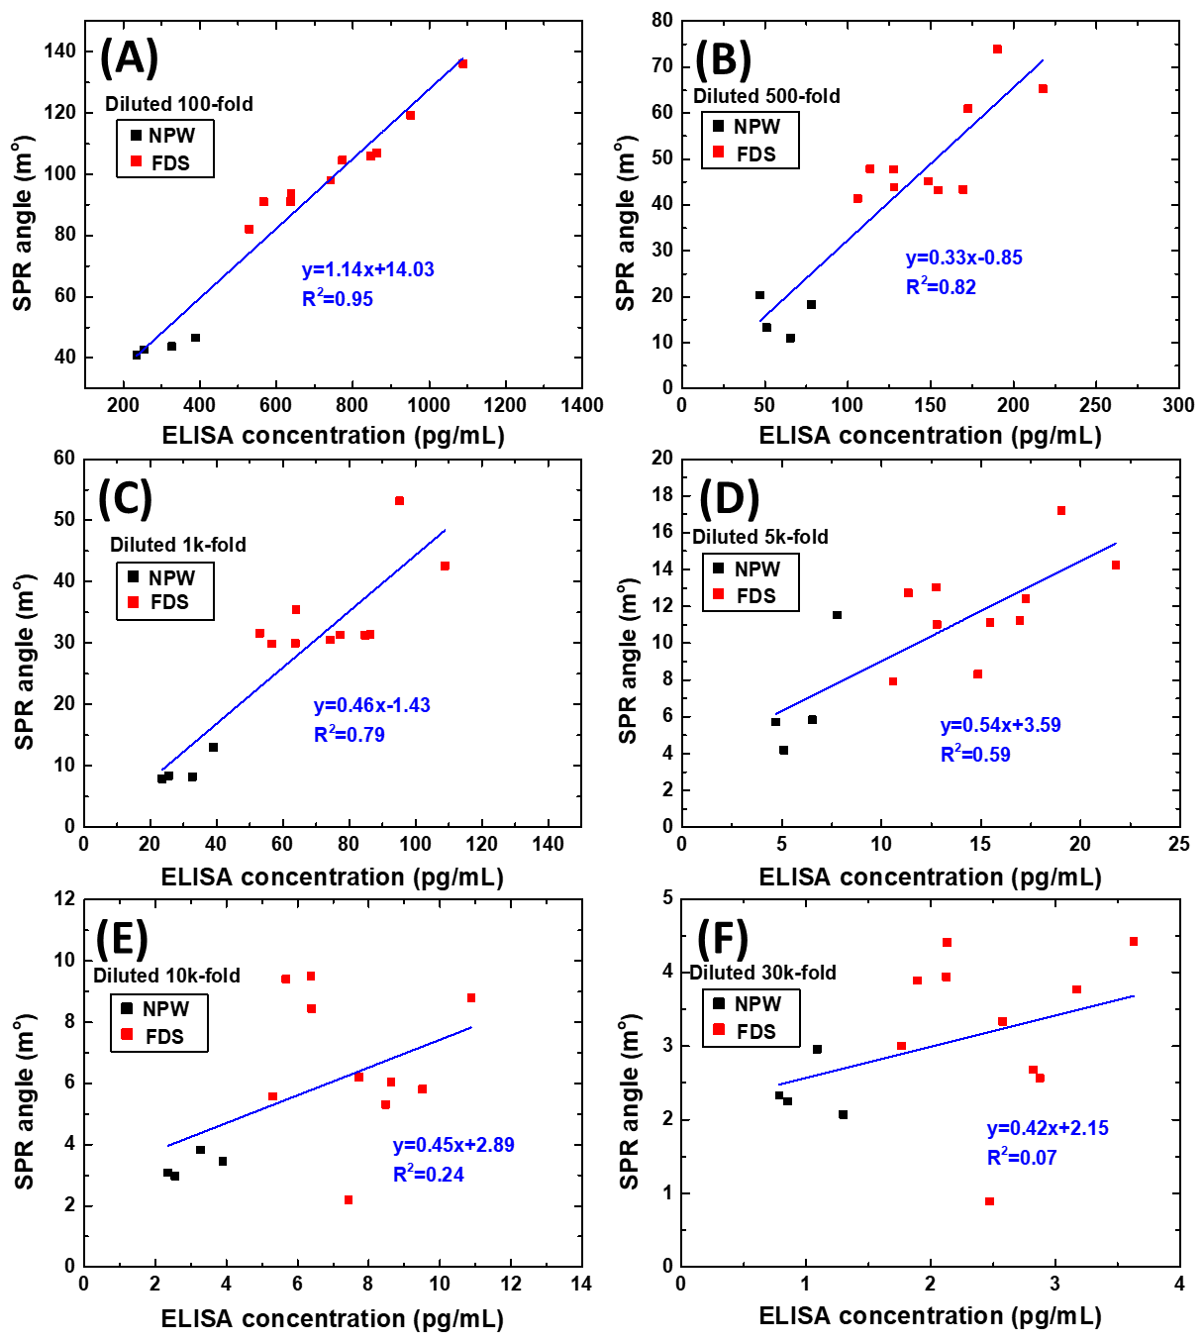
Figure S1. Correlations between the SPR biosensor and ELISA results for different maternal serum dilution factors in PAPP-A2 protein assay. (a) 100-fold, (b) 500-fold, (c) 1k-fold, (d) 5k-fold, (e) 10k-fold, and (f) 30k-fold.
Abbreviations: SPR, surface plasmon resonance; ELISA, Enzyme-linked immunosorbent assay; PAPP-A2, pregnancy-associated plasma protein-A2.

fetal Down’s syndrome (FDS) group
Dilution factors | FDS-1 (19W) |  | FDS-2 (20W) |  | FDS-3 (14W) |  | FDS-4 (14W) |  | FDS-5 (22W) |  | FDS-6 (19W) |  | FDS-7 (21W) |  | FDS-8 (18W) |  | FDS-9 (19W) |  | FDS-10 (18W)
Dilution factors | MA: 34  (MT=1) |  | MA: 43  (MT=0) |  | MA: 39  (MT=0) |  | MA: 31  (MT=0) |  | MA: 39  (MT=2) |  | MA: 37  (MT=1) |  | MA: 43  (MT=2) |  | MA: 36  (MT=2) |  | MA: 40  (MT=2) |  | MA: 30  (MT=1)
Dilution factors | C(B) | θ_{SPR} | C(B) | θ_{SPR} | C(B) | θ_{SPR} | C(B) | θ_{SPR} | C(B) | θ_{SPR} | C(B) | θ_{SPR} | C(B) | θ_{SPR} | C(B) | θ_{SPR} | C(B) | θSPR | C(B) | θSPR
100-fold | 951.50 | 119.24 | 847.45 | 105.98 | 742.69 | 98.02 | 1088.36 | 136.14 | 862.60 | 106.93 | 639.20 | 93.61 | 567.40 | 91.05 | 772.80 | 104.59 | 529.58 | 82.12 | 637.38 | 91.14
500-fold | 190.30 | 73.90 | 169.49 | 43.38 | 148.54 | 45.14 | 217.67 | 65.28 | 172.52 | 60.95 | 127.84 | 43.86 | 113.48 | 47.84 | 154.56 | 43.18 | 105.92 | 41.39 | 127.48 | 47.75
1K-fold | 95.15 | 53.18 | 84.75 | 31.31 | 74.27 | 30.53 | 108.84 | 42.59 | 86.26 | 31.44 | 63.92 | 35.49 | 56.74 | 29.89 | 77.28 | 31.35 | 52.96 | 31.62 | 63.74 | 29.98
5K-fold | 19.03 | 17.22 | 16.95 | 11.21 | 14.85 | 8.31 | 21.77 | 14.23 | 17.25 | 12.40 | 12.78 | 11.02 | 11.35 | 12.73 | 15.46 | 11.12 | 10.59 | 7.91 | 12.75 | 13.04
10K-fold | 9.52 | 5.81 | 8.48 | 5.31 | 7.43 | 2.19 | 10.88 | 8.79 | 8.63 | 6.04 | 6.39 | 8.45 | 5.67 | 9.41 | 7.73 | 6.203 | 5.29 | 5.58 | 6.37 | 9.51
30K-fold | 3.17 | 3.77 | 2.83 | 2.68 | 2.48 | 0.89 | 3.63 | 4.42 | 2.87 | 2.57 | 2.13 | 4.41 | 1.89 | 3.89 | 2.57 | 3.34 | 1.76 | 3.01 | 2.13 | 3.94
40K-fold | 2.38 | 3.63 | 2.12 | 2.53 | 1.86 | 0.78 | 2.72 | 4.23 | 2.16 | 1.09 | 1.59 | 2.65 | 1.42 | 1.60 | 1.93 | 2.16 | 1.32 | 1.18 | 1.59 | 1.76
MA: maternal age
MT: miscarriage times
C(B): serum PAPP-A2 concentrations (pg/mL).
θ_{SPR}: SPR angle shift, millidegrees (mº).
Table S1 for FDS group

Table S2 for NPW group

normal pregnant women (NPW) group
Dilution factors | NPW-1 (14W) |  | NPW-2 (12W) |  | NPW-3 (14W) |  | NPW-4 (16W)
Dilution factors | MA: 30  (MT=0) |  | MA: 27  (MT=0) |  | MA: 30  (MT=0) |  | MA: 34  (MT=0)
Dilution factors | C(B) | θ_{SPR} | C(B) | θ_{SPR} | C(B) | θ_{SPR} | C(B) | θ_{SPR}
100-fold | 255.20 | 42.77 | 326.74 | 43.78 | 389.70 | 46.57 | 235.02 | 40.96
500-fold | 51.04 | 13.31 | 65.35 | 11.03 | 77.94 | 18.30 | 47.01 | 20.35
1K-fold | 25.52 | 8.38 | 32.67 | 8.24 | 38.97 | 13.01 | 23.50 | 7.89
5K-fold | 5.11 | 4.20 | 6.53 | 5.83 | 7.79 | 11.52 | 4.70 | 5.72
10K-fold | 2.55 | 2.98 | 3.27 | 3.83 | 3.89 | 3.45 | 2.35 | 3.08
30K-fold | 0.85 | 2.25 | 1.09 | 2.96 | 1.29 | 2.07 | 0.78 | 2.33
MA: maternal age
MT: miscarriage times
C(B): serum PAPP-A2 concentrations (pg/mL).
θ_{SPR}: SPR angle shift, millidegrees (mº).

