Supplementary Figure 1. Study protocol. In this 15-day protocol, both the 8-h split sleep group and the 8-h continuous group had 2 adaptation and baseline nights (B1 and B2; time-in-bed indicated by black bars = 9 h from 23:00 to 08:00). The first cycle of sleep manipulation consisted of 5 nights (M11 to M15) followed by 2 nights of recovery sleep with 9 hours of sleep opportunity (R11, R12). Participants had 3 manipulation nights (M21 to M23) and 2 recovery nights (R21 and R22) during the second cycle of the protocol. During the two sleep opportunity manipulation periods indicated with M, the split sleep group had a nocturnal TIB of 6.5 hours (00:15-06:45) and a 1.5-h nap opportunity between 14:00 and 15:30, while the continuous sleep group had a nocturnal TIB of 8 hours (23:30-07:30). The type of sleep data collected from participants during each nocturnal sleep episode is indicated in the graph. ‘A’ and ‘O’ indicate nights when actigraphy and Oura ring sleep measurements were present (all nights of the study). ‘P’ indicates nights when polysomnography was recorded. Asterisks indicate nights of data that were used during analysis. Data from B1 night was excluded as an adaptation night.

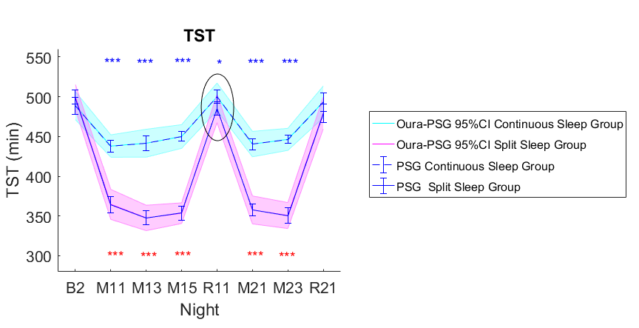
Supplementary Figure 2 PSG-measured TST in the Continuous (dotted lines) and Split (solid lines) sleep groups. Solid error bars denote 95% confidence intervals for the PSG measures, while shaded error bars denote 95% confidence intervals of the Oura-PSG discrepancy. When error bars of the Oura-PSG discrepancy render an overlap larger than half of its width (black ellipse on R11), then the effect is no longer detectable by Oura.

Supplementary Results
Comparing the Actiwatch M10 and PSG
Similar to the Oura, Actiwatch M10 significantly underestimated TST by an average of 25.8 to 33.8 minutes across all TIB conditions (ts ≥ 7.80, Ps < 0.001, Cohen’s ds ≥ 1.47). For WASO, we observed a significant overestimation by M10, ranging from 27.9 to 37.9 minutes (ts ≥ 9.79, Ps < 0.001, Cohen’s ds ≥ 1.85; Table 2). Epoch-by-epoch (EBE) analyses indicated excellent sleep-wake classification accuracies and sensitivities (ability to detect sleep) ranging from 0.90 to 0.91, while specificity (ability to detect wake) ranged from 0.86 to 0.87 across all TIB conditions (Table 5).
Comparing the Actiwatch H5 and PSG
We observed a similar pattern of underestimation of TST and overestimation of WASO for the H5 setting, despite a better overall agreement with PSG compared with M10, TST was significantly underestimated by an average of 5.3 to 7.5 minutes in 8 and 9-hour groups (ts ≥ 2.15, Ps < 0.05, Cohen’s ds ≥ 0.29). No significant TST bias was observed in the 6.5-hour TIB condition (ts = 0.77, Ps = 0.45, Cohen’s d = 0.16). WASO was significantly overestimated across all TIB conditions by an average of 14.4 to 19.1 (ts ≥ 7.92, Ps < 0.001, Cohen’s ds ≥ 1.49 Table 2). EBE analyses indicated excellent sleep-wake classification accuracies ranging from 0.93 to 0.94, and a sensitivity of 0.95. The observed specificity (ability to detect wake) was albeit lower, yet still in an acceptable range of 0.70 to 0.71 across all TIB conditions (Table 5).

Supplementary Tables

Table S1. Mean (SD) of TST biases, in minutes, from PSG of each device setting by sex, grouped by TIB recordings.
 | M10 | H5 | Oura | F | P
6.5h TIB
Female (n=12) | -24.21 (16.93) | -2.42 (13.91) | -31.60 (21.61) | 0.293 | 0.748
Male (n=10) | -27.77 (9.59) | -1.90 (13.40) | -34.16 (10.17)
8h TIB
Female (n=15) | -27.92 (24.07) | -2.74 (16.74) | -39.74 (15.80) | 0.134 | 0.875
Male (n=13) | -40.18 (20.14) | -13.11 (13.02) | -53.42 (21.76)
9h TIB
Female (n=28) | -31.14 (18.87) | -3.65 (16.74) | -46.66 (23.80) | 0.33 | 0.632
Male (n=24) | -37.03 (19.60) | -7.24 (19.10) | -47.96 (25.99)
F-values of Device × Sex interactions are indicated. Main effect of Sex was trending towards significance in the 8h TIB condition, P = 0.061.
Abbreviations: M10, the default actiwatch setting that uses a medium wake threshold with 40 counts per epochs with 10 immobile minutes for sleep onset and termination; H5, actiwatch setting that has a higher wake threshold of 80 counts per epoch and 5 immobility minutes for sleep onset and termination.

Table S2. Mean (SD) of TST biases, in minutes, from PSG of each device setting grouped by BMI, across TIB conditions.
 | M10 | H5 | Oura | F | P
6.5h TIB
BMI > 20 (n=11) | -29.66 (10.33) | -6.22 (10.74) | -30.15 (21.69) | 0.154 | 0.858
BMI < 20 (n=11) | -21.99 (16.30) | 1.85 (14.95) | -35.37 (11.18)
8h TIB
BMI > 20 (n=14) | -29.25 (17.65) | -3.71 (13.52) | -45.55 (18.45) | 0.866 | 0.427
BMI < 20 (n=14) | -37.98 (26.95) | -11.39 (17.37) | -46.63 (21.57)
9h TIB
BMI > 20 (n=26) | -35.06 (16.51) | -3.95 (16.42) | -44.14 (21.45) | 1.197 | 0.292
BMI < 20 (n=26) | -32.65 (21.91) | -6.65 (19.26) | -50.38 (27.46)
F-values of Device × BMI interactions are indicated.
Abbreviations: BMI, body mass index; M10, The default actiwatch setting that uses a medium wake threshold with 40 counts per epochs with 10 immobile minutes for sleep onset and termination; H5, actiwatch setting that has a higher wake threshold of 80 counts per epoch and 5 immobility minutes for sleep onset and termination.

