FIG.S1 Validation results of the refined 3D structure of multi-epitope vaccine structure by ERRAT software. ERRAT plot showed the overall quality score of the refined structure as 89.362.
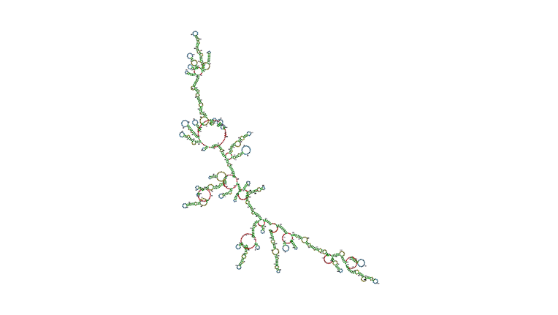
FIG.S2 The secondary structure of the m RNA vaccine construct predicted using RNAfold server.
Table.S1. Allignment of selected epitopes between SARS-COV2 and SARS (Conserved amino acids showed bold).
 | Protein | Seq | Spice | Allignment
1 | Spike | 20-49 | COVID19 | QCVNLTTRTQLP PAYTN SFT RGVYYPDKVF
1 | Spike | 20-49 | SARS | DLDRCTTFDDVQAPNYTQHTSSMRGVYYPDEIF
2 | Spike | 418-446 (RBD1) | COVID19 | KIADYNYKLPDDFTGCVIAWN SNNLDSKVG
2 | Spike | 418-446 (RBD1) | SARS | KIADYNYKLPDDFMGCVLAWNTRNIDATST
3 | Spike | 505-534 (RBD2) | COVID19 | YQPYRVVVLSFELLHAPATVCGPKKSTNLV
3 | Spike | 505-534 (RBD2) | SARS | YQPYRVVVLSFELLNAPATVCGPKLSTDLI
4 | N | 360-388 | COVID19 | YKTFPPTEPKKDKKKKADET QALPQRQKK
4 | N | 360-388 | SARS | YKTFPPTEPKKDKKKKTDEAQPLPQRQKK
5 | M | 169-198 | COVID19 | TVATSRTLSYYKLGASQRVA GDSGFAAYSR
5 | M | 169-198 | SARS | TVATSRTLSYYKLGASQRVGTDSGFAAYNR
6 | E | 51-71 | COVID19 | LVKPSFYVYSRVKNLNSSR VP
6 | E | 51-71 | SARS | LVKPTVYVYSRVKNLNSSEGVP

