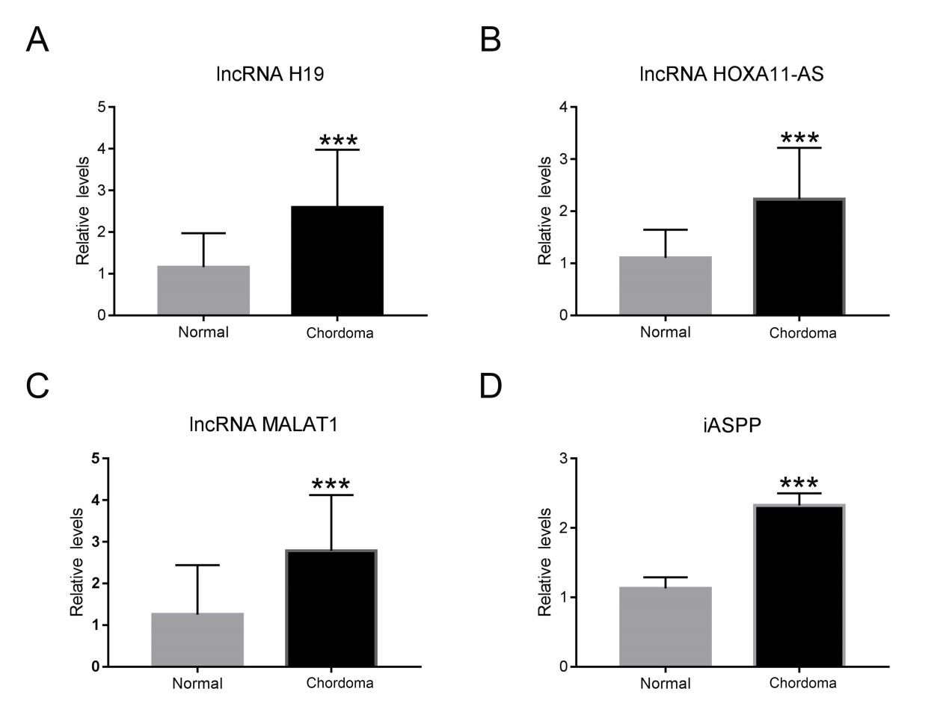
Figure S1: Expression of lncRNA H19 (A), lncRNA HOXA11-AS (B), lncRNA MALAT1 (C) and iASPP (D) was upregulated in human chordoma tissues, *** p < 0.001 vs Normal.

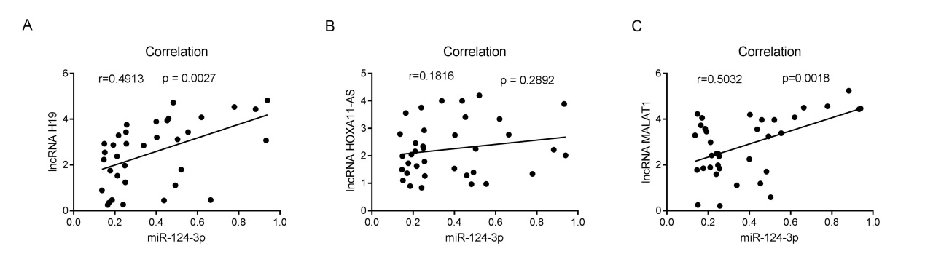
Figure S2: Correlation analysis between lncRNA (H19 (A), HOXA11-AS (B) and MALAT1(C)) and miR-124-3p in human chordoma tissues.

