Supplementary Materials
Isolation of hucMSC-Exos
The conditioned medium of hucMSCs was successively centrifuged at 400 × g for 10 min, 2000 × g for 30 min and 10,000 × g for 60 min. The supernatant was passed through a syringe filter (0.22 μm) to remove particles larger than 220 nm, and then centrifuged at 100,000 × g for 120 min to pellet exosomes. The pellet was washed with ice-cold phosphate buffer saline (PBS, pH 7.4), and then centrifuged for another 120 min at the same high speed. The resulting pure exosomes were resuspended in ice-cold PBS, and stored at –80 °C until use.
In vivo skin penetration study
Mice were anesthetized with isoflurane at concentrations of 3% for induction and 1.5% for maintenance on a small animal anaesthesia machine (R520, RWD Life Science, Shenzhen, China). Following the removal of hair shafts by an electric hair clipper, the donor chambers from Franz diffusion cells were one-to-one stuck on the backs of the mice using tissue adhesive (VetbondTM, 3M, St. Paul, MN, USA). SHSs (10 mg) suspended in PBS (100 μL) were pipetted into the donor chamber, and the skin inside was massaged as mentioned earlier. Then, 150 μL of the ExoGlow-Protein™-labeled hucMSC-Exos (1 mg/mL) was applied on the skin surface non-occlusively under dark condition. In the other group, only labeled exosomes were given without SHSs (and massage). In order to maintain the body temperature of anesthetized mice, an infrared heat lamp was used at a distance of 30 cm over the mice. Eight hours later, the mice were euthanized by CO₂ inhalation. The skin treated with exosomes were washed with PBS six times and then harvested using scissors. The skin specimens were subjected to cryosection and confocal microscopic observation following the same procedures used in the in vitro study.
Establishment of photoaged mouse model
The mice were in groups put into a flat stainless-steel cage under the lamps at a distance of around 43 cm, and exposed to UV irradiation once per day (except Thursday and Sunday) for ten weeks. Prior to each exposure, the backs of mice needed to be shaved carefully. The integrated UV irradiance was determined using a digital UV meter (290–400 nm; UV-340A, Lutron, Taiwan), and the minimal erythema dose (MED) measured on the mouse dorsal skin turned out to be around 100 mJ/cm². The irradiation dose per exposure was 1 MED for the 1st week, then increased by 1 MED weekly up to 4 MED for the 4th week, and maintained at 4 MED for the remaining weeks.
Histopathological examination
Skin samples were fixed with 4% paraformaldehyde in PBS, dehydrated in increased concentrations of ethanol solution, and then embedded in paraffin. The obtained paraffin blocks were sectioned (5 μm in thickness), and stained with hematoxylin and eosin (H&E). The sections were imaged by using an inverted light microscope (Eclipse Ts2, Nikon, Tokyo, Japan). The thickness of epidermis was measured by ImageJ software. The number of skin cells in a certain area of guinea pig dermis layer (450 μm × 150 μm) was analyzed with ImageJ software.
RNA extraction and real-time RT-PCR
Total RNA was isolated from HDFs and skin tissues by using the Trizol reagent (Invitrogen, Carlsbad, CA, USA), and cDNA was synthesized with PrimeScriptTM RT-PCR kit (Takara, Kusatsu, Shiga, Japan). Real-time RT-PCR amplification was carried out using FastStart Universal SYBR Green Master (ROX) (Roche Diagnostics, Mannheim, Germany) on a 96-well real-time PCR instrument (StepOnePlus™, Applied Biosystems, Carlsbad, CA). Primer sequences are listed in Table S1. The cycle threshold (CT) values for the individual reactions were calculated with Step One™ software v2.3 (Applied Biosystems). The gene expressions were normalized using ΔCt relative to β-actin. The expression changes were analyzed with the 2^{-ΔΔCt} method.¹
Table S1. Sequences of primers for real-time RT-PCR.
Gene | Species | Primer | Sequence (5’→3’)
Collagen I | Human | F | CACAGAGGTTTCAGTGGTTTGG
Collagen I | Human | R | GCACCAGTAGCACCATCATTTC
Collagen I | Mouse | F | CCGAACCCCAAGGAAAAGA
Collagen I | Mouse | R | CTGTTGCCTTCGCCTCTGA
MMP-1 | Human | F | TTGAGAAAGCCTTCCAACTCTG
MMP-1 | Human | R | CCGCAACACGATGTAAGTTGTA
MMP-1 | Mouse | F | AAGGCGATATTGTGCTCTCC
MMP-1 | Mouse | R | CCTCATTGTTGTCGGTCCAC
Fibronectin | Human | F | AAGATTGGAGAGAAGTGGGACC
Fibronectin | Human | R | GAGCAAATGGCACCGAGATA
Fibronectin | Mouse | F | ATGTGGACCCCTCCTGATAGT
Fibronectin | Mouse | R | GCCCAGTGATTTCAGCAAAGG
Elastin | Human | F | GGGTTGTGTCACCAGAAGCA
Elastin | Human | R | CAACCCCGTAAGTAGGAATGC
Elastin | Mouse | F | GCTGGAGGTTTAGTGCCTGG
Elastin | Mouse | R | GCTCCGTATTTGGCAGCTTT
β-Actin | Human | F | AATCGTGCGTGACATTAAGGAG
β-Actin | Human | R | ACTGTGTTGGCGTACAGGTCTT
β-Actin | Mouse | F | CTGGCTGGCCGGGACCTGAC
β-Actin | Mouse | R | CCGCTCGTTGCCAATAGTGATGAC

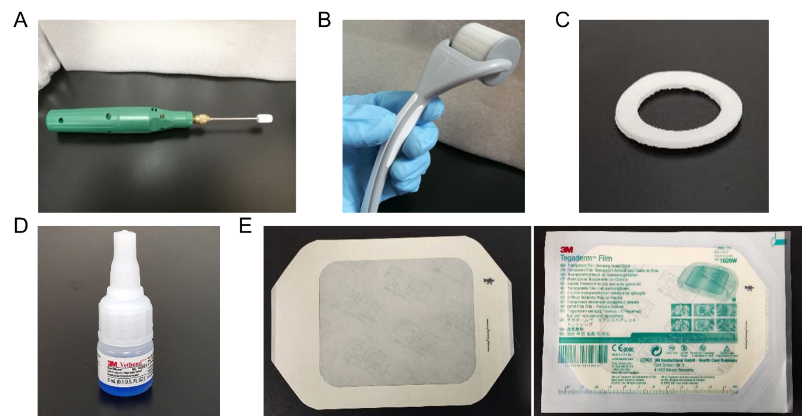
Figure S1. Some materials used in the experiments. (A) Electrical massager. (B) Dermaroller. (C) Anti-leakage plastic ring. (D) VetbondTM tissue adhesive. (E) TegadermTM transparent film dressing.
References
1. Livak KJ, Schmittgen TD. Analysis of relative gene expression data using real-time quantitative PCR and the 2(-Delta Delta C(T)) Method. Methods. 2001;25(4):402-408.

