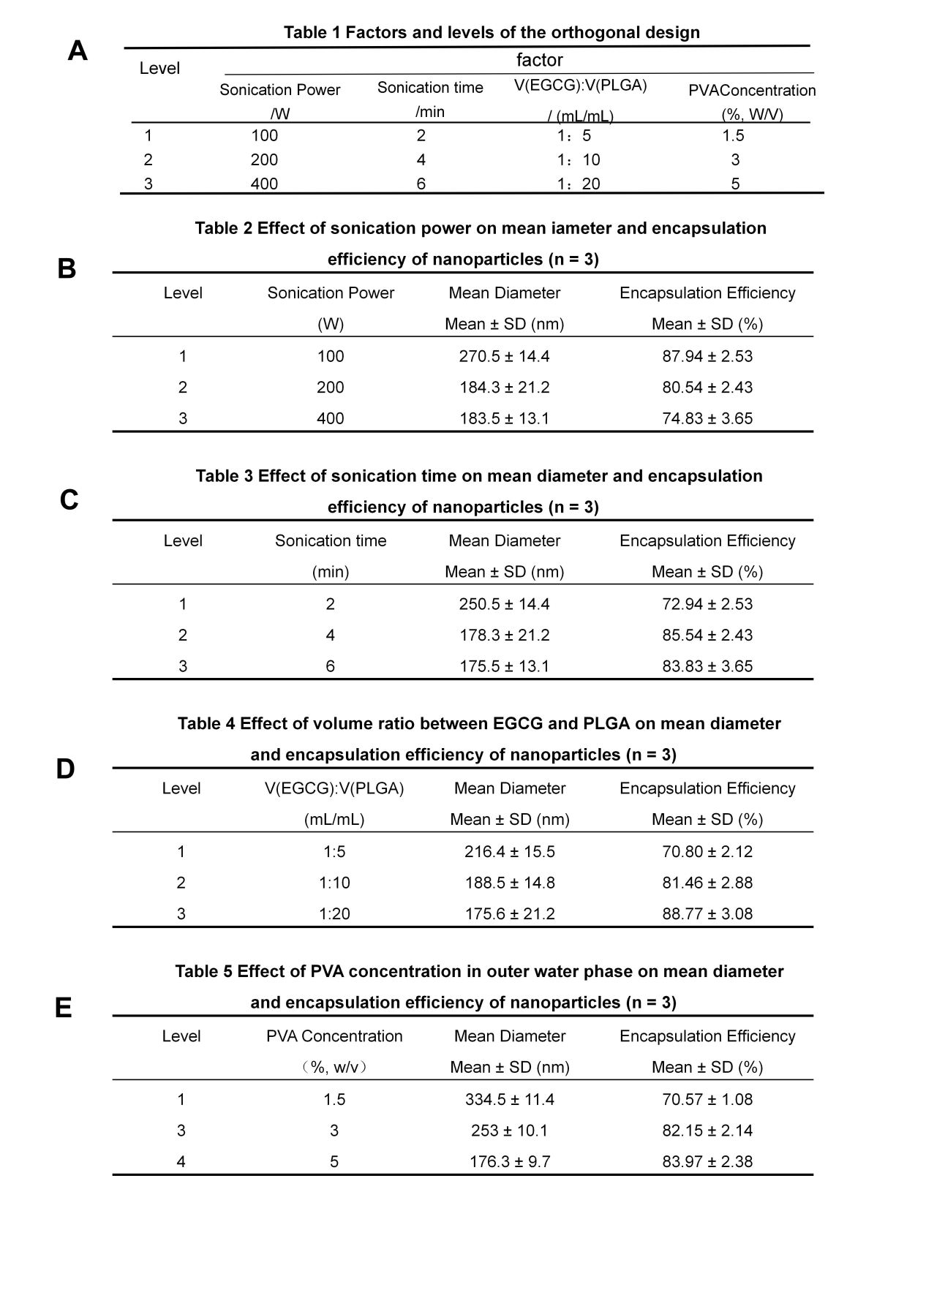
Supplementary Figure S1： Effect of various processing parameters on mean particle size and EE% . The factors and levels of the orthogonal design are listed in the table (A). (B) sonication power. (C) sonication time. (D) volume ratio between EGCG and PLGA. (E) PVA concentration.

