Supplementary materials

Figure S1

Figure S1: Flow diagram of patients taking part of study.
Abbreviations: ECOG score, Eastern Cooperative Oncology Group Performance Status Score; PSM, Propensity Score Matching.

Figure S2
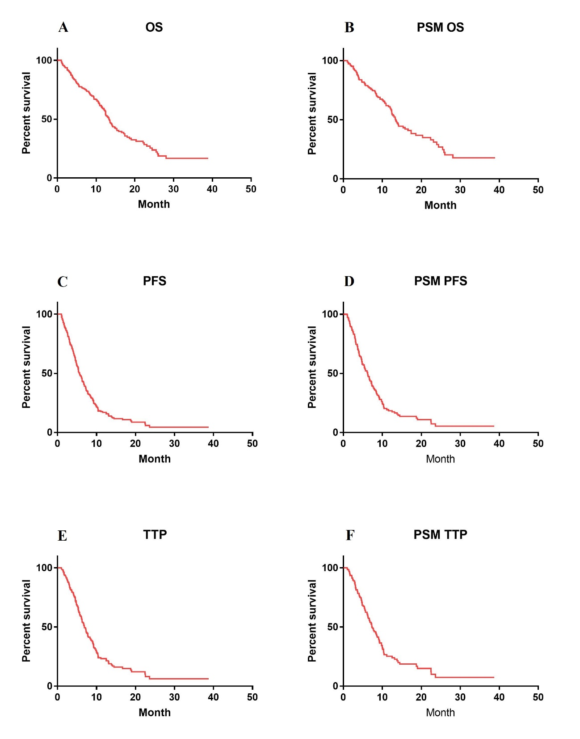
Figure S2: Overall survival (OS), progression-free survival (PFS) and time to progression (TTP) curves drawn by Kaplan–Meier method. (A) Overall survival curve of all patients (13.4m). (B) Overall survival curve of all patients after PSM (1:1) (13.4m). (C) Progression-free survival curve for all patients (5.7m). (D) Progression-free survival curve for all patients after PSM (1:1) (6.2m). (E) Time to progression curve for all patients (6.9m). (F) Time to progression curve for all patients after PSM (1:1) (7.4m).
Abbreviations: OS, overall survival; PFS, progression-free survival; TTP, time to progression; PSM, propensity score-matched.

