Supplementary information

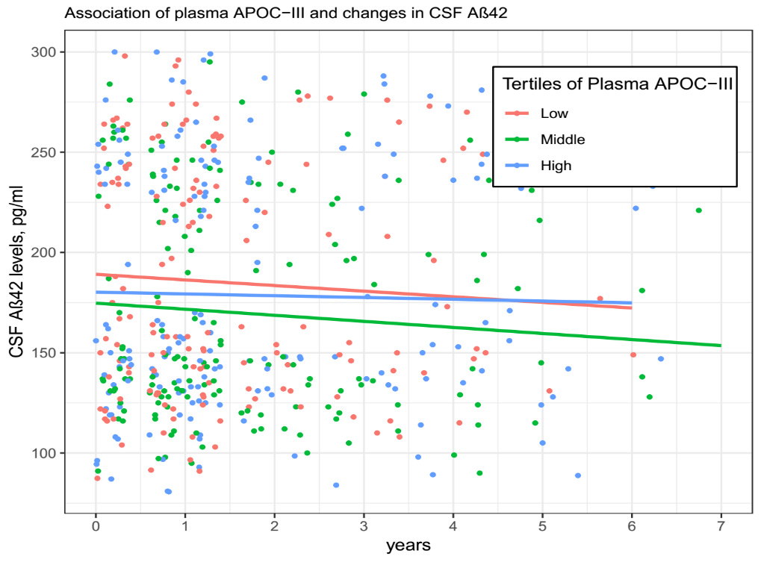

Figure S1. Associations of baseline plasma APOC-III levels with changes in CSF AD pathologies.

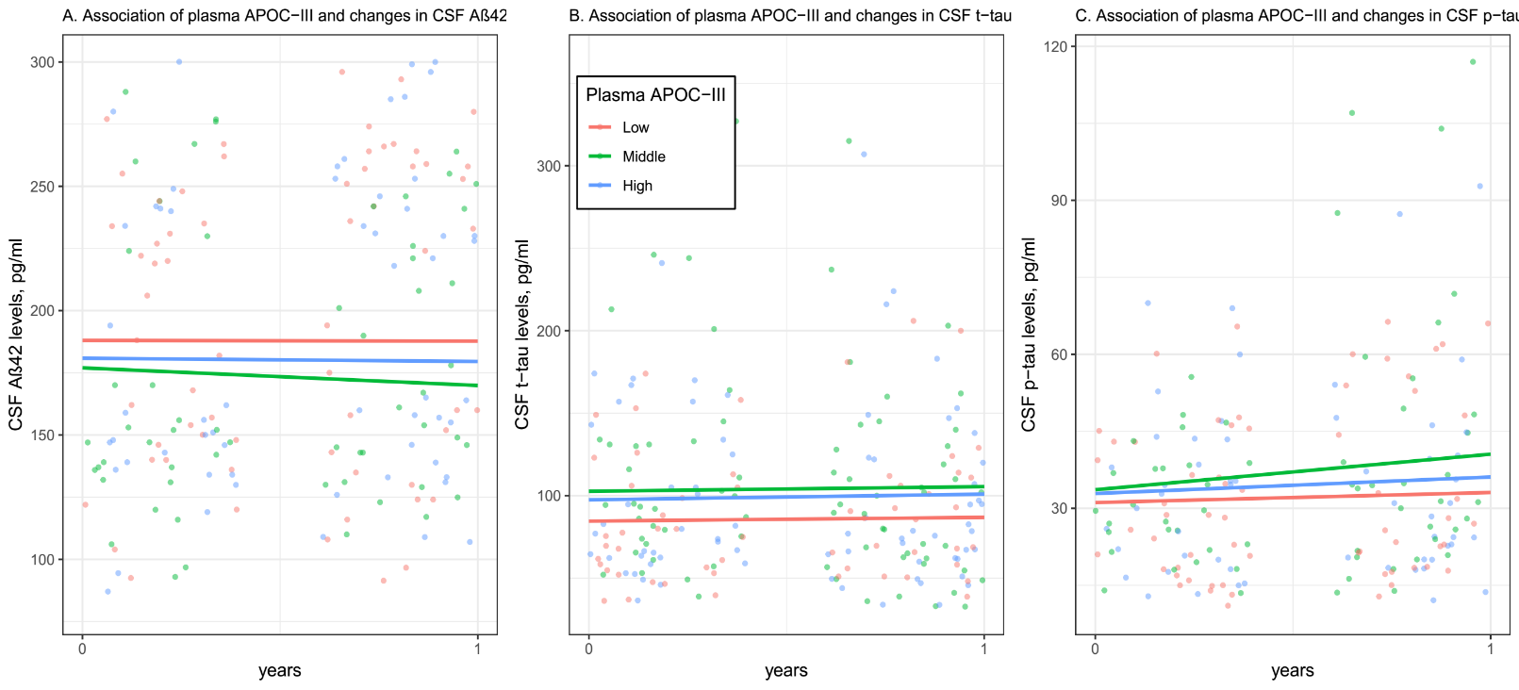
Figure S2. Associations of baseline plasma APOC-III levels with changes in CSF AD pathologies over one year.

Table S1. Summary of linear mixed models examining the associations of plasma APOC-III with changes in CSF AD pathologies over a year
Dependent variable: CSF Aβ42
Predictors | Estimate | SE | P value
Middle APOC-III × time | -6.7985 | 3.0356 | 0.0251
High APOC-III × time | -1.0215 | 3.0356 | 0.7365
Dependent variable: CSF t-tau
Predictors | Estimate | SE | P value
Middle APOC-III × time | 0.5415 | 3.3874 | 0.8730
High APOC-III × time | 1.1908 | 3.3874 | 0.7252
Dependent variable: CSF p-tau
Predictors | Estimate | SE | P value
Middle APOC-III × time | 4.9641 | 2.4948 | 0.0467
High APOC-III × time | 1.2523 | 2.4948 | 0.6147
Abbreviation: APOC-III: apolipoprotein C-III; Aβ42: β-amyloid 42; t-tau: total tau; p-tau: phosphorylated tau. Estimates are unstandardized values, representing the amount of change in each CSF AD biomarker per year. All linear mixed models were adjusted for age, education, sex and APOE4 genotype.

