Supplementary appendix
Clinical manifestations and risk factors of Streptococcus suis mortality among northern Thai population: retrospective 13-year cohort study
Ajaree Rayanakorn¹, Wasan Katip², Bey Hing Goh^{3,4}, Peninnah Oberdorfer⁵, Learn Han Lee¹
1 Novel Bacteria and Drug Discovery Research Group (NBDD), Microbiome and Bioresource Research Strength, Jeffrey Cheah School of Medicine and Health Sciences, Monash University Malaysia, Bandar Sunway, Malaysia
2 Department of Pharmaceutical Care, Faculty of Pharmacy, Chiang Mai University, Chiang Mai, Thailand
3 Biofunctional Molecule Exploratory Research Group (BMEX), Biomedicine Research Advancement Centre (BRAC), School of Pharmacy, Monash University Malaysia, Bandar Sunway, Malaysia
4 Health and Well-Being Cluster, Global Asia in the 21st Century (GA21) Platform, Monash University Malaysia, Bandar Sunway 47500, Malaysia
5 Division of Pediatric Infectious Diseases, Department of Pediatrics, Faculty of Medicine, Chiang Mai University, Chiang Mai, Thailand

Table S1 List of Northern provinces of Thailand as of 2018 (National Statistics Office (NSO). [cited 2019 22 July]; Available from: http://www.nso.go.th/sites/2014/nsopublic)
Upper Northern Thailand | Lower Northern Thailand
Chiang Rai | Tak
Chiang Mai | Kamphaeng Phet
Nan | Nakhon Sawan
Phayao | Phetchabun
Phrae | Phichit
Mae Hong Son | Phitsanulok
Lumphun | Sukhothai
Lampang | Uthai Thani
Uttaradit

Figure S1 Biochemical test protocol for identification of Streptococcus suis strains

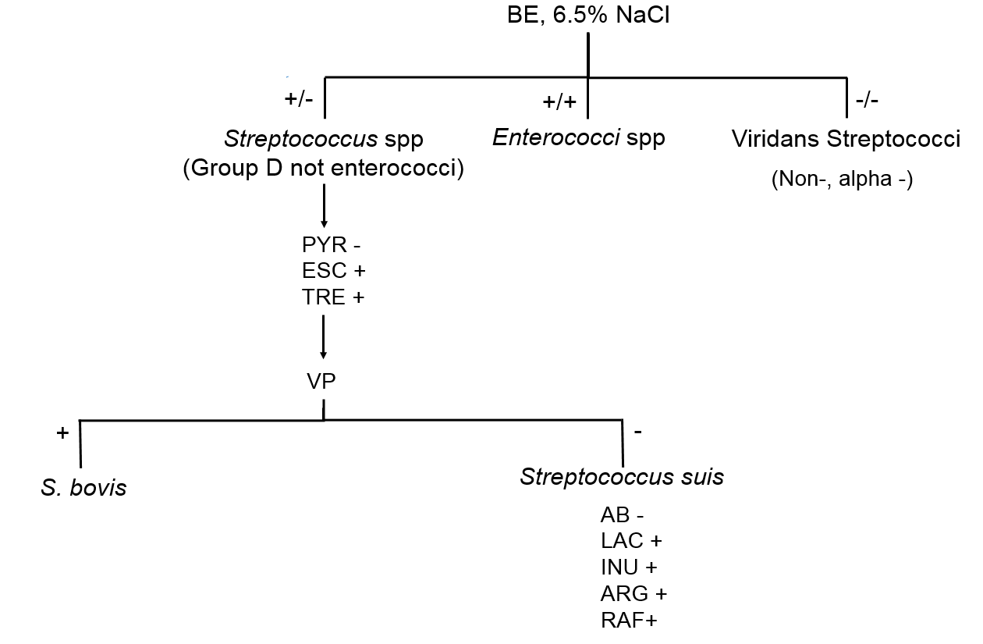
Streptococcus suis strains is alpha-hemolysis in sheep blood agar with no growth in broth with 6.5% NaCl and positive in esculine, trehalose reactions, negative in Voges-Proskauer, pyrrolidonyl arylamidase with following biochemical characteristics: acid fermentation of lactose, inulin, raffinose broth, hydrolysis of L-arginine, no acid fermentation of arabinose.
Abbreviations: BE, bile esculin, PYR, pyrrolidonyl arylamidase, ESC, esculin, TRE, D-Trehalose, VP, Voges-Proskauer, AB, arabinose, LAC, D-Lactose, INU, inulin, ARG, L-arginine, RAF, D-raffinose

Table S2 Significant predictors of S. suis mortality
Predictors | Multivariable analysis |  |  | Multivariable analysis
 | Adjusted OR | 95% CI | p-value | Adjustedª OR | 95% CI | p-value
GCS <8 | 1.71 | 0.10-28.50 | 0.709 | - | - | -
Time to microbiological cure > 6 days | 43.57 | 2.46-772.80 | 0.010 | 33.19 | 2.82-386.10 | 0.005
ALD | 2.24 | 0.32-15.84 | 0.417 | - | - | -
Acute meningitis | 0.24 | 0.03-2.33 | 0.236 | - | - | -
Septic shock | 13.34 | 1.63-109.03 | 0.016 | 13.61 | 2.57-72.00 | 0.002
Direct bilirubin >1.5 mg/dl | 12.86 | 1.91-86.59 | 0.009 | 17.06 | 2.73-106.47 | 0.002
Creatinine >1.8 mg/dl | 0.41 | 0.01-6.49 | 0.414 | - | - | -
Bicarbonate <18 mmol/L | 3.00 | 0.12-73.62 | 0.500 | - | - | -
Albumin <3.5 g/dl | 10.97 | 0.96-125.81 | 0.054 | 23.46 | 2.44-225.92 | 0.006

Note: Significant predictors were indicated in bold.
ª Forward and backward stepwise logistic regression with p-value <0.05

