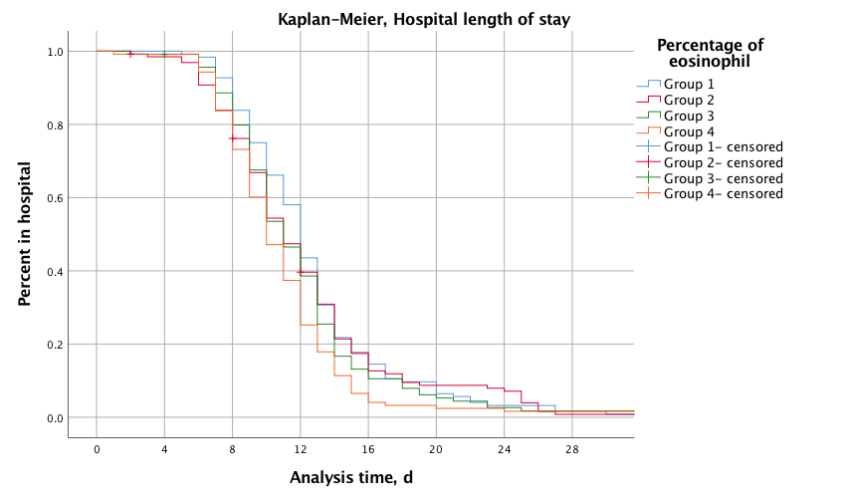
Figure S1 Hospital length of stay according to quartile-percentage of eosinophil cohorts. Kaplan-
Meier analysis of length of hospital stay in quartile-percentage of eosinophil cohorts.

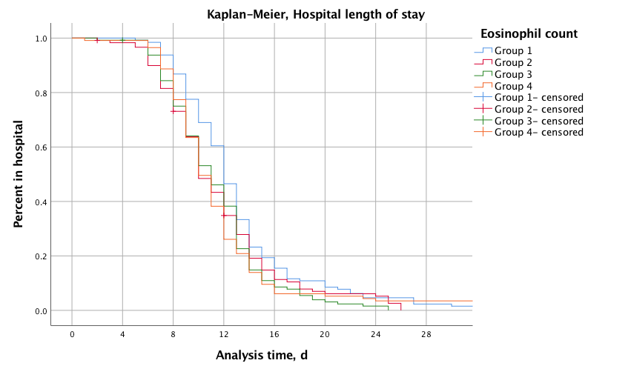
Figure S2 Hospital length of stay according to quartile-count of eosinophil cohorts. Kaplan-
Meier analysis of length of hospital stay in quartile-count of eosinophil cohorts.

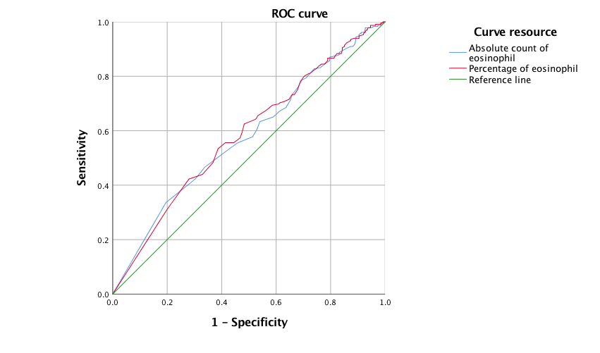
Figure S3 The receiver operating characteristic (ROC) curve analysis for length of hospital stay of peripheral blood eosinophil.

Percentage of eosinophil | 25.0% |  | 50.0% |  | 75.0%
Percentage of eosinophil | Estimate | Std. Error | Estimate | Std. Error | Estimate | Std. Error
1 | 14.000 | 0.574 | 12.000 | 0.307 | 9.000 | 0.438
2 | 14.000 | 0.540 | 11.000 | 0.485 | 9.000 | 0.486
3 | 14.000 | 0.318 | 11.000 | 0.484 | 9.000 | 0.417
4 | 13.000 | 0.354 | 10.000 | 0.395 | 8.000 | 0.339
Overall | 14.000 | 0.184 | 11.000 | 0.243 | 9.000 | 0.214
Table S1 Quartiles for hospital length of stay in percentage of peripheral blood eosinophil cohorts.
 | Chi-Square | df | Sig.
Log Rank (Mantel-Cox) | 9.542 | 3 | 0.023
Breslow (Generalized Wilcoxon) | 11.470 | 3 | 0.009
Tarone-Ware | 11.702 | 3 | 0.008
Table S2 Overall Comparison of hospital length of stay in percentage of peripheral blood eosinophil cohorts.
Group | 25.0% |  | 50.0% |  | 75.0%
Group | Estimate | Std. Error | Estimate | Std. Error | Estimate | Std. Error
1 | 14.000 | 0.533 | 12.000 | 0.324 | 10.000 | 0.457
2 | 14.000 | 0.466 | 10.000 | 0.451 | 8.000 | 0.458
3 | 13.000 | 0.316 | 11.000 | 0.513 | 8.000 | 0.377
4 | 13.000 | 0.467 | 10.000 | 0.370 | 9.000 | 0.356
Overall | 14.000 | 0.184 | 11.000 | 0.243 | 9.000 | 0.214
Table S3 Quartiles for hospital length of stay in absolute count of peripheral blood eosinophil cohorts.
 | Chi-Square | df | sig.
Log Rank (Mantel-Cox) | 8.633 | 3 | 0.035
Breslow (Generalized Wilcoxon) | 12.777 | 3 | 0.005
Tarone-Ware | 11.701 | 3 | 0.008
Table S4 Overall Comparison of hospital length of stay in absolute count of peripheral blood eosinophil cohorts.

Variable | AUC | Std. Error | Progressive Sig. | Progressive 95% CI
 |  |  |  | Lower | Upper
Percentage of eosinophil | 0.585 | 0.026 | 0.001 | 0.535 | 0.635
Absolute count of eosinophil | 0.579 | 0.026 | 0.003 | 0.528 | 0.629
Table S5 The area under the curve (AUC) for length of hospital stay of peripheral blood eosinophil.

Groups |  | Eosinophil < 2% | Eosinophil ≥2% | P value
Participants, n |  | 342 | 151 | -
Stay of hospital, median (IQR) |  | 11(9-14) | 11(9-13) | 0.036
ICU admission, n (%) |  | 5(1.5) | 1(0.7) | 0.672*
Mortality, n (%) |  | 5(1.5) | 1(0.7) | 0.672*
Comorbidity, n (%) | Cardiovascular disease | 263(76.9) | 108(71.5) | 0.202
 | Ischemic heart disease | 52(18.4) | 21(13.9) | 0.230
 | Heart failure | 145(45.4) | 43(28.5) | 0.003
 | Hypertension | 143(41.8) | 64(42.4) | 0.906
 | Peripheral vascular disease | 42(12.3) | 21(13.9) | 0.618
 | Arrhythmia | 56(16.4) | 22(14.6) | 0.630
 | Diabetes | 59(17.3) | 22(14.6) | 0.459
 | Bronchiectasis | 64(18.4) | 23(15.2) | 0.350
 | Respiratory failure | 163(47.7) | 51(33.8) | 0.004
 | Pulmonary heart disease | 150(43.9) | 53(35.1) | 0.068
Mechanical ventilation, n (%) | NIMV | 111(32.5) | 36(23.8) | 0.054
 | IMV | 3(0.9) | 1(0.7) | 1.000
 | Duration of NIMV | 0(0-128.25) | 0(0) | 0.071
Table S6 Comparison of clinical outcomes of hospitalized AECOPD classified by percentage of peripheral blood eosinophil ≥2%. IQR, interquartile range: 25%–75%; *, Fisher's exact probability method; n, number; ICU, intensive care unit; NIMV, noninvasive mechanical ventilation; IMV, invasive mechanical ventilation.

 |  | Eosinophil < 100cell/ul | Eosinophil ≥ 100 cell/ul | P value
Participants, n |  | 316 | 177 | -
Stay of hospital, median (IQR) |  | 11(9-14) | 11(8.5-13) | 0.053
ICU admission, n (%) |  | 5(1.6) | 1(0.6) | 0.472*
Mortality, n (%) |  | 4(1.3) | 2(1.1) | 1.000*
Comorbidity, n (%) | Cardiovascular disease | 246(77.8) | 125(70.6) | 0.074
 | Ischemic heart disease | 47(14.9) | 26(14.7) | 0.956
 | Heart failure | 134(42.4) | 54(30.5) | 0.009
 | Hypertension | 133(42.1) | 74(41.8) | 0.952
 | Peripheral vascular disease | 39(12.3) | 24(13.6) | 0.698
 | Arrhythmia | 52(16.5) | 26(14.7) | 0.606
 | Diabetes | 54(17.1) | 27(15.3) | 0.598
 | Bronchiectasis | 59(18.7) | 28(15.8) | 0.426
 | Respiratory failure | 152(48.1) | 62(35.0) | 0.005
 | Pulmonary heart disease | 143(45.3) | 60(33.9) | 0.014
Mechanical ventilation, n (%) | NIMV | 106(33.5) | 41(23.2) | 0.016
 | IMV | 3(0.9) | 1(0.6) | 1.000
 | Duration of NIMV | 0(0-141.5) | 0(0) | 0.020
Table S7 Comparison of clinical outcomes of hospitalized AECOPD classified by absolute count of peripheral blood eosinophil ≥ 100 /µL.IQR, interquartile range: 25%–75%; *, Fisher's exact probability method; n, number; ICU, intensive care unit; NIMV, noninvasive mechanical ventilation; IMV, invasive mechanical ventilation.

 |  | Eosinophil < 300cell/ul | Eosinophil ≥ 300 cell/ul | P value
Participants, n |  | 450 | 43 | -
Stay of hospital, median (IQR) |  | 11(9-14) | 11(8-13) | 0.172
ICU admission, n (%) |  | 5(1.1) | 1(2.3) | 0.423*
Mortality, n (%) |  | 6(1.3) | 0(0) | 1.000*
Comorbidity, n (%) | Cardiovascular disease | 342(76.0) | 29(60.4) | 0.214
 | Ischemic heart disease | 67(14.9) | 6(14.0) | 0.869
 | Heart failure | 178(39.6) | 10(23.3) | 0.036
 | Hypertension | 186(41.3) | 21(48.8) | 0.341
 | Peripheral vascular disease | 56(12.4) | 7(16.3) | 0.472
 | Arrhythmia | 73(16.2) | 5(11.6) | 0.430
 | Diabetes | 75(16.7) | 6(14) | 0.646
 | Bronchiectasis | 81(18) | 6(14) | 0.506
 | Respiratory failure | 200(44.4) | 14(32.6) | 0.133
 | Pulmonary heart disease | 193(42.9) | 10(23.3) | 0.012
Mechanical ventilation, n (%) | NIMV | 138(30.7) | 9(20.9) | 0.182
 | IMV | 3(0.7) | 1(2.3) | 0.307
 | Duration of NIMV | 0(0-110) | 0(0) | 0.018
Table S8 Comparison of clinical outcomes of hospitalized AECOPD classified by absolute count of peripheral blood eosinophil ≥ 300 /µL.IQR, interquartile range: 25%–75%; *, Fisher's exact probability method; n, number; ICU, intensive care unit; NIMV, noninvasive mechanical ventilation;
IMV, invasive mechanical ventilation.

Model |  | Collinearity diagnosis ª
Model |  | Tolerance |  | VIF
1 | Neutrophil % | 0.719 |  | 1.390
 | Eosinophil % | 0.719 |  | 1.390
2 | Neutrophil count | 0.972 |  | 1.029
 | Eosinophil count | 0.972 |  | 1.029
3 | Neutrophil % | 0.816 |  | 1.226
 | Eosinophil count | 0.816 |  | 1.226
4 | Neutrophil count | 0.899 |  | 1.112
 | Eosinophil % | 0.899 |  | 1.112
a. Variable：stay of hospital
Table S9 Collinearity diagnosis of the eosinophil count, neutrophil count, percentage of eosinophil and neutrophil variable on stay of hospital.

