Supplementary Table 1 Extended sample characteristics and comparisons between groups

Variable | HC | MCI-nonAD | MCI-AD | ADD | Group comparisons p-value | HC vs  MCI-nonAD  p-value | HC vs  MCI-AD  p-value | HC vs  ADD  p-value | ADD vs  MCI-nonAD  p-value | ADD vs  MCI-AD  p-value | MCI-nonAD  vs MCI-AD  p-value
Numbers | 14 | 8 | 8 | 12
Sex (male:female) | 6:8 (42.9%:57.1%) | 7:1 (87.5%:12.5%) | 4:4  (50.0%:50.0%) | 6:6  (50.0%:50.0%) | 0.229 | n. a. | n. a. | n. a. | n. a. | n. a. | n. a.
Caffeine (yes:no) | 14:0 (100.0%:0.0%) | 6:2 (75.0%:25.0%) | 6:2  (75.0%:25.0%) | 9:3  (75.0%:25.0%) | 0.139 | n. a. | n. a. | n. a. | n. a. | n. a. | n. a.
Nicotine (yes:no) | 1:13 (7.1%:92.9%) | 3:5 (37.5%:62.5%) | 1:7  (12.5%:87.5%) | 1:11  (8.3%:91.7%) | 0.278 | n. a. | n. a. | n. a. | n. a. | n. a. | n. a.
Arterial hypertension (present:absent) | 6:8 (42.9%:57.1%) | 3:5  (37.5%:62.5%) | 3:5  (37.5%:62.5%) | 7:5  (58.3%:41.7%) | 0.816 | n. a. | n. a. | n. a. | n. a. | n. a. | n. a.
Treatment for hypertension (yes:no) | 6:8 (42.9%:57.1%) | 3:5  (37.5%:62.5%) | 3:5  (37.5%:62.5%) | 7:5  (58.3%:41.7%) | 0.816 | n. a. | n. a. | n. a. | n. a. | n. a. | n. a.
AChEI treatment (yes:no) | 1:13 (7.1%:92.9%) | 1:7  (12.5%:87.5%) | 6:2  (75%:25%) | 8:4  (66.7%:33.3%) | <0.001 | 0.364 | <0.001 | <0.001 | 0.028 | 1.000 | 0.041
Variable mean ± SD (range)
Age at examination (in years) | 65.4 ± 7.85 (54.0-78.0) | 66.0 ± 11.40 (45.0-82.0) | 66.3 ± 9.74  (51.0-77.0) | 71.3 ± 9.49  (54.0-84.0) | 0.333 | n. a. | n. a. | n. a. | n. a. | n. a. | n. a.
Z-Score MMSE | -0.2 ± 1.09  (–2.4-1.2) | -0.5 ± 0.83  (–1.8- 1.0) | -2.9 ± 1.94  (–5.8- -0.1) | -9.9 ± 7.08  (–21.9- -1.6) | <0.001 | 0.330 | <0.001 | <0.001 | <0.001 | 0.016 | 0.007
CERAD-Sumscore | 85.8 ± 8.60 (68.0-97.0) | 72.0 ± 12.69 (47.0-86.0) | 69.3 ± 8.97  (55.0-80.0) | 47.8 ± 14.43  (25.0-79.0) | <0.001 | 0.006 | 0.001 | <0.001 | 0.004 | 0.003 | 0.645
CDR global | 0.0 ± 0.00 (0.0-0.0) | 0.5 ± 0.00  (0.5-0.5) | 0.5 ± 0.00  (0.5-0.5) | 1.3 ± 0.45  (1.0-2.0) | <0.001 | <0.001 | <0.001 | <0.001 | <0.001 | <0.001 | 1.000
CDR-SOB | 0.0 ± 0.00 (0.0-0.0) | 1.6 ± 0.95  (0.5-2.5) | 2.8 ± 1.16  (0.5-4.0) | 6.1 ± 2.84  (3.5-14.0) | <0.001 | <0.001 | <0.001 | <0.001 | <0.001 | <0.001 | 0.038
Awake for (in hours) | 6.4 ± 1.05 (4.8-8.0 | 7.7 ± 1.76  (5.3-10.5) | 6.1 ± 0.95  (5.0-7.5) | 6.4 ± 1.06  (4.5-8.0) | 0.208 | n. a. | n. a. | n. a. | n. a. | n. a. | n. a.
Duration of sleep last night (in hours) | 7.9 ± 0.82 (6.8-10.0) | 7.4 ± 1.88  (4.8-9.5) | 8.3 ± 1.29  (6.5-10.0) | 8.7 ± 1.11  (6.5-10.0) | 0.194 | n. a. | n. a. | n. a. | n. a. | n. a. | n. a.
Variable median mean ± SD (range)
Mean RI MCA right | 0.559  0.56 ± 0.059 (0.482-0.673) | 0.562  0.55 ± 0.081 (0.377-0.654) | 0.595  0.60 ± 0.073  (0.497-0.738) | 0.614  0.61 ± 0.066  (0.496-0.703) | 0.183 | n. a. | n. a. | n. a. | n. a. | n. a. | n. a.
Mean RI MCA left | 0.540  0.56 ± 0.064  (0.489-0.735) | 0.582  0.56 ± 0.082 (0.386-0.657) | 0.617  0.59 ± 0.091  (0.447-0.696) | 0.589  0.61 ± 0.049  (0.551-0.700) | 0.293 | n. a. | n. a. | n. a. | n. a. | n. a. | n. a.
Mean PI MCA right | 0.763  0.79 ± 0.135  (0.613-1.033) | 0,780  0.80 ± 0.210 (0.430-1.152) | 0,867  0.89 ± 0.218  (0.589-1.317) | 0.880  0.90 ± 0.213  (0.629-1.320) | 0.575 | n. a. | n. a. | n. a. | n. a. | n. a. | n. a.
Mean PI MCA left | 0.763  0.82 ± 0.192  (0.586-1.301) | 0.789  0.79 ± 0.192 (0.468-1.049) | 0.899  0.85 ± 0.218  (0.506-1.062) | 0.870  0.93 ± 0.190  (0.735-1.353) | 0.370 | n. a. | n. a. | n. a. | n. a. | n. a. | n. a.

Notes: For continuous variables p-values for group comparisons were calculated using Kruskal-Wallis test with post-hoc pairwise comparisons using Mann-Whitney U test where appropriate. For categorical variables p-values for linear by linear association and if appropriate pairwise comparisons were calculated using Fisher’s exact test

Abbreviations: SD: Standard deviation; Caffeine/Nicotine (yes:no): consumption of caffeine/nicotine on day of examination; AChEI: treatment with acetylcholinesterase inhibitor; z-score MMSE: z-score of the Mini-Mental state examination subtest of CERAD Neuropsychological Assessment Battery; CDR-SOB: Clinical dementia rating scale sum of boxes; RI: Resistance Index; PI: Pulsatility Index; MCA: middle cerebral artery; HC: healthy controls; ADD: Alzheimer’s dementia, MCI: Mild cognitive impairment; MCI-nonAD: MCI with biomarkers not indicative for Alzheimer’s disease, MCI-AD: MCI with biomarkers indicative for Alzheimer’s disease

Supplementary Table 2: AV ratio in healthy controls and subjects with Alzheimer’s dementia

AV ratio of HC (mean value ± SD (range)) | AV ratio of ADD (mean value ± SD (range)) | p-value
0.769 ± 0.053 (0.670-0.833) | 0.792 ± 0.059 (0.718-0.930) | 0.308

Notes: p-value calculated from Mann-Whitney U test
Abbreviations: AV-ratio: retinal arteriolar-venular ratio; HC: healthy controls; SD: standard deviation; ADD Alzheimer’s dementia

Supplementary Figure 1: Diagram displaying progress of participants.
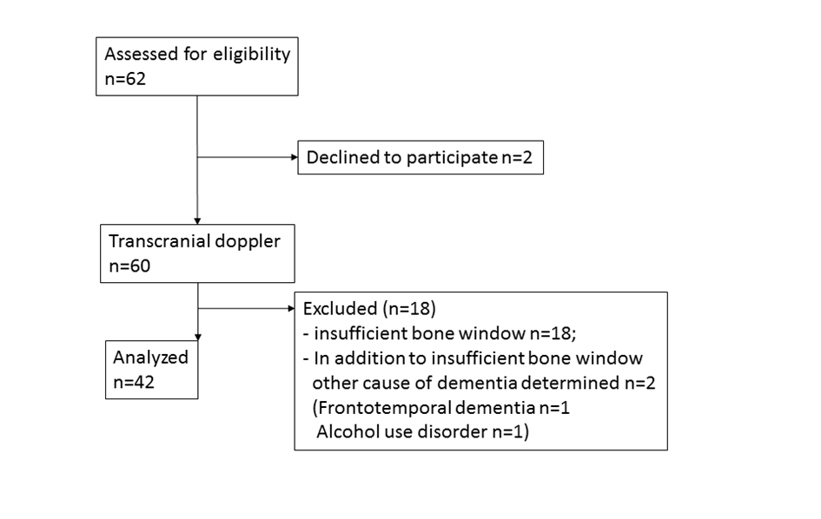
Abbreviations: n: numbers of participants

Supplementary Figure 2: Resistance and pulsatility indices middle cerebral artery for HC, MCI-non-AD, MCI-AD, ADD

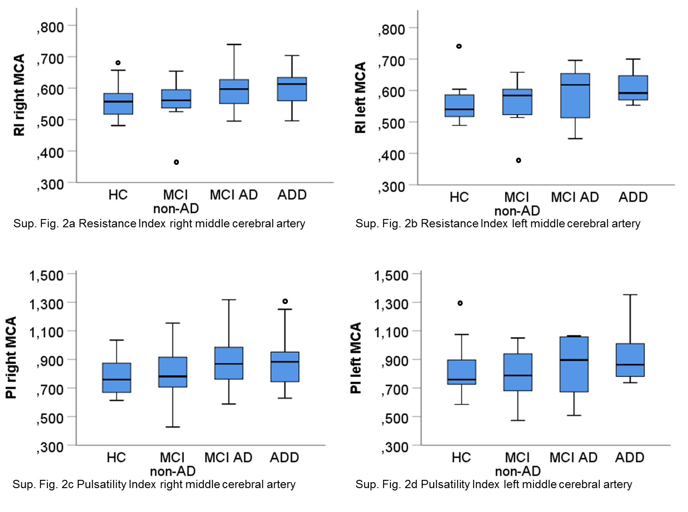
Abbreviations: RI: resistance index; PI: pulsatility index; MCA: middle cerebral artery; HC: healthy controls; MCI non-AD: mild cognitive impairment with biomarkers not indicative for Alzheimer’s disease; MCI AD: mild cognitive impairment with biomarkers indicative for Alzheimer’s disease; ADD: Alzheimer’s disease dementia

Supplementary Figure 3: additional ROC analyses for clustered data.

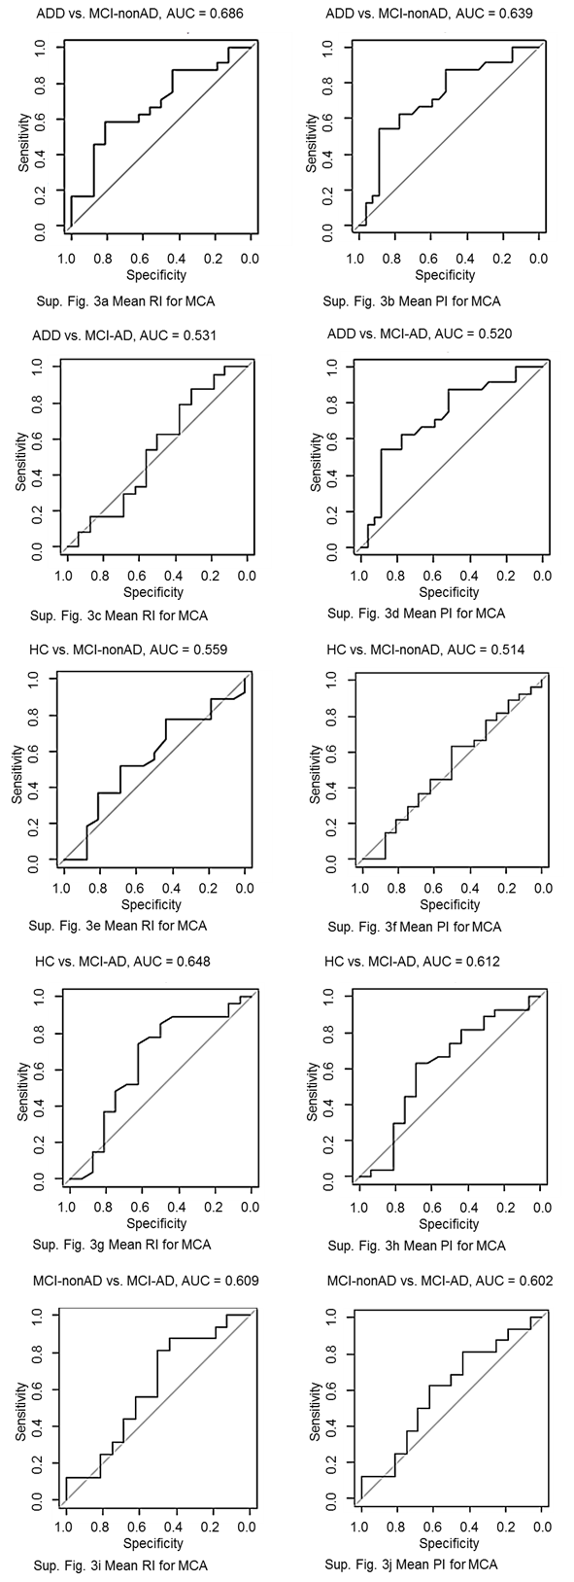

Abbreviations: ADD: Alzheimer’s disease dementia; MCI non-AD: mild cognitive impairment with biomarkers not indicative for Alzheimer’s disease; MCI-AD: mild cognitive impairment with biomarkers indicative for Alzheimer’s disease; HC: healthy controls; AUC: area under the curve; RI: resistance index; PI: pulsatility index; MCA: middle cerebral artery

