Supporting Information
Apoptosis-promoting effect of rituximab-conjugated magnetic nanoprobes on malignant lymphoma cells with CD20 overexpression
Lina Song^{1, 2,} Wei Zhang³, Hong Chen⁴, Xizhi Zhang¹, Haoan Wu¹, Ming Ma¹, Zhongqiu Wang², Ning Gu¹,* and Yu Zhang ¹,*

¹ State Key Laboratory of Bioelectronics, Jiangsu Key Laboratory for Biomaterials and Devices, School of Biological Science and Medical Engineering & Collaborative Innovation Centre of Suzhou Nano Science and Technology, Southeast University, Nanjing 210096, P. R. China.
² Department of Radiology, Affiliated Hospital of Nanjing University of Chinese Medicine, Nanjing 210029, P. R. China
³ The Jiangsu Province Research Institute for Clinical Medicine, the First Affiliated Hospital with Nanjing Medical University, Nanjing 210009, P. R. China
⁴ Department of Gastroenterology, Zhongda Hospital, School of Medicine, Southeast University, Nanjing 210009, P. R. China
* Corresponding author: Ning Gu, Ph.D. Professor and Yu Zhang, Ph.D.Professor
Tel: (86) 25-8327,2496.
E-mail: zhangyu@seu.edu.cn; guning@seu.edu.cn

The determination of Fe concentration in the aqueous solution of Fe₃O₄ @DMSA nanoparticles and Fe₃O₄@DMSA@Ab nanoprobes
The Fe concentration in the aqueous solution of Fe₃O₄ nanoparticles and Fe₃O₄@DMSA@Ab nanoprobes were measured via the phenanthroline method on a UV-visible spectrophotometer (UV-3600, Japan). A calibration curve was established under standard protocol with 1.10-phenanthroline spectrophotometric method.¹ Briefly, a certain amount of Fe standard solution (0, 10, 20, 40, 60, 80,100 μg) was added to each volumetric flask (50 ml). Hydrochloric acid (6M, 2ml) was served as acid digestion agent to dissociate Fe (or Fe₃O₄ nanoparticles in the Fe concentration detection). The acid digestion was performed under sonication for 20min. Then Fe³⁺ iron was reduced to Fe²⁺ by hydroxylamine hydrochloride (10%, 1ml). 1.10-phenanthroline aqueous solution (0.1%, 2ml) and sodium acetate buffer (pH 5.0, 5ml) were added in sequence to form the Fe²⁺- 1.10-phenanthroline compound. Dilute with distilled water to volume, the absorbance of Fe²⁺- 1.10-phenanthroline compound at 510 nm was measured after standing for at least 20 min. The standard curve was graphed with the amount of Fe standard solution (0, 10, 20, 40, 60, 80,100 μg) as abscissa, the absorbance value of Fe²⁺- 1.10-phenanthroline compound as ordinate (Figure S1A). After knowing the absorbance of a Fe₃O₄@DMSA nanoparticles sample after treated following the above protocol, the concentration of Fe in Fe₃O₄@DMSA nanoparticles (or Fe₃O₄@DMSA@Ab nanoprobes) sample can be read according to the standard curve. Each sample was tested in triplicate. The average value with standard deviation was recognized as the concentration of Fe in Fe₃O₄@DMSA nanoparticles sample.
Antibody quantification of Fe₃O₄@DMSA@Ab nanoprobes by enhanced BCA assay
The original reaction fluid of Fe₃O₄@DMSA@Ab nanoprobe without BSA blocking was purified by gel chromatography (GE sephacryl s-300). The initial 1 mL of percolate of the Fe₃O₄@DMSA@Ab nanoprobes was collected. The following percolates were collected every milliliter to detect the amount of un-coupling antibodies using UV-visible spectrophotometer (UV-3600, Japan) and enhanced BCA assay kit (Beyotime Biotechnology). Briefly, every milliliter of percolates was analyzed qualitatively, as shown in Figure S1B-D. The uncoupling antibodies were separated completely with the Fe₃O₄@DMSA@Ab nanoprobes, which was defined as the zeroth milliliter percolate. And it is obvious that all the uncoupling antibodies were in the fifth percolate.
The main principle of protein quantitative BCA method is that the peptide bond in protein can reduce Cu²⁺ to form a stable complex compound with diquinolinic acid. The complex compound has a characteristic absorption peak at 562 nm. The absorption value is proportional to the protein concentration. The testing procedure was as follows: regent A (containing diquinolinic acid) and reagent B (containing Cu²⁺) in the kit were mixed into working fluid by volume ration of 50:1. Different concentrations of protein standard solution were prepared. They (100 µL) were mixed with BCA working solution ( 1 mL) respectively. The absorption value of these mixture was determined at 562 nm after 30 min ( 37 °C water bath) to draw standard curve. The fifth percolate ((100 µL) were mixed with BCA working solution ( 1 mL) and standing at 37°C for 30min. Then the absorbance value at 562 nm was measured and calculated according to the standard curve to get the concentration of antibody in the fifth percolate. Subtract the amount of antibodies in the percolate from the total amount of antibodies, the amount of antibody conjugated on the surface of Fe₃O₄@DMSA nanoparticles can be obtained.

Supplementary Figure legends.
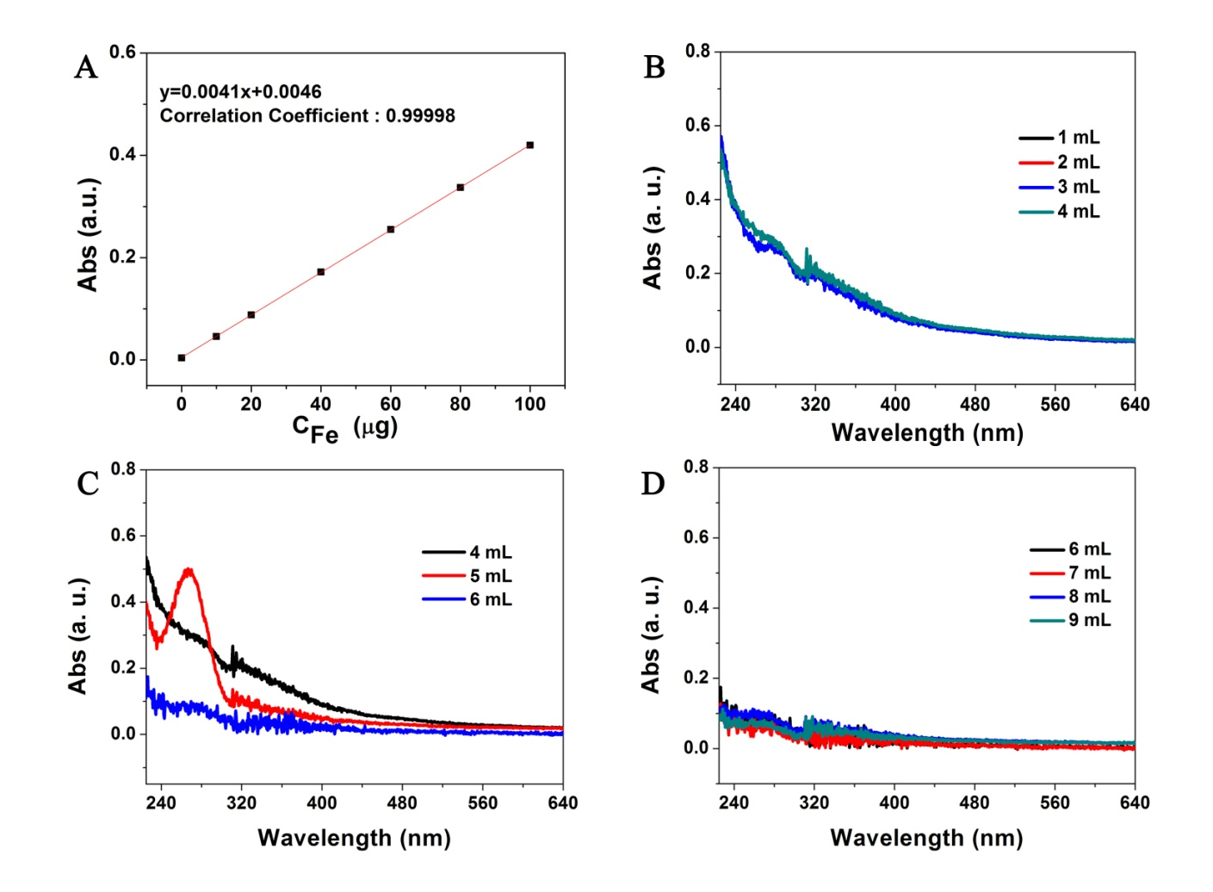
Figure S1. The standard curve was graphed with the amount of Fe standard solution as abscissa, the absorbance value of Fe²⁺- 1.10-phenanthroline compound as ordinate. Every milliliter of nanoprobe percolates was analyzed qualitatively by UV spectrum. The UV-vis absorption spectra of the first to the forth milliliter of percolates (B), the forth to the sixth milliliter of percolate (C) and the sixth to the ninth milliliter of percolate (D).

Figure S2. The hydrodynamic size variation in volume of Fe₃O₄@DMSA (A) and Fe₃O₄@DMSA@Ab (B) in distilled water during a month. The hydrodynamic size variation of Fe₃O₄@DMSA (C) and Fe₃O₄@DMSA@Ab (D) in cell culture medium RPMI-1640 within 24h. And the zeta potential of Fe₃O₄@DMSA nanoparticles and Fe₃O₄@DMSA@Ab nanoprobes (E).

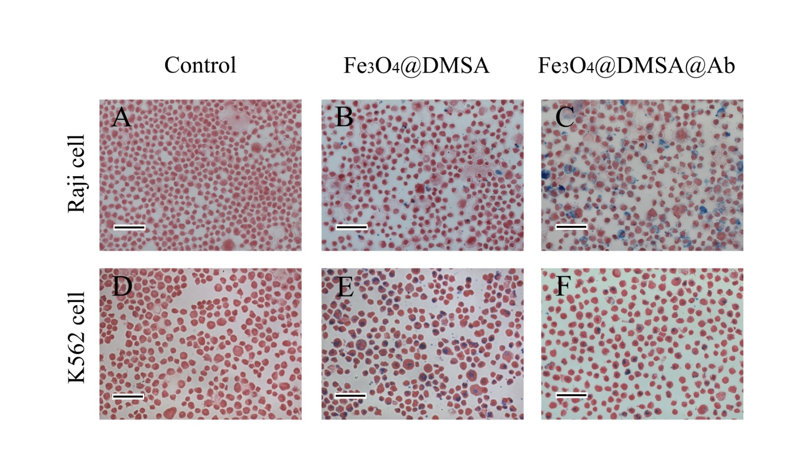
Figure S3. Microphotography of Raji and K562 cells labeled with Fe₃O₄@DMSA and Fe₃O₄@DMSA@Ab for 24 h to visualize the targeting effect (Scale bar 100 μm). Raji cells were cultured in RPMI-1640 medium (A) only, with Fe₃O₄@DMSA nanoparticles in the medium (B), or with Fe₃O₄@DMSA@Ab in the medium (C). K562 cells were cultured in IMDM medium (D) only, with Fe₃O₄@DMSA nanoparticles in the medium (E), or with Fe₃O₄@DMSA@Ab in the medium (F).

Figure S4. Cytotoxicity of BB buffer on Raji and K562 cells after culturing for 24 h and 72 h, which was detected by CCK-8.

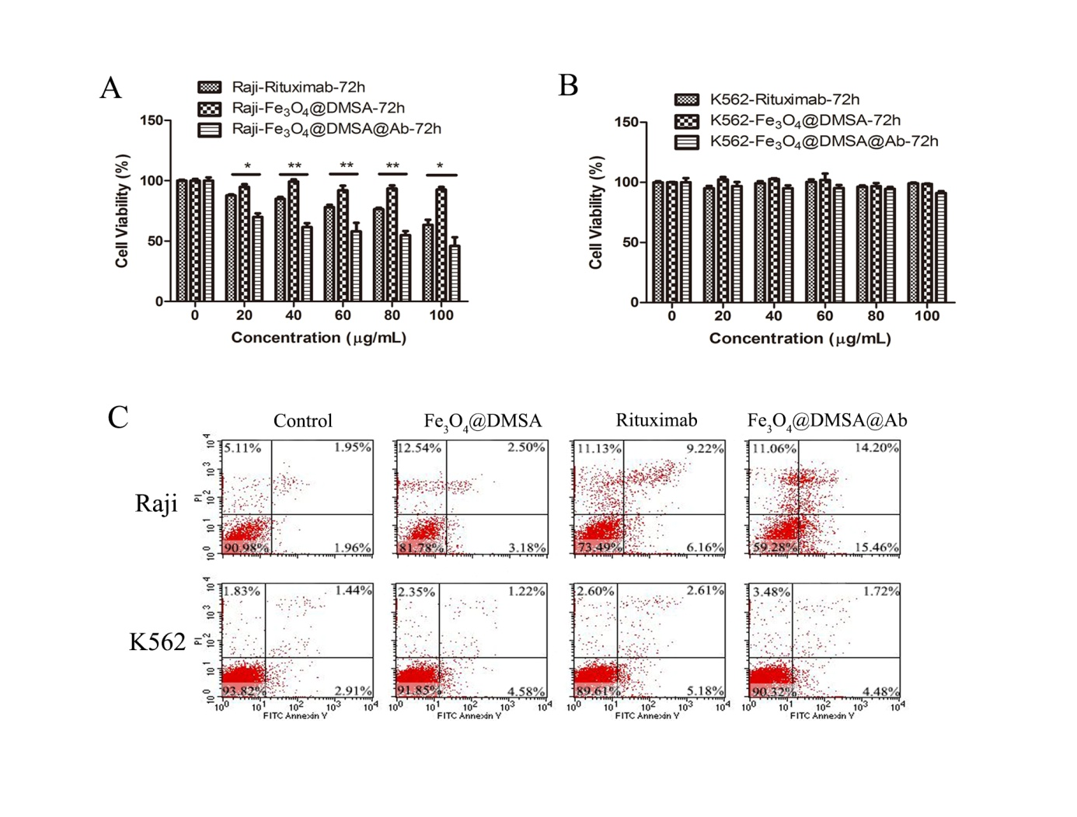
Figure S5. Cytotoxicity of Fe₃O₄@DMSA nanoparticles and Fe₃O₄@DMSA@Ab nanoprobes on Raji and K562 cells after culturing for 72 h, which was detected by CCK-8(A, B) and FACS (C).

Figure S6. The intracellular Ca²⁺ flux of Raji (A) and K562 (B) cells after incubating with rituximab, Fe₃O₄@DMSA nanoparticles, or Fe₃O₄@DMSA@Ab nanoprobes for 72 h. The corresponding variations of intracellular ROS (C) and mitochondrial membrane potential (ΔΨm) (D).

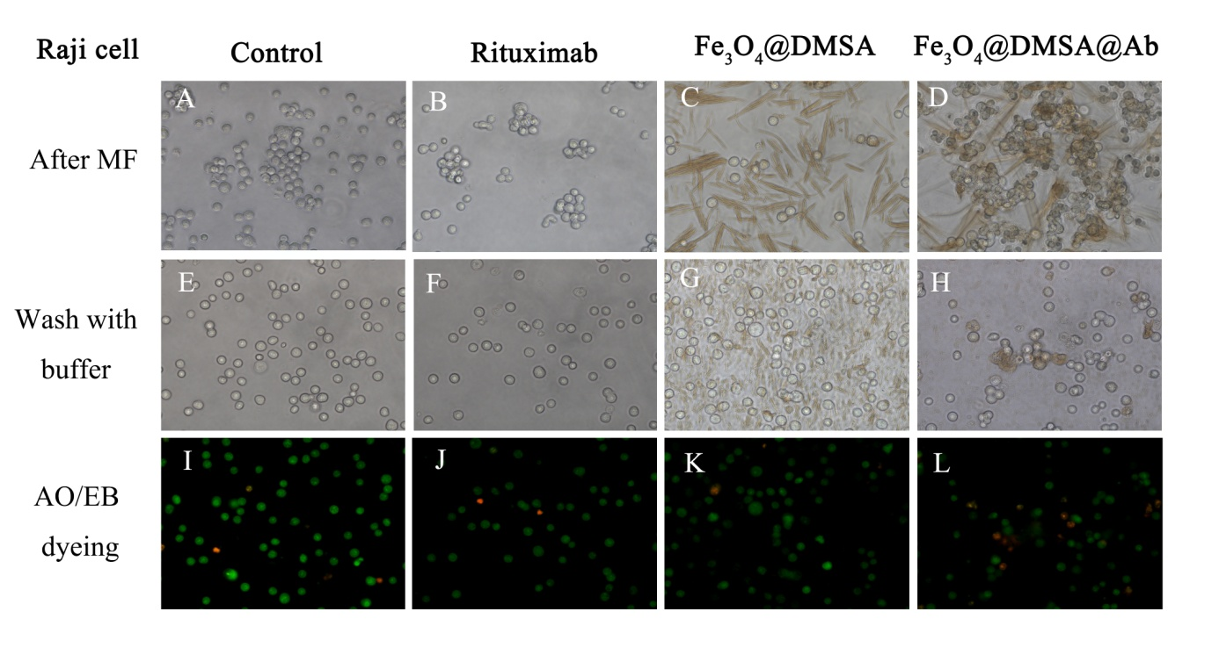
Figure S7. The morphological change in Raji cells before and after the incubation without and with Rituximab, Fe₃O₄@DMSA, or Fe₃O₄@DMSA@Ab under magnetostatic field (MF) (a-h). The live/dead cells were stained with AO/EB (i-l). The green color in the picture represents living cells and the orange color represents apoptosis or dead cells.

Reference
[1] Jr A E H, Smart J A, Amis E S. Simultaneous Spectrophotometric Determination of Iron(II) and Total Iron with 1,10-Phenanthroline[J]. Anal Chem, 1955, 27(1):26-29.

